Business Analysis Portfolio Level 4

University Hospitals Plymouth | Derriford Road, Crownhill, Plymouth, Devon, PL6 8DH

Business Analysis level 4 apprenticeship

INWANG, Collins (UNIVERSITY HOSPITALS PLYMOUTH NHS TRUST)

2024

Contents

Chapter 1 – Week in My Life. 6

Where do I Work? 7

Our Vision 7

Who do we care for? 7

How my job role fits into the Organisation: - 7

The Value of Business Analysis: 9

Personal Assessment: 9

About SWOT analysis, I would explain the following regarding me. 10

• Strength 10

• Weaknesses 10

• Opportunity 10

• Threats 10

Personal Development Plan (PDP) 10

• Specific 10

• Measurable 11

• Achievable: 11

• Relevant 11

• Time-bound 11

The Barriers 11

Stakeholders Support 12

Skills Application 12

Conclusion 14

**1.** Strength 14

**2.** Weakness 14

**3.** Opportunities 15

**4.** Threats 15

Chapter 2 - GAP ANALYSIS 15

INTRODUCTION: 15

WHAT IS GAP ANALYSIS: 16

WHAT IS BUSINESS PROCESS MODELLING? 16

THE BENEFITS OF BUSINESS PROCESS MODELLING: 17

• Access and utilise quantitative process data 17

• Streamline and accelerate process automation 17

• Keep operation costs down 17

• Align Operations with Business Strategy 17

• Improve Process Communication 17

THE DIFFERENCE WAYS TO DOCUMENT PROCESS MODELS: 18

• Activity Flow-Oriented Diagram Approaches 18

• Data Flow Diagramming Approach 18

• Swimlane Diagrams 18

• Activity Diagrams 18

• Unified Modelling Language (UML) Diagrams 19

• Flowchart Technique 19

GAP ANALYSIS APPROACH/PROCESS: 19

SWOT Analysis**:** 23

Strength 23

Weakness 23

Opportunities 23

Threats 24

CURRENT STATE/SITUATION: 24

A Swimlane Diagram 24

Business Process Model and Notation (BPMN): 24

CURRENT SITUATION/ STATE: 25

Issues with the Current Process 25

DESIRED SITUATION/ FUTURE STATE: 27

GAP ANALYSIS: 29

Definition 29

• The Gap and Recommended Action 30

• Actions to move from Current State to Future State 30

Summary: 31

Conclusion: 32

REFERENCES 33

Chapter 3 - BUSINESS SITUATION ANALYSIS 34

INTRODUCTION 34

ANALYSIS OF THE CURRENT SITUATION: 35

SWOT, PESTLE, VMOST ADVANTAGES/ DISADVANTAGES 36

PESTLE AND SWOT BASED ON THE CURRENT SYSTEM 42

TECHNOLOGY AND INDUSTRY TRENDS 44

THE PRINCIPLES/ DIFFERENCES OF WATERFALL AND AGILE METHODOLOGY 47

**1.** DEFINITION OF AGILE 48

PROS AND CONS OF PRACTICAL ADOPTION OF AGILE METHODOLOGIES 49

DEFINITION OF WATERFALL 50

• Requirement Gathering and documentation 51

• System Design 51

• Implementation 51

• Testing 51

• Delivery 52

• Maintenance 52

• Strict, one-way structure 52

• Little to no stakeholder involvement after the first stage 52

• In-depth upfront documentation of the entire process 52

HOW DOES THIS RELATE TO THE EPR PROJECT IN MY NHS TRUST 52

AIMS AND OBJECTIVES OF EPR INTRODUCTION TO MY NHS TRUST 53

KEY FINDINGS AND RECOMMENDATIONS 55

WHAT IS EPR 55

BENEFITS OF SHARED SYSTEM ACROSS THE TRUST AND THE COMMUNITY AND POTENTIAL SERVICE IMPROVEMENTS 56

HOW I COMMUNICATED THIS TO VARIOUS STAKEHOLDERS: 57

ELECTRONIC PATIENT RECORDS (EPR) BASELINE MAPPING STAKEHOLDERS’ ENGAGEMENT 64

EPR -BENEFITS TO MY NHS TRUST 64

EPR STRATEGIC BENEFIT OUTCOMES 65

BENEFIT OF OUTBOUND DATA SHARING 68

• For patient 68

• For clinical 68

• Service providers and commissioners 68

EPR BENEFITS FROM SHARING THE SAME SYSTEM: 68

• Overall Benefits 68

• Overall challenges 69

• lesson learned by the organisation 69

SWOT ANALYSIS BENEFITS TO ELECTRONICS PATIENT RECORD(EPR 70

• SWOT Analysis 70

CONCLUSION 70

REFERENCES: 72

Chapter 4 - Requirements Engineering and Management 73

INTRODUCTION 73

Project Background 73

Business Goals/ Objectives 75

Benefits/ Rationale 75

Supporting Independent Healthy Lives: 76

*For patient* 76

• *Lessons learned by the organisation*. 77

• Benefits/ Rationale to Maternity Pathway 78

Benefits/ Rationale to Urgent Care and Emergency**: -** 79

REQUIREMENT: 81

REQUIREMENT ELICITATION: 84

Examples of Non-Functional Requirements 92

FUNCTIONAL REQUIREMENTS 94

NON-FUNCTIONAL REQUIREMENTS: - 97

REQUIREMENT ANALYSIS, VALIDATION & TRACEABILITY: 98

Requirements Documentation Approaches 98

ADVANTAGES AND DISADVANTAGES OF USING SPREADSHEETS FOR PROJECT DOCUMENTATION 99

Requirements Management 109

Benefits Realisation and Management 111

Virtual Fracture Clinic: 111

Rapid access to information 111

Electronic alerts 111

Smartcard 111

Single source of truth: 111

Real-time information for effective management 112

Using digital technology to identify and treat sepsis quicker 112

Allergy improvement 112

Referrals to our community sites 112

Improving flow and capacity 112

Recording care at the bedside 113

Patients do not stay in the hospital for longer than necessary 113

Improving flow and capacity 113

Medicine take-home improvements 113

Pottering on the go 113

Fast Pass success 113

Responding to deteriorating patients: 114

Productivity and efficiency 114

How all the Benefits would be managed 114

Stakeholders' feedback on the benefits of Electronic Patient Records (EPRs): 114

CONCLUSION: 116

References: 117

Chapter 5 - DATA MODELLING 118

INTRODUCTION: 118

WHAT IS A CLASS DIAGRAM: 119

Benefits of UML: 121

Investigating the Data Model: 121

**1.** Interviews 121

**2.** Conference 121

**3.** Primary Analysis 122

**4.** Secondary Analysis 122

Documenting the Data Model 131

Software Used in Designing the UML Class Diagram: 131

Issues Encountered when designing the Diagram 133

Analysing the Data Model 133

Conclusion 134

REFERENCES 135

Chapter 6 - ACCEPTANCE TESTING 136

INTRODUCTION 136

Importance of Acceptance Testing 137

Test Phase Identification 137

Business Analyst role within the Testing Lifecycle 141

• Requirement analysis 141

• Planning 142

• Engineering and Design 143

• Software Development 143

• Testing 144

• Deployment 146

Put People First**: -** 147

Empower Staff Members Through Communication 147

Ignoring Resistance to Change 147

Supporting User Acceptance Testing (UAT): 148

Acceptance Criteria: - 148

• Patient Details 150

• Patient Medical/Treatment History 150

Defect Management Process/Procedure 150

Conclusion: 151

REFERENCES: 152

# **Chapter 1 – Week in My Life.**

**Enjoy Skills Portfolio**

**Week in My Life.**

Where do I Work? **-**

My name is Collins Anwana INWANG and I have a Certificate of Proficiency in Information Systems Management (CPISM), a Diploma in Information Systems Management (DISM), a Higher Diploma in Software Engineering (HDSE), a BSc in Multimedia Computing from the University of Plymouth and I have worked as a PHP developer for Caston Global Solutions, before moving to Acer Service centre as a Computer hardware engineer, then decided to change back to software development at CDS Range head office Plymouth, before moving to Matrix Technologies Solutions Plymouth as a PHP Developer. I have also volunteered at my local church as a Technology Assistant (Helping with the projection of lyrics and messages on a Sunday) which I have been doing for quite a while now (7 years). I am currently working for University Hospitals Plymouth NHS Trust which is part of the National Health Service (NHS) and the Trauma Centre for the Southwest of England United Kingdom in 2019 as a Theatre Systems Administrator, before moving to become the Discharge Case Manager covering Devon, Cornwall, and Plymouth, and now a Change Analyst within the Digital and Innovation Department. And just started Apprenticeship in Business Analysis in October. This will give me the needed exposure to how business models are designed and give me the full insight into what is expected from a good well-grounded Business Analyst. It has always been my dream to be a BA specialist to transfer my acquired Change Analyst experience/skills to more use. The Trust provides Health and social care services across Plymouth, Devon, and Cornwall. And most of the Southwest region.

## Our Vision

Our vision is to provide excellent care, with compassion, wrapped around people and their individual needs. Together with our partners we develop nationally leading integrated health and care, unlocking better outcomes and reducing inequalities.

(https://www.plymouthhospitals.nhs.uk/about-us/, 2023)

Who do we care for? **–**

We care and support people across the wider spectrum, including people’s homes, and care/ residential homes, and working with other voluntary sector partners within the local communities in Plymouth, Devon, and Cornwall to offer the best specialist hospital care available in the regional centre.

**Which other teams do I work with? I work with the Clinical Systems trainers and the project implementation team (both teams are part of the Digital Transformation Team, DTT). We collaborate with the Project team and the software team, too. The wider Digital and innovation team works** together to deliver first-class service within the trust.

## How my job role fits into the Organisation: -

* I work within the Business Change Team (BCT) that seats within the Digital Transformation Team (DTT) which seats within the wider IT department called Digital & Innovation Service (D&I). The business change team (BCT) fits into the wider organisational structure under the umbrella of the Digital Transformation Team (DTT) which is a sub-department within the Digital and Innovation Service(D&I) and we are a team of 7.

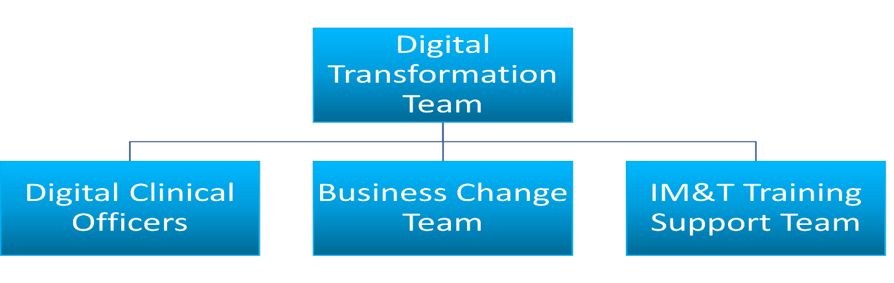

**(Team, Digital Transformation, 2023)**

* We have a team leader in the person of Sean ROBINSON. Who reports to the Business Change Manager in the person of Raymond MCANDREW, who also reports to Jocelyn GEANY who is the Digital Transformation Manager.
* The main priority of the Business Change Team (BCT) which am part of is to design the business change process (Process Mapping) whenever there is a potential role out of new business systems. I would refer to us as change analysts because the job description is the same.
* The main priority is to capture the current/ future state using process mapping and the purpose is to meet with different stakeholders and discuss how to help design the changes required in the future state. We are in the process of acquiring electronic Patient Records (EPR) with a deadline of 2026 given by NHS England and my main task is to design the current state process maps that capture the entire inpatient journey from start to finish so that the project team can present this to the procurement team before the final decisions are made.
* The system I use is Microsoft Windows Laptop and the design is Microsoft Visio.
* We follow the General Data Protection Regulation (GDPR) and The Data Protection Act 2018. The relevant General Data Protection Regulation (GDPR) or the Data Protection Act 2018 (DPA) helps monitor how personal data is processed and stored to deter cybercrime and companies selling personal data to the highest for personal gain. In the NHS Plymouth University Hospital NHS

Trust (PUHNT) we have the information governance team that manages the information governance policies and procedures that help keep data safe, while the

cyber security team handles any phishing emails that finds its way into the trust intranet space. We all have a part to play and comply with the Data Protection Legislation and make sure personal information is processed fairly, lawfully, and transparently and has good cyber security procedures in place.

## The Value of Business Analysis:

* The role of business analysis is to help organisations and businesses identify areas of change and improvement processes for organisational efficiency and performance. And BA’s is the glue that the business users need to help marry them with the IT department.
* Business analysis enables businesses to improve business processes, and software through data management and bridge the gap while improving efficiency.
* i.e.: When the eDischarge software was conceived the business improvement team where the business analysis team sits, had to write a good business improvement proposal and also address the benefits of eDischarge to the trust, before getting the change analyst team(My team) to design the current state and the future state in process mapping and then get it signed off by all the stakeholders/stockholders before handing it over to the project team who in turn gets the Software Development team to design the process.

## Personal Assessment:

The way I conduct my assessment differs from situation to situation depending on the task or job at hand and what is expected of me in terms of delivery.

|  |  |
| --- | --- |
|  |  |
| **Positives** | **Negatives** |
| **Strengths**   * **More motivated in the morning.** * **Always eager to learn new skills.** * **Determined to succeed.** | **Weakness**   * **Can’t concentrate after 1pm.** * **The fear of failing.** * **The anxiety of being told NO.** * **Fear of being not able to finish.** |
| **Opportunities**   * **New job prospects.** * **Learning new skills(self-development).** * **Career progression within the Trust.** | **Threats**   * **The obstacles of being used to tick a box of diversity.** |

My line manager (Sean Robinson) had this to say about my work ethic. Please see below.

**“Collins was tasked with completing a piece of work that came about quite urgently and at short notice. He recognised that this would be a good opportunity to develop his process mapping skills by following the process from start (research) to finish (presenting the final map). I felt that he was motivated by this opportunity to complete the task to a high standard and within the agreed time frame, testing his abilities and proving he can do the job well. The outcome of this is that Collins produced a fantastic process map which pleased the people he was supporting, and at the same time he has upskilled himself. A time when Collins was de-motivated was when there was a lot of uncertainty around the future of the team’s workload, and what his role would be in this future. Along with other members of the team, there was a slump in motivation with project work which was totally understandable at the time. I managed this by keeping him constantly updated with what I knew about the future to ensure he didn’t lose sight of the bigger picture and made sure that any work he did in the meantime held value to him. We have made great progress since then and now have a good idea of what the next 12 months will look like for the team. Since this update, Collins has shown a higher level of motivation with his work.”**

## About SWOT analysis, I would explain the following regarding me.

* Strength: I derive my strength from having a good sense of direction whenever I have a project am working on. And I get motivated more when I look into the future and see that the road is clear, and the team has a clear vision of what we are doing and where we are headed. And understand the role I would play in the project moving forward.
* Weaknesses: I get demotivated easily when there is uncertainty around a project and where the team is headed in terms of workloads. I also lose interest easily when I don’t have a clear direction to what am doing, or what the team is doing to move the project forward.
* Opportunity: I would also look at the project as an opportunity for self-development and improvement. Also, as an avenue to upskill myself in the areas I was lacking. I take the time to ask questions when meeting with stakeholders, and managers so that I can understand where I need to work on the most. Because I don’t know everything and there is always room for improvement.
* Threats: The fear of failing makes me worry about how I can deliver every project to perfection without any errors. And the fact that stakeholders can scrap the work and ask you to start all over again. That threat is real, and I sometimes feel it.

## Personal Development Plan (PDP)

I develop myself through courses like the BA that I am doing right now with Estio. I am a member of loads of forums on LinkedIn which helps me to post questions that I don’t know answers to. I take part in the NHS Podcast also to build and develop my skills in the

workplace so that I can stay relevant in the industry. Also, I am a keen learner of new technologies that are very interesting to me (Not just for making money) but doing what love

in terms of Technology updates. I would also address my SMART targets in my Business Analysis apprenticeship.

* Specific: My first goal is to finish/complete my Business Analysis (BA) apprenticeship as the foundation and fundamental of getting me ready for the industry. Prepare for the foundation exam of “The Entry Certificate in Business Analysis (ECBA) – Certified Business Analysis Professional (CBAP).
* Measurable**:** The goals I have set for myself are to perfect my business modelling skills and understand process modelling which is capturing all the current state of the business process through process mapping, before getting it reviewed and signed off by all the stakeholders. Then designing the future state and implementing the required changes that is needed before the final sign-off, then handing it over to the project team to review and come back with some questions if any. The Software Development team can now develop the system before the test engineers would test the finished product for any bugs or errors.
* Achievable:I believe all my goals can be achieved with shared determination and mental focus. I can realistically say that I might encounter challenges along the way in terms of finances to fulfil all this goals for myself. On the other hand, I look at the positive side of being sponsored by my employer to reach my personal development goals/ plans (PDP) if things align perfectly for me. I have come a long way in my PDP in terms of my career within the Digital Transformation Team (DTT). When I joined, I knew nothing about process modelling and mapping, but with shared determination, study, and training by my line manager I have been able to master process mapping/modelling and anchor meetings with stakeholders/stockholders to discuss business models and processes.
* Relevant**:** NHS Plymouth University Hospital NHS Trust (PUHNT) is in the process of securing Electronic Patient Records (EPR) and my team DTT & BCT play a very vital role in the preparation phase which is process modelling the current process and looking into the future state by capturing how all the wards do thing through process mapping. I organise meetings with different stakeholders/stockholders to discuss their expectations of the new EPR, then have it signed off after its finished before handing it over to the solutions architects to review. My team takes part in the piloting phase where we select a service line that would be used as the pilot/testing to monitor how the new system works with attention on failed areas that would need to be improved or corrected before the full rollout.
* Time-bound**:**  The process modelling, or process mapping has a deadline of mid-November which to me is unrealistic because other small projects are also being worked on at the same time. I have captured all the processes for the inpatient process from the time of admission to Discharge, with minor corrections that am working on now. The Theatre Process mapping is also being done alongside the inpatient.

The Barriers**:**

The barriers that might prevent me from achieving the goal and meeting the deadline are not focusing on the business modelling from start to finish but being called to

attend to multiple process modelling at the same time. This hinders the completion of one project in time. Currently, we are working on implementing two (2) different EPRs within the trust, which is a bit challenging to fulfil both deadlines back-to-back. This is why we have focussed our attention on the Electronic Patient Record (EPR) for Maternity which is meant to be rolled out on the 22nd of November 2023 to take it across the line.

Stakeholders Support: Stakeholders have been very helpful all through the process from start to finish, by being willing to meet and discuss how the business modelling/process mapping should look like. They have contributed to the design and development of the new systems. The stakeholders/stockholders have supported me with all projects reviewing all the business modelling designs and making correction

and meetings to discuss the future state of the business models. I would be able to finish my projects without input from stakeholders. They are the end users of the finished project so they must have a say in the design until the rollout, as our job is to make sure they are looked after and satisfied with the product.

Skills Application**:**

The personal attributes that I have used effectively during the design and implementation of new business models are my communication skills, my attention to detail and my asking the right questions when meeting with stakeholders/ stockholders to discuss project design ( current/future states) and my areas of confidence I would say is the ability to communicate in a friendly manner, and build the good relationship with all the parties involved. I would take the Inpatient Process modelling that am mapping for the Electronic Patient Records (EPR) which I have included in the screenshot below. The design phase was an eye-opener for me because it allowed me to test my strengths and abilities. Also, when I was meeting with stakeholders and stockholders, I was able to put my communication skills to the test by engaging in conversations about their expectations of what needs to be addressed in the current state and the new elements that would be needed in the future state when it's designed and signed off.

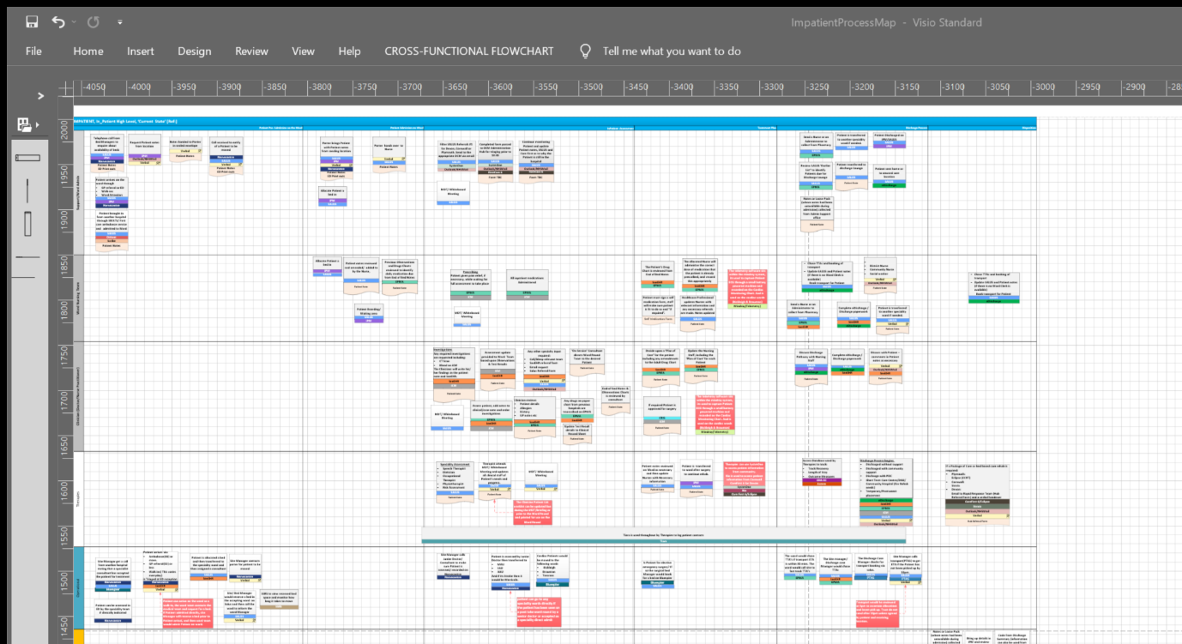

**High-level Process modelling for In-Patient Process mapping.**

The high level is the first page of the process modelling that breaks down all the lower levels and what to expect from the whole business model. This was the hard part to design because the stakeholders/stockholders didn’t understand the reason behind the high level. It was my duty to explain to them the reason behind the high level. After the explanation, they became more relaxed and interested in what I had to offer.

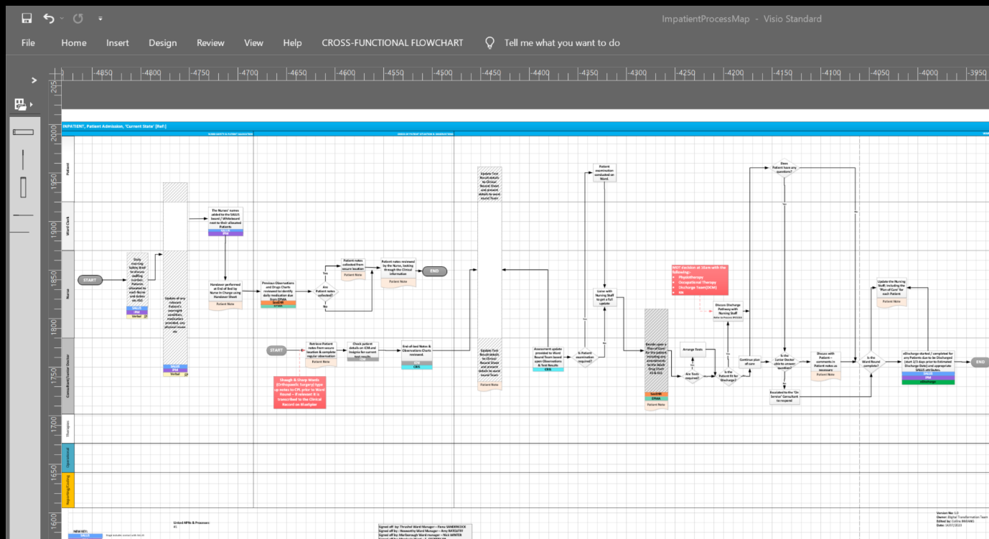

**Patient Admission Process Modelling**

The Patient Admission Process modelling is where I break down the process in more detail much more than the high level to let them into the lower level so that they can be relaxed and communicate by explaining to me what happens in the current state of the process modelling.

Conclusion**:**

In conclusion, I have discovered a lot about my work ethic and how I can be easily distracted if I don’t have a good sense of direction where the project is headed. Also, I have learnt to approach things differently should I find myself in similar situations again in the future. By learning how to engage with stakeholders/ stockholders in a friendly and I enjoyed the communication with stakeholders and building good working relationships with stakeholders that would help understand stakeholders’ engagement and deliver the project to suit stakeholders’ expectations. The process modelling went well, and the stakeholder’s engagement and contributions were the icing on the cake for me because I got them talking among themselves and coming up with wonderful ideas that helped move the project forward. What I would do differently next time would be to start early and plan well ahead with a draft of the project road map at hand to work with/towards. And I reflect on my **SWOT** analysis below to explain what makes me want to win at all costs.

1. Strength**:** I consider myself a morning person because am more energetic and fired up in the morning when my head and mind are sound to get the work done before the afternoon sets in (from 2 pm). Am motivated to get the job done in the morning. And the determination to learn new skills that can help me in my future

career pursuit. I don’t take “NO” for an answer. It makes me want to push even further to prove that I can do it and do it even better.

1. Weakness**:** My concentration begins to slow down from 2 pm, and fear of not being able to finish keeps me pushing till I cross the finish line, which is why I tend to get all my daily tasks completed before that time. The fear of failing keeps me more motivated every day and gives me the mental strength to push further to make sure I grow and better myself. The anxiety of being told “NO” also gives me the drive to keep going. I know it's not easy to get my mind off it sometimes.
2. Opportunities**:** I believe that the Business Analysis apprenticeship would open new and prospective opportunities for me in the workplace and outside the Trust as well. I know that I will learn a lot during this time and trust the process to bring a huge change in my future career and give me the most needed sense of direction/purpose. I believe learning new skills opens new doors and opportunities for growth and personal development for me in the future.
3. Threats**:** The threat of being used to tick exercise just to meet diversity targets whenever I apply for jobs. My experience has been heartbreaking in terms of job interviews. And it happens to me regularly whenever I apply for jobs within my NHS trust. Even though I can’t prove it, I know it happens regularly. This does not only happen within the NHS, but it has also happened outside as well (e.g., National Grid, National Highways) to name a few. But I won’t let that affect my determination to succeed career-wise.

# **Chapter 2 - GAP ANALYSIS**

**APPRENTICESHIP COURSE WORK**

**GAP ANALYSIS**

# INTRODUCTION:

Within this project am discussing the current system for pregnant mothers' scan requests and how it is done using **iClinical Manager (ICM)** software. The current system process that we have in place is inefficient and includes too many steps without any visibility. It is causing a lot of dissatisfaction among the clinicians, consultants, nurses, **Sonographers** and most importantly the patients which in this case are the pregnant mothers. We need to streamline the process to be more efficient and create more visibility. We are looking at improvements which will make life easier for the clinicians, and consultants who request scans and look at how we can carry the patient along in the journey.

As part of this project, I have been tasked with doing the **gap analysis** to capture how requests are made on **iClinical Manager** (**ICM**) for pregnant mothers' scan requests. This will help Clinicians and consultants search for patients using Hospital/NHS numbers whenever they want to review or request scans or examinations on Pregnant mothers using the in-house scan request platform called **CDN Radiology Information System** (**CRIS)**.

My input is to design the current way tasks are carried out (Current State Process Model) and then get it signed off or amended by the stakeholders/stockholders if there is anything that is missing during the information-gathering meetings. Once it's signed off, I then design (**Gap Analysis**) how they want things to look in the new system (Future State Process modelling) would look at all the new changes that would take effect once it's done.

## WHAT IS GAP ANALYSIS:

This is a method of assessing the performance of a business unit to determine whether business requirements or objectives are being met and, if not, what steps should be taken to meet them. This may also be referred to as a needs analysis, needs assessment, or need-gap analysis. The “**Gap**” in the gap analysis process refers to the space between “**where we are**” as part of the business (Current State) and “**where we want to be**” (The future State or Desired State). The above graphic is what I have included explaining my point. As part of my gap analysis, I will be documenting the current state and the future state using process models. Below is the graphics I have included.

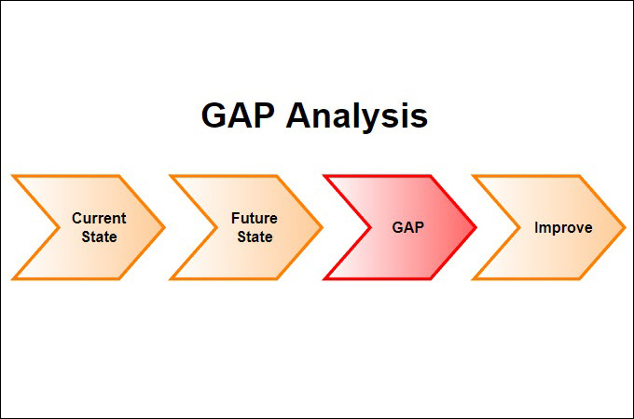

**(Opinaldo, 2022)**

As part of my Gap Analysis, I will be documenting the current state and the future/desired state using process models.

## WHAT IS BUSINESS PROCESS MODELLING?

A business process model is a graphical representation of a business process or workflow and its related sub-processes. Process modelling generates comprehensive, quantitative activity diagrams and flowcharts containing critical insights into the functioning of a given process, which includes the following:

* Events and activities that occur within a workflow.
* Who owns or initiates those events and activities.
* Decision points and the different paths workflows can take based on their outcomes.
* Devices involved in the process.
* Timelines of the overall process and each step in the process
* Success and failure rates of the process.

## THE BENEFITS OF BUSINESS PROCESS MODELLING:

Business process modelling arms and enterprises with objective business intelligence that supports more informed decisions for resource allocation, process improvement and the overall business strategy. With a clear view of processes, enterprise teams can ensure that workflows always drive the desired results. As a result, operating costs are lower, revenue is higher and business outcomes are stronger.

Specifically, business process modelling allows companies to do the following.

* Access and utilise quantitative process data**:** Without a process model, teams are limited to discussing and analysing workflows in quantitative and subjective terms. As a result, teams may not accurately understand their workflows; they may make business decisions based on misunderstandings, assumptions and/or incomplete knowledge. With process modelling, teams can access quantitative workflow data, including success and error rates, allowing for more rigorous analysis of business processes.
* Streamline and accelerate process automation**:** Before a process can be automated, an organization needs a clear understanding of how that process plays out, including the business logic underpinning each decision point. A process model illuminates both the way a workflow unfolds and the relationship between events, actors, tools, and systems within and between processes. This viewpoint helps a team document the process itself and the business rules that guide its execution. This information makes it easier to effectively automate workflows the first time.
* Keep operation costs down**:** Process models provide organisations with an easy way to identify opportunities to optimise existing processes. This makes it easier for the company to ensure that processes consistently produce the desired outcomes. As a result, business processes require less investment to maintain and generate positive outcomes at a lower cost.
* Align Operations with Business Strategy**:** Implementing a business strategy or new business model will require changes in the operations and in how people perform their work. Business process modelling facilitates by helping managers and executives ensure that business processes are consistent and enable business execution toward achieving the overall strategy and goals of the organisation.
* Improve Process Communication**:** Having a clear idea of what should be done, how it is supposed to be done, and what the exact role of every team member entails, represents key factors that lead businesses and teams to success.

Business process modelling enables the documentation and communication of an organisation’s business processes. It also provides a common, unified language and methodology for communicating processes, information and guidelines about the processes; it minimizes the loss of business process knowledge (for example, the loss of staff); jumpstarts the organisational process documentation initiative; and allows for rapid knowledge transfer with thoroughly documented processes.

## 

## THE DIFFERENCE WAYS TO DOCUMENT PROCESS MODELS:

* Activity Flow-Oriented Diagram Approaches**: -** This is the most used in business redesign. Activity flow-oriented representations of business processes. Business process redesign approaches that build on activity flow representations are often referred to as work-flow-oriented approaches to business process redesign. Because of their popularity, many different activity flow-oriented business process representation conventions exist, each with its own set of standard symbols.
* Data Flow Diagramming Approach**: -** The traditional systems analysis and design approach, also known as the structured systems analysis and design approach, has served as the basis for hundreds of thousands of software development projects. This approach’s main business process modelling diagram is the data flow diagram (or DFD). Different sets of symbols and notations have been proposed in the past for data flow diagramming.
* Swimlane Diagrams**: -** A Swimlane diagram is a type of flowchart that delineates who the stakeholders are and the roles they play in the process. Using the metaphor of lanes in a pool, a swim lane diagram provides clarity and accountability by placing the process steps within the horizontal or vertical “swim lanes” of a particular employee, workgroup or department. It shows connections, communication and handoffs between these lanes, and it can serve to highlight waste, redundancy and inefficiency in a process.
* Activity Diagrams**: -** This diagram describes how activities are coordinated to provide a service which can be at different levels of abstraction. Typically, an event needs to be achieved by some operations, particularly where the operation is intended to achieve many different things that require activities coordination, or how the event in a single use case relates to one another use cases where activities may overlap and require coordination. It is also suitable for modelling how the collection of use cases coordinates to represent business workflows.
* Unified Modelling Language (UML) Diagrams**: -** This is used for specification, visualisation, development and documentation of software systems. However, business professionals have adapted it as a powerful business process modelling technique. With 14 different UML diagram types, these offer a flexible and powerful way to visualize almost any business process. They are typically used for modelling the detailed logic of a business process. UML diagrams are the object-oriented equivalent of flowcharts.
* Flowchart Technique**: -** Flowcharts are the most popular diagram type in the world. Because it has few standard symbols it can be easily understood by many. Simplicity makes it a powerful and effective tool. BPMN can be considered as an advanced version of the basic flowchart technique. Also, most drawing software supports the creation of flowcharts, it is used by a much wider audience as well.

## 

## GAP ANALYSIS APPROACH/PROCESS:

By analysing the gap between the current state and the target required for the future state, I had to set up meetings with all the stakeholders/stockholders to discuss how things are done presently (Current State) and what works well and what doesn’t. I ask questions about the changes that need to be carried out in the new system to address the gaps (Future State) by collecting all the information, and data that would help me build and design the target state (Future State) and then compare both information and note the changes that this would address while also identifying the gaps that would be addressed.

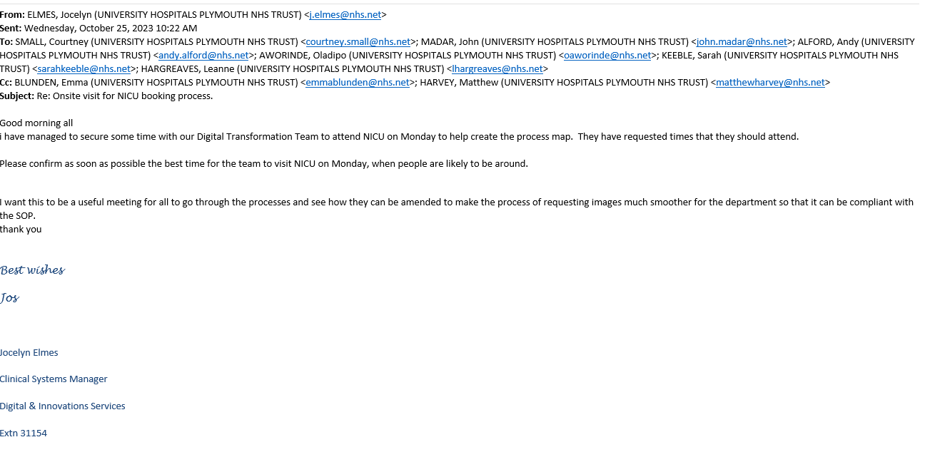

**The meeting invites from the senior clinical systems manager**

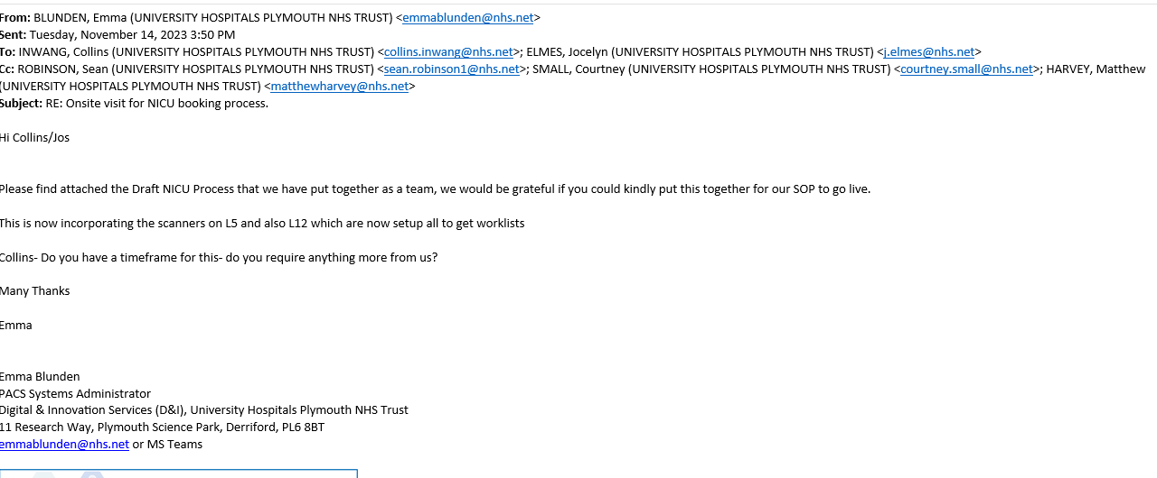

**The email after the initial meeting**

I will start the design phase of the current state and then send it via email to all the stakeholders for review and try to see if anything is missing. Once that is signed off, I then start the future state design and implement all the changes that would take place. Send it back to stakeholders for a final review and signoff in case I missed anything, or the stakeholders notice something missing while looking through it, a different pair of eyes might see what I didn’t notice because they would be the ones that would be using the system once it goes live.

The investigative steps I used, in this case, were to visit the unit/ ward to spend a day with the members of staff to watch how things are done and ask all the necessary questions that would help me in the design phase of the model design (Process Mapping) while also asking questions that would help me in the design phase I then map the shortfalls and deficiencies on Business activity model (BAM) using RAG analysis to illustrate and identify all the changes that would replace the old ways of doing things and what the new system would be addressing.

Using RAG, helps me present the analysis in a graphic method and the result of the gap analysis. I had to conduct individual interviews and group interviews to try and

understand what is needed in the new system and also visited the Neonatal ward to spend a day with the ward Nurses just so I could observe how things are done and how the scan is requested on the **CDN Radiology Information System (CRIS)** which is an in-house image requesting system that consultants, clinician use to request scans.

The **investigation** technique I used was to ask questions on the ward when I was observing to know where the scanning machine is located, if it's stationary or if it can be moved from its stationary position to the bedside of the pregnant mother, just in case she can’t move due to some medical reason.

The **problems** of the current business process were the fact that scan requests were not working well enough to the satisfaction of the ward Consultants/Clinicians which was making life harder and difficult for scans to be carried out, especially when the pregnant mother is in the maternity ward rather than the neonatal ward.

The **Decision** was to help bridge the gap that is being experienced by designing a new system that would help address the issue. I was **tasked** to capture the current state and also design the future state while addressing the gap between the way things are done presently and where/what is expected of the new system (Future State) of the process modelling.

I then did a **SWOT** Analysis to determine the strengths, weaknesses, opportunities and Threats that the new business process modelling would pose. I know that most people fear change and enjoy staying with whatever they are used to, which is why the SWOT analysis would be looking at the fears and the opportunities that the new system would bring to the department. This is explained below: -

(Estio Training Provider, 2023)

### SWOT Analysis**:**

Strength**:** We had to look at the software integration how it would sit within the Maternity Electronic Patient Records (EPR) and how easy it would be for the stakeholders to use. Deeper research was carried out to make sure the chosen EPR can be integrated into the in-house software called **Badger** so that information can sync between systems.

Weakness**:** The staff is not motivated due to system failures which hinder staff from monitoring CTGs at the nurse station (Front desk). Which is bound to happen in the early stage of the rollout (Teething period). Sometimes this can be frustrating and make the nurses want to quit using the system.

Opportunities**:** The opportunities the new system brings are so vast and endless in terms of cloud-based storage so that the fear of losing data isn’t an issue for the ward staff (consultants, midwives, secretaries), **Sonographers** won't be scared of losing scan images in transit. If the network suddenly drops the image is stored automatically in the cloud.

Threats**:** The threats and setbacks in some cases make the nurses worry about not being able to complete treatments and observations on the mother and child due to the system or software freezing/logging them out in the middle of an event. So, we end up being stationed on the wards should such incidents occur. We are giving 24/7 support on all the delivery wards (Argyle, Central Delivery Suite, Transitional Care Ward, Neonatal Intensive Care Unit (NICU)) for 4 weeks which is a full month to help them stabilise the new system and make them settle into the new business/process model.

I then decided to document the current process model using a swim lane diagram, Business Process Model Notation (BPMN) and Microsoft Visio to design the current process model and the future/desired state.

## CURRENT STATE/SITUATION:

A Swimlane Diagramis a type of flowchart that outlines who does what in each process. Based on the analogy of lanes in a pool, a swim lane diagram places process steps within the horizontal or vertical “Swim lanes” of a particular department, workgroup or employee, thus ensuring clarity and accountability and highlighting connections and communication between these lanes. It can serve as an indicator of waste, redundancy, and inefficiency in a process. And it also helps to structure the process properly with all the stakeholders, and stockholders according to the part everyone plays in the process modelling.

Business Process Model and Notation (BPMN):

This is a graphical notation style or a visual language that enables the description and optimisation of business processes. A Key to Business Process Management (BPM), visually depicts a detailed sequence of business activities and information flows needed to complete a process.

Its purpose is to model ways to improve efficiency, account for new circumstances or gain competitive advantage. The method has been undergoing a standardisation push in the past few years and is now often called by a slightly different name: **Business Process Model and Notation,** still using the BPMN acronym.

Below is a step-by-step breakdown of what the current state does:

## 

## CURRENT SITUATION/ STATE:

* *Request exam/Scan for patient on ICM/iSOFT –* ***Clinicians***
* *ICM order automatically turned into a CRIS request by way of the MACRO –* ***Automatically done by MACRO.***
* *Load CRIS -* ***Clinicians/secretary (depending on out of hours)***
* *Search for patients using hospital /NHS number -* ***Clinicians/secretary (depending on out of hours)***
* *Find previously requested exam/event done in the first step -* ***Clinicians/secretary (depending on out of hours)***
* *Load selected event for the patient by double clicking or clicking the change button -* ***Clinicians/secretary (depending on out of hours)***
* *Add room code DNICU for scans taking place on L5 and then ‘Attend’ the patient -* ***Clinicians/secretary (depending on out of hours)***

Issues with the Current Process**:**

* The **Sonographer** can't see the request that is made by the clinicians and that slows down the time frame allocated for each pregnant mother this also contributes to the clinicians not being able to meet the daily target of scan requests to clear the backlog.
* The **Sonographer** always finds it mentally draining to have to scroll through a huge list of patients before getting to the required Patient. This needs to be addressed by making sure that the **Sonographer** goes straight to the required patient once the system is loaded to be able to deal with the patient in question and move on to the next.
* The Clinician and Consultants find it time-consuming to sit down and go through a long list of pregnant mothers to request a scan, and it delays the clinics and makes it longer than necessary.
* The Pregnant mothers are not being carried along in the current process which doesn’t help at all,
* The pregnant mothers don’t keep track of their clinic appointments and miss clinics in the process. So, this doesn’t help the Clinicians and consultants.
* Scans go missing in the current process or are not requested on time due to system inadequacies.

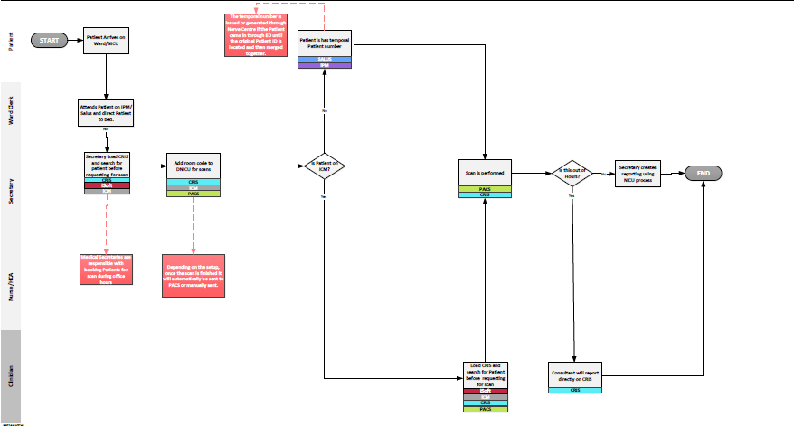

**Current State**

## DESIRED SITUATION/ FUTURE STATE:

In the desired situation, the goal is to address the concerns of the Clinician, **Sonographer** which is listed below.

* Patient details are now sent to L5 scanner worklists. – **Sonographer**
* Load worklists on the scanner – **Sonographer**
* Select the correct patient (as others may show) – **Sonographer.**
* Scan patient - **Sonographer**
* Finish scan - **Sonographer**
* Images sent to PACS (network connection required) - **Sonographer.**
* *Depending on how US Scanner is set up; once the scan is finished scan will automatically be sent to PACS or a manual send may be required.*
* Log into PACS - **Sonographer**
* Check Images have arrived in PACS **- Sonographer**
* Create a report using the current NICU process. – **Secretary (if attaching) if reporting directly to CRIS this will be done by the Consultant.**

I then documented the desired situation using the process model that addresses all the clinicians'/Consultants'/Sonographers' concerns using Microsoft Visio

Below is the breakdown of the desired/future state using Microsoft Visio:

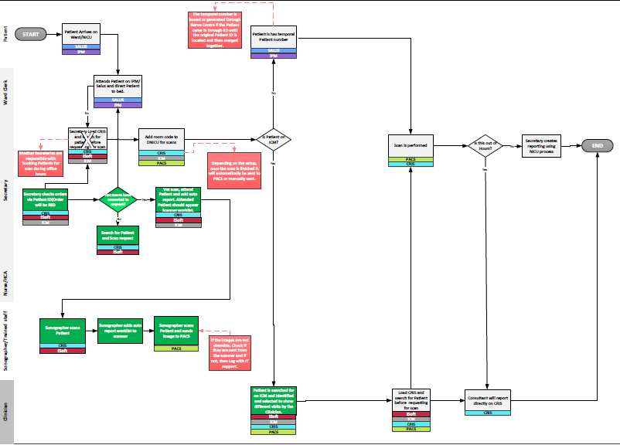

**Future State**

## GAP ANALYSIS:

Definition: This is classified as the gap between where the organisation or department is presently and where it is in the desired/future state.

|  |  |  |
| --- | --- | --- |
| **CURRENT STATE** | **FUTURE STATE** | **DIFFERENCE** |
| * The **Clinician** requests a Patient scan exam on ICM/iSOFT | * The patient scan needs to be picked up by the **Sonographer** on the level 5 scanner worklist. | * The gap between when the scan is requested for the pregnant mother to when it occurs and how the **Sonographers** can track the request in real-time, and make sure the scan is carried out on time for the pregnant mother and the baby’s safety while monitoring the scan request. |
| * ICM order automatically turned into a CRIS request by way of the MACRO – automatically done. | * The **sonographer** loads the worklist onto the scanner | * The task is to make sure the gap is closed, and the consultants/clinicians can request scans and be sure it is picked up by the **Sonographer** on the system and get the scan done on time. |
| * *Load CRIS -* ***Clinicians/secretary (depending on out of hours).*** | * *Select the correct patient (as others may show) –* ***Sonographer.*** | * The **Sonographer** is to make sure the work list is sent to the level 5 scanner and the worklist is loaded on the scanner to be able to select the Patient required using the unique hospital number of the Patient (As other Patients would show on the same list) and then scan the patient. |
| * *Search for patients using hospital /NHS number -* ***Clinicians/secretary (depending on out of hours)*** | * *Scan patient -* ***Sonographer*** * *Finish scan -* ***Sonographer*** | * After the scan is finished, the images are sent to **Picture Archiving Communication Service (PACS)**, this also depends on how the scanner is set up so that the images are sent automatically to **Picture Archiving Communication Service** (**PACS)**, or manually sent where required. |

* The Gap and Recommended Action**:**

The gap between when the scan is requested for the pregnant mother to when it occurs and how the **Sonographers** can track the request in real-time, and make sure the scan is carried out on time for the pregnant mother and the baby’s safety while monitoring the scan request. The task is to make sure the gap is closed, and the consultants/clinicians can request scans and be sure it is picked up by the **Sonographer** on the system and get the scan done on time. The **Sonographer** is to make sure the worklist is sent to the level 5 scanner and the worklist is loaded on the scanner to be able to select the Patient required using the unique hospital number of the Patient (As other Patients would show on the same list) and then scan the patient. After the scan is finished, the images are sent to **Picture Archiving Communication Service (PACS)**, this also depends on how the scanner is set up so that the images are sent automatically to **Picture Archiving Communication Service** (**PACS)**, or manually sent where required.

* Actions to move from Current State to Future State**:**

The actions that would be taken to gradually transition from the current state to the desired/future state would have to be considered very carefully to not affect the flow of daily activities that occur within the ward. The plan is to run a **pilot scheme** in some sections of the Neonatal Intensive Care Unit (NICU) that will be used to test the new system and monitor how the staff use and interact with it. And used that time to monitor/ assess the functionalities of the new system for setbacks malfunctions or bugs. And if there is any, then we can fix it during the testing period, before rolling it out to the entire ward. During the testing period, we will be monitoring it closely and have staff members on the shop floor to monitor the progress and answer all questions that may arise from midwives and patients alike.

## Summary:

In summary, the difference between the current state and the future state is the fact that **Sonographers** do play a vital role in the scanning process by keeping track of the scan request from the consultants and clinicians through PACS and see when it arrives so that they can take all the necessary actions required so that the secretary can attach the Image using neonatal intensive care unit (NICU) reporting process. But if reporting directly to CDN Radiology Information System (CRIS) that can be done by the consultant on duty. ***Recommended actions*** are to test the new system and see where corrections need to be carried out. And, to run a pilot scheme which is to pick a ward to use as the pilot scheme so that we know where the new system needs a remodelling or redesigning before the final rollout is carried out. We didn’t have time for a pilot, as we were running on a very tight schedule to get the job done before the Maternity electronic patient records (EPR) was in place.

## Conclusion:

In conclusion, during the investigation and information gathering, I ***learnt***that in most cases the stakeholders/ stockholders are not sure what they want the new system to address until the current state of the business model and processes is designed for them to see the visuals for them to be able to make corrections and amendments and also decide on what to include in the future state when designing the process model/future state. Even with this, I still learnt that “**NOT**” all information gathered was allowed on the future state/desired situation because the stakeholders kept moving the goal post and amending all the information that was agreed upon during the brainstorming stages of the process.

The process modelling/mapping of the future state is ***What went well*,** even though the stakeholders kept coming back with more expectations and changes in the final process mapping, which was mentally draining for me because of the back and forth. It made me realise my patience and strength of being able to weather the storm of rejection in terms of the stakeholders accepting my first process modelling of the desired state.

I had to schedule new meetings with the stakeholders (Consultants, Matron, Nurses, and Secretary) to understand what the new process is supposed to address so as to not make mistakes or have it rejected again. ***What I will do differently*,** is make sure that I send the sample design to the stakeholders/stockholders as many times as possible for them to look at and make corrections before I design the desired situation/future state process model.

REFERENCES**:**

* ( IBM Cloud Education, 2021):

<https://www.ibm.com/blog/business-process-modeling/>

* (Edited by Richard Smith, 2015, p. 123)

[The Effective Change Manager's Handbook (aston-recruitment.co.uk)](https://www.aston-recruitment.co.uk/wp-content/uploads/2023/02/The-Effective-Change-Managers-Handbook_-Essential-Guidance-to-the-Change-Management-Body-of-Knowledge-PDFDrive-.pdf)

* (Estio Training Provider, 2023):

[Curriculum, Innovation & Technology Hub - Day 3 - All Documents (sharepoint.com)](https://estiotraining.sharepoint.com/sites/InnovationDevelopment/Shared%20Documents/Forms/AllItems.aspx?id=%2Fsites%2FInnovationDevelopment%2FShared%20Documents%2FAll%20Standards%20Material%20Deployment%2FLive%20Materials%20for%20VLE%2FAnalysis%2FIS%20Business%20Analyst%2FM1%20New%202021%20ISBA%20Foundation%2FArchive%2FDay%203&p=true&ga=1)

[Open eLMS meeting 2023-11-14 09_30_00 (115471)-20231114_093320-Meeting Recording.mp4 (sharepoint.com)](https://estiotraining-my.sharepoint.com/personal/james_hooper_estio_co_uk/_layouts/15/stream.aspx?id=%2Fpersonal%2Fjames%5Fhooper%5Festio%5Fco%5Fuk%2FDocuments%2FRecordings%2FOpen%20eLMS%20meeting%202023%2D11%2D14%2009%5F30%5F00%20%28115471%29%2D20231114%5F093320%2DMeeting%20Recording%2Emp4&ga=1&referrer=StreamWebApp%2EWeb&referrerScenario=AddressBarCopied%2Eview)

* (Opinaldo, 2022)

[GAP Analysis: Definition, Methods and Templates to Download (gitmind.com)](https://gitmind.com/gap-analysis.html)

* [What is gap analysis and how does it work? (techtarget.com)](https://www.techtarget.com/searchcio/definition/gap-analysis)
* [11315_book_item_11315.pdf (sagepub.com)](https://us.sagepub.com/sites/default/files/upm-assets/11315_book_item_11315.pdf)
* [What is a Swimlane Diagram | Lucidchart](https://www.lucidchart.com/pages/tutorial/swimlane-diagram)
* [Business Process Modeling Techniques Explained with Example Diagrams (creately.com)](https://creately.com/blog/bpm/business-process-modeling-techniques/#uml)
* What is Business Process Modeling Notation | Lucidc

# **Chapter 3 - BUSINESS SITUATION ANALYSIS**

**APPRENTICESHIP COURSE WORK**

**BUSINESS SITUATION ANALYSIS**

## INTRODUCTION

In the Hospital that is outdated, and inefficient and people are getting delayed, and Clinicians are getting increasingly frustrated with the current systems and their inability to manage the patient list and appointments effectively. The old system is clustered, and the response time is not fast enough. The sharing of patient details such as previous/ current treatments, and medications with other hospitals So, we need a new system replacement preferably electronic. The benefit of the new system is that it would bring more visibility to the various stakeholders (Consultants, Nurses, Junior Doctors, and clinicians) by making work easy and more streamlining patient information down to the most required and making it much more efficient to manage and help the staff to handle workloads and patient appointments effectively. This information, which is collected for all patients, can be used to provide better and more targeted healthcare for the individual, and collectively to provide the data needed to deliver care more efficiently and effectively to the population and to assist in the creation of new treatments and techniques. The new system will help the various stakeholders (consultants, Junior Doctors, Nurses, Matrons, Clinicians, and various clinical staff) to manage patient prescriptions, X-rays, Scans, and blood/urine test requests. The new system will also allow the hospital to introduce a virtual ward to help reduce hospital visits by making sure patients with critical medical issues/ emergencies are allowed or invited to attend the hospital.

Within the hospital currently, there are multiple systems and processes or touch points for all the departments across the trust and each has different processes of dealing with patients that come in for treatment and surgical procedures. Some may be electronic, or manual-based and very decentralised for example, all the systems a cluttered and not manageable which makes it very difficult for the trust and our regional partners to locate patient documentation/ notes very easily. So, the Trust needs a more centralized system and make everything fully automated for all the departments to be able to speak to each other and be aware of what is happening in terms of patient journey and treatment, and also the Trust wants to be able to oversee patient journey across all its local and regional partners and also to be able to communicate adequately and help give the patients the best care possible. The whole country was given a deadline of the 6th of April 2026 for the whole NHS to go digital so that patient care can be monitored and audited easily,

I will be using a series of tools and techniques (**SWOT** and **PESTLE)** to analyse the current business situation and make recommendations based on the tools and techniques. This will help improve the way patients are looked after and cared for when they come in for medical emergencies, coming in for surgical procedures, medical treatments, continuous rehab, and follow-up. Also, from medication prescribing to issuing.

## ANALYSIS OF THE CURRENT SITUATION:

I conducted my analysis of the current situation by meeting with various stakeholders on various occasions by scheduling face-to-face meetings and they were very helpful all through the process from start to finish, by being willing to meet and discuss how the business situation analysis would help with clinical delivery within each ward. They contributed to the design and development of the new systems. The stakeholders/stockholders have supported me with all projects reviewing all the business modelling designs and making corrections and meetings to discuss the future state of the business models. I wouldn’t be able to finish my projects without input from stakeholders. They are the end users of the finished project so they must have a say in the design until the rollout, as our job is to make sure they are looked after and satisfied with the product.

I had to set up meetings with all the stakeholders/stockholders (Senior Nursing staff, Consultants, Clinicians, Medical directors, and Matrons) to discuss what is expected in the system. I ask questions about the changes that need to be carried out in the new system to address them by collecting all the information, and data that would help me build and design the target state (Future State) and then compare both information and note the changes that this would address while also identifying the gaps that would be addressed.

The stakeholders' engagement (Nursing staff, ward Managers and clinicians) was very instrumental to my being able to carry out the design of the process modelling. The wards and clinical staff would rely more on this new system to help them understand and treat their patient better. I had to go to the wards to observe how things were done and ask questions about what to expect from the new centralised system.

I had to conduct individual and group interviews with ward staff and stakeholders to try and understand what is expected in the new system. I visited wards to spend a day with the ward Nurses just so I could observe how things are done and how the new system would help consultants and clinicians manage their patients and workload effectively.

As part of my analysis, I will be addressing both external and internal analysis and its benefits and, in this case, I used a series of tools which are **SWOT, and PESTLE.**

I will now analyse the current situation using different tools and techniques (**SWOT, PESTLE)** to analyse the current practice and make some recommendations.

I then did a **SWOT** Analysis to determine the strengths, weaknesses, opportunities and Threats that the new business process modelling would pose. I know that most people fear change and enjoy staying with whatever they are used to, which is why the SWOT analysis would be looking at the fears and the opportunities that the new system would bring to the department. This is explained below: -

SWOT, PESTLE, VMOST ADVANTAGES/ DISADVANTAGES**:**

In the table below I will compare the advantages and disadvantages of using a SWOT Analysis to look at the internal factors that would affect the project negatively and positively.

|  |  |  |
| --- | --- | --- |
| **DEFINITION** | **ADVANTAGES** | **DISADVANTAGES** |
| **SWOT:** This is defined as the technique used for assessing four (4) aspects of business which are strengths, Weaknesses, opportunities and Threats (SWOT) This can help companies analyse what they do best and devise a successful strategy for the future. SWOT analysis helps to increase awareness of the factors that go into making a business decision or establishing a business strategy. | * This can serve as a valuable benchmark for tracking a company’s progress over time and businesses can monitor their performance and evaluate the effectiveness of their strategies to adjust as needed. These ongoing evaluations help ensure that organisations remain adaptable and responsive to changes in the industry. * SWOT analysis also allows leaders to benefit from the combination of quantitative and qualitative information. Having this data available can improve planning, increase communication, and ultimately lead to better decision-making. * **SWOT** can inspire innovation by highlighting areas where the company can improve or capitalise on emerging trends. By identifying gaps in the market or technological advancements, businesses can explore new ideas, develop innovative products and services, and stay ahead of the competition. * Involving employees in the **SWOT** analysis process can foster a sense of ownership and commitment to the organisation’s success. Employees who feel engaged and understand the company’s strategic direction are more likely to be motivated, productive and loyal resulting in a more comprehensive understanding of the company’s business position. * A Thorough **SWOT** analysis enables businesses to recognise opportunities in the market that they may have otherwise overlooked. These opportunities could range from untapped markets and new partnerships to technological advancements or shifts in consumer preferences. By identifying and capitalising on these opportunities, companies can increase their profitability. * This helps to identify potential threats and risks within the industry. These threats can emerge from various sources, such as competitors, changes in regulations, or economic downturns. By acknowledging these threats, companies can take proactive measures to mitigate their impact and safeguard their operations. * **SWOT** analysis can support effective risk management by identifying potential vulnerabilities and threats that could adversely impact the organisation. Effective risk management allows companies to better navigate uncertain market conditions, maintain operational stability, and ensure long-term sustainability. | * **SWOT** analysis is only one stage of business planning. Business planning requires several pieces of data, research, and analysis. Companies are likely going to need more than a **SWOT** analysis for adequate business planning. Companies are out to make appropriate and intelligent decisions for their business. Companies want to grow and be profitable and to achieve that, they will want as much information as possible. Unfortunately, SWOT analysis only concentrates on four (4) primary functions (Political, Economic, Social, Technological, (PEST). * Information overload can affect results. Most people sit down and brainstorm during the SWOT analysis. No information is too small to be added. SWOT analysis doesn’t the company where to focus attention or effort, and it doesn’t have a threshold for information. You will never know if the information gathered is too much or too little. Although that can be a problem, the issue lies elsewhere. Especially, you may have too much information for a section that doesn’t matter as much as another. * **SWOT** analysis becomes an impossible subject without the right information. All strategic business decisions should be based on reliable and relevant information. In most cases, this means using facts and data from reputable sources. SWOT analysis typically goes against the format. Unlike other formal analyses. SWOT doesn’t require scholarly information to be successful. * A lack of hierarchy leads to problems. SWOT only represents four (4) study categories: Strength, Weakness, Opportunity, and Threats. These four categories are the only points included in the analysis. If it doesn’t fit into one of these four (4), it would be shoved to one side. So, the problem lies in the lack of hierarchy. Which one needs it at least? Only the company can decide because SWOT doesn’t say. Any wrong decision can jeopardise the company’s success in the future. * One disadvantage is that SWOT analysis may be a listing technique that helps the company group how different factors affect the business. It may be challenging to determine the significance of each factor versus others on a different list. For instance, the company lists the availability of financial resources as a strength and the lack of a suitable business location as a weakness. The SWOT analysis may simply categorise both factors as a strength or weaknesses when, ideally, the availability of capital is a good enough strength to overpower the effects of lacking a business location. |
| **PESTLE:** This is a concept in marketing principles. However, this concept can be used as a tool by companies to track the environment they operate in or are planning to launch a new project, product, service etc. **PESTLE** can also be referred to as PEST and is a mnemonic which, in its expanded form denotes (**P-Political, E-Economic, S-Social, T-Technological, L-Legal, and E-Environmental**) which gives a bird’s eye view of the whole environment from many different angles that one wants to check and keep track of while contemplating ideas or plans. | * **Cost Effectiveness:** The only cost of PESTLE analysis is time. While additional programs can help organise input and feedback, PESTLE analysis can be completed through a simple document or pen and paper. PESTLE analysis is also straightforward. The amount of research necessary, how much time, and how often you do PESTLE analysis for your firm is optional. * **Deeper Understanding:** Without PESTLE analysis, environments that directly or indirectly affect business can go unnoticed. For example, you may overlook safety and consumer laws when developing the prototype of a product. Or you may not realise which technological barriers customers in rural areas face, compared to customers in highly populated areas. If your product works well in its current environment, exporting to the other side of the country may be financial suicide. Or disaster. * **Alertness Development:** While we can use PESTLE to Analyse firms in a broad sense, it can also be narrowed down and used for specific products, marking plans, and customer relationships. Particularly, when used in development within the firm, PESTLE analysis can raise awareness of potential threats. Whether that is an existing competitor, an upcoming competitor or within your own products. * **Exploit Opportunities:** Opportunities are often external. By using PESTLE analysis to study external environments, opportunities can be found and used to strengthen a firm’s business model. If you are using PESTLE analysis to research social and technological trends, for example, you could learn that your target market is moving towards a new social media channel. This is now an opportunity to build and create a marketing campaign before your competitor. A strong outreach approach allows converting these users into customers before anyone else. | * **DATA ISSUES:** (a) data quality issues due to multiple data models; (b) data not in real-time and less reliable due to multiple versions of the truth; (c) data ownership unclear due to multiple data versions and handlers; and * **FUNCTIONALITY/EASE OF USE AND COST ISSUES:** (a) lack of integrated functionality resulting in users having to navigate multiple legacy systems to take actions (order tests, prescribe drugs, schedule appointments/MDTs, communicate with multiple agencies, document care, use decision support, drill down into past data, plot real-time vitals); (b) need for multiple IT skills and support teams; (c) multiple suppliers, contracts, upgrades; (d) potentially higher costs over time. These issues are not resolved by open interoperability standards or FHIR. The authors are preparing a separate paper addressing these factors. These challenges will apply equally to the IT strategies considered for an Integrated Care System such as the Shared Care Record. Shared Care Records are extracts from other information systems to facilitate read-only information access by staff in other facilities. They are based on interfacing systems from different vendors and so share the same problems as those that attend best-of-breed EPRs. * **Lost of Data:** Most data isn’t easily found. Unfortunately, a lot of the data you’re after isn’t easily obtained online. If you find anything, it will likely be cloaked in a vacuum of information. It could take hours to sift through and you won’t know if it’s trustworthy. We’re in an “information overload” age. Anyone with a computer, phone or tablet can write whatever they want and publish it. And most time those articles can bog down your search. |
| **VMOST:** This can also be referred to as **MOST Analysis, which** is a framework and evaluation technique for strategic planning in an organisation. This type of analysis ensures stakeholders in an organisation gain reliable insight into the desired changes in their organisation. After carefully performing this analysis, it will present various options on how to bring about change while keeping sight of the strategic and long-term vision of the organisation. | * It Helps define what the organisation has set out to achieve (the mission and objectives). * Determines how it aims to achieve this (strategy and tactics). * Identifies, strengths, weaknesses, opportunities, and threats that the organisation faces. * Helps the organisation communicate its purpose. * Helps define business and transformation roadmaps to help enable the strategy. * Enables alignment with stakeholders. * Avoids day-to-day distractions and provides a basis for overall strategic direction. | * The MOST model can be difficult to implement in practice as it requires a high level of buy-in from multiple parties within the business (and often external stakeholders). * MOST has been criticised as it can be difficult to measure the success of an organisation against its mission and objectives. * MOST require a high level of commitment and effort to be successful. * MOST analysis should not just involve senior management but also require support from across the entire organisation, including other stakeholders such as customers and suppliers. * MOST analysis can be a tricky technique to use when assessing internal capability. It is important to remember that merely defining and displaying a coherent MOST does not necessarily result in buy-in and motivation on the part of the staff. |

## PESTLE AND SWOT BASED ON THE CURRENT SYSTEM

|  |  |
| --- | --- |
| **PESTLE:** | |
| **Political:**   1. Changing government impact on NHS. 2. Changing Health Ministers. 3. Better care fund initiatives with Local Authority. 4. Funding, grants and initiatives. 5. Home market lobbying groups 6. Political trends. 7. Terrorism. | **Economic:**   1. Financial position to develop technical solutions. 2. NHS England's financial potential in the future. 3. Balanced financially with neighbouring trusts. 4. Financial monitoring from Monitor. 5. Third-party price rises. 6. Digital workforce Gap 32,000 by 2030. 7. Sector-specific taxation changes. 8. Tariffs. 9. Job growth /unemployment. |
| **Social:**   1. Effective links with other NHS, local and national organisations. 2. Engagement with local authorities’ health and social care 3. Social media use internally and externally – trust reputation. 4. Patient Digital capability. 5. Below national and regional average hourly pay. 6. Immigration/emigration. 7. Living standards Service-user need pattern. 8. Ethnic/ religious factors. 9. Demographics. 10. Population shifts. | **Technological:**   1. Experts within the health informatics environment. 2. discoveries. 3. Better use of Biotechnology 4. Ability to redesign technical aspects in order to provide effective solutions. 5. Vast NHS Experience within technical procurement for solutions. 6. Health informatics national benchmarks are carried out regularly. 7. Health informatic audited within agreed areas on an annual basis. 8. Rate of technical change. 9. Development in Robotic Automation. |
| **Legal:**   1. Qualified professionals with experience in various legislative areas. 2. Trust appointed legal specialists for advice. 3. Experience and maturity regarding contractual developments. 4. Third-party confidential agreements in place. 5. Data processing agreements in place. 6. GDPR. 7. Data Security and Protection Act. | **Environmental:**   1. Trust lies within a large geographical area, managing resources and patients to the best provider. 2. Three PFI hospitals and developing other sites potential to expand ED footprints and theatres. 3. Compliance with equality and diversity. 4. Net Carbon Neutral. 5. Waste from Electrical and Electronic Equipment regulations. 6. Cooling data centres as outside temperature rises. 7. Staff engagement. |
| **SWOT:** | |
| **Strength:**   1. Talented leaders dedicated to success. 2. Strong experience in Electronic Patient Records demonstrating. 3. Consistency of inputs and perspectives. 4. Very Knowledgeable and experienced team across health and care. 5. Local autonomy. 6. Management understanding of the challenges and the opportunity. | **Weakness:**   1. Multiple Systems. 2. Multiple Data entry record duplication. 3. Separate Logins for each system across settings. 4. Mobile working & devices not supported. 5. Certain systems are used for extended purposes (RiO mental health system used for Adult Care). 6. Little or no business intelligence from the legacy systems. 7. Lack of a strategic approach to replacing or extending systems & poor contract management. 8. Clinical coding process which is more time consuming. 9. User competence/training. 10. Legacy IT (Infrastructure/ Devices / Software versions). |
| **Opportunities:**   1. When offered the chance to supply to an integrated healthcare organisation, suppliers can react favourably. 2. Gaining knowledge from other nations, such as Northern Ireland. 3. Possibility of serving as a model study for other ICSs 4. A chance to take a provocative stance. 5. Feedback indicates that suppliers are amenable to cost sharing. 6. Creating this solution might present a chance to deal with current data-sharing problems. 7. Involve clinicians early in the process. 8. Create shared priorities and an agreement for the future course of action. | **Threats:**   1. Out-of-support legacy systems 2. Reluctance to share information across organisation and national boundaries (data sharing agreements). 3. Some systems are nearing their "end of life," such as Medway and EMIS. 4. Clinical risks persist if patient record history is not fully obtained. 5. The level of culture changes necessary. 6. External events or pressures impact timescales due to the attention required and the ability of stakeholders to deliver the change under such circumstances. 7. The cost of the preferred option and ongoing costs may be high. |

TECHNOLOGY AND INDUSTRY TRENDS**:**

Within the healthcare sector, there has been a big move towards more centralised Electronic Patient Records (EPR) systems. I researched online to understand the industry's best players and found that CERNER and EPIC are the two main suppliers in the UK. But there are 11 in total that are known in the UK healthcare sector. The trend in electronic patient records (EPRs) deployment in the United Kingdom and the United States hospitals, where Electronic Patient records (EPRs) are used across the healthcare setting, has potentially significant implications for Integrated Case Systems (ICSs).

Analysis of the Electronic Patient Record (EPR) system used by each of the 146 acute hospitals in England (as of July 2020) shows that 54 hospitals which make up (37%) use the best of breed, 82(56%) use integrated EPR solutions and 10(7%) use in-house EPRs, as shown in the diagram below.

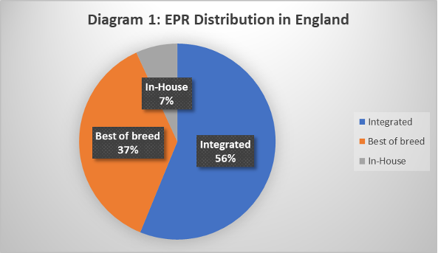

**(David Kwo, 2020)**

The diagram below shows the trend in best-of-breed and integrated EPR types (excluding in-house) in hospitals in England from 2000 to 2020 (the uptick in 2003 is due to the National Programme in IT).

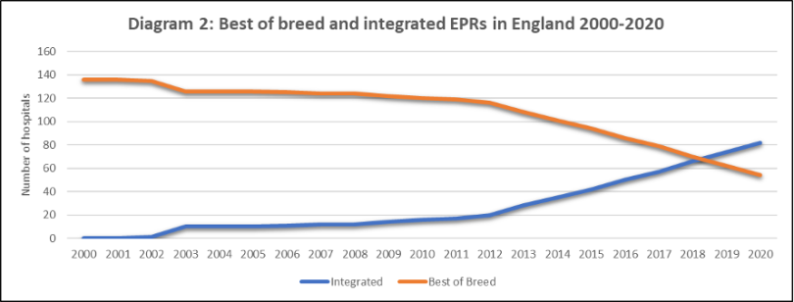

**(David Kwo, 2020)**

The Electronic Patient Records (EPR) suppliers in the UK as of July 2020 and the number of contracts signed in the UK (as reported in the health IT media). This is shown in the diagram below –

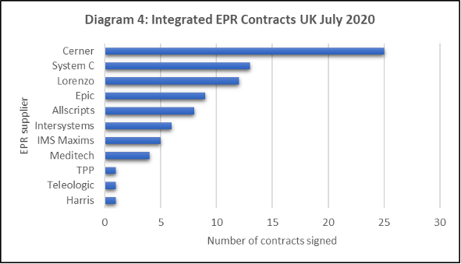

**(David Kwo, 2020)**

In the table below I have listed the hospitals in the UK that use or plan to use a single integrated electronic Patient Record (EPR) system across multiple hospitals and care settings: -

|  |  |
| --- | --- |
| **WHO SHARE A SINGLE INTEGRATED EPR ACROSS HOSPITALS?** | **WHO SHARE A SINGLE INTEGRATED EPR ACROSS CARE SETTINGS?** |
| * Imperial College Healthcare and Chelsea & Westminster Hospital (Cerner, separate Trust, in live use). | * **Royal Devon and Exeter** (in live use across acute and community care settings). |
| * **University College London Hospital** (covers 8 hospitals) (Epic, same Trust, in use) | * **Guy’s and St Thomas’, Royal Brompton, King’s College Hospital** (planned use across acute and community care settings). |
| * **Bradford Teaching Hospitals and Calderdale and Huddersfield**(Cerner, different Trusts, in live use) | * **Northern Ireland** (planned use across all 5 acute hospitals, community and social care). |
| * **Manchester Foundation Trust** (covers 9 hospitals) (Epic, same Trust, planned). | * **Devon STP** (there is a plan to use a single integrated EPR system across acute, community and social care organisations, subject to approval and funding). |
| * **Royal Devon and Exeter and North Devon Healthcare**(Epic, different Trusts, pending approval). |  |
| * **Guy’s and St Thomas’, Royal Brompton and Harefield and King’s College Hospital** (Epic, different Trusts, |  |
| * **Northern Ireland** (Epic, 5 separate acute hospitals, planned |  |

**(David Kwo, 2020)**

This trend suggests that UK hospitals believe that a strategy for sharing a single integrated Electronic Patient Records (EPRs) can reduce cost and reduce unwarranted variation and ultimately improve the quality and safety of care for patients.

## THE PRINCIPLES/ DIFFERENCES OF WATERFALL AND AGILE METHODOLOGY

Traditionally waterfall approaches tend to treat scope as a driver and calculate the consequential time and cost; whereas agile commits to set resources over a limited period to deliver products that are developed over successive cycles.

**Agile** and **waterfall** approaches to project management exist on a continuum of techniques that should be adopted as appropriate to the goals of the project and the organisational culture of the delivery environment.

Overall, agile and waterfall approaches to project management both bring strengths and weaknesses to project delivery, and professionals need to adopt a “golf bag” approach to selecting the right techniques that best suit the project, the project environment and contracting parties with an emphasis on the behaviours, leadership and governance, rather than methods, that create the best opportunities for successful project delivery.

1. DEFINITION OF AGILE**:** Agile development, or agile project management, is an iterative and incremental method of managing the design and build activities for engineering, information technology, and new products or services development projects, for example, agile software development. It requires capable individuals from the relevant business, with supplier and customer input to work in a highly collaborative manner, in small stages, to complete small portions of the deliverables in each delivery cycle(iteration), and where possible deploying deliverables to live(increment) to achieve value and real feedback, whilst iterative methods evolve the entire set of deliverables over time, completing them near the end of the project.

The result is a product that best meets current customer needs and is delivered with minimal cost, waste, and time, as the iterations encourage feedback and review, achieving benefits earlier than via traditional approaches.

**AGILE SOFTWARE DEVELOPMENT LIFE CYCLE**

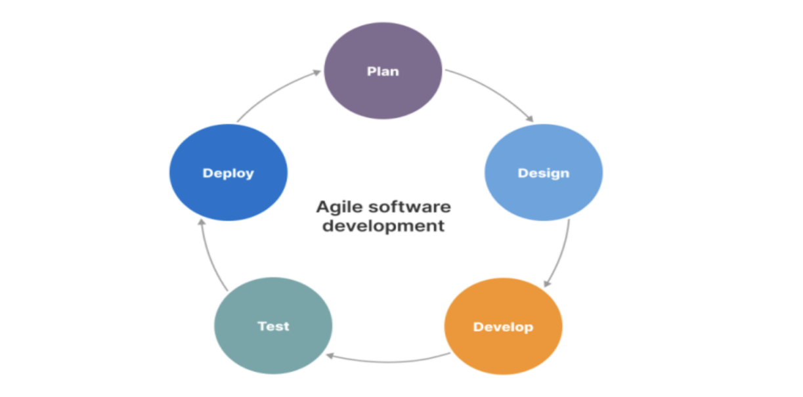

**(Shafiq, 2023)**

PROS AND CONS OF PRACTICAL ADOPTION OF AGILE METHODOLOGIES**:**

|  |  |
| --- | --- |
| **WATERFALL:** | |
| **PROS** | **CONS** |
| * Works best when there are defined requirements. * Best for a stable environment * The team is distributed and hence control can be managed by defined deliverables, milestones, and dependencies. * Best if scarce skills or resources have limited availability. * Plans are repeatable for similar projects. | * Requires investment to define scope and schedule before work begins. * Scope changes can be slow and the adverse impact increases over the life cycle. * Risk of nothing to show for the money until the end. * Change adds effort and risk, so a strict change control process must be in place to avoid ‘scope creep’. |
| **AGILE:** | |
| **PROS** | **CONS** |
| * Works well when the detailed requirements are unknown or subject to change. * Give flexibility to ‘course correct’. * Needs regular stakeholder feedback. * The team is co-located, multi-functional and enables to work collaboratively. * Early return on investment by regular delivery. | * No advantage for projects where the scope and detailed requirements are well understood, and change can be controlled. * Uncertainty around scope and schedules can make stakeholders nervous. * Less effective if the ‘team’ is distributed. * Demands management and prioritisation of the backlog. |

**(Association for Project Management, 2024)**

Agile software development is a project management approach that values flexibility, collaboration, and constant adaptation to change. The Agile methodology was first introduced in 2001 with the publication of the Agile Manifesto, which outlined the principles of Agile software development.

The key principles of Agile software development include the following:

* Individuals and interactions over processes and tolls.
* Working software over comprehensive documentation.
* Customer collaboration over contract negotiation.
* Responding to change over following a plan.

Agile software development focuses on delivering working software in small, incremental iterations, known as sprints. This allows teams to quickly adapt to changing requirements and feedback from stakeholders, and to deliver high-quality software that meets the needs of the customer and the company.

The Agile methodology also emphasises close collaboration between development teams, stakeholders, and customers, with regular meetings, such as daily stand-ups and sprint retrospectives, to ensure that everyone is aligned and informed.

Agile software development is often used in combination with scrum, and agile framework that provides a set of best practices for managing software development projects.

DEFINITION OF WATERFALL**:** The waterfall methodology involves breaking down each part of a project into clearly defined sequential phases. The word “waterfall” illustrates the way the water flows in one direction down a waterfall, as you can only complete each project stage in order - backtracking is allowed.

Imagine a series of pools separated by waterfalls. These pools represent each stage in the project management timeline, from planning to development to release. The water cannot reach the next pool until it is full and overflows into the next. Likewise, using the waterfall method, you only move on to the next stage when the current stage is 100% complete.

**WATERFALLS METHODOLOGY**

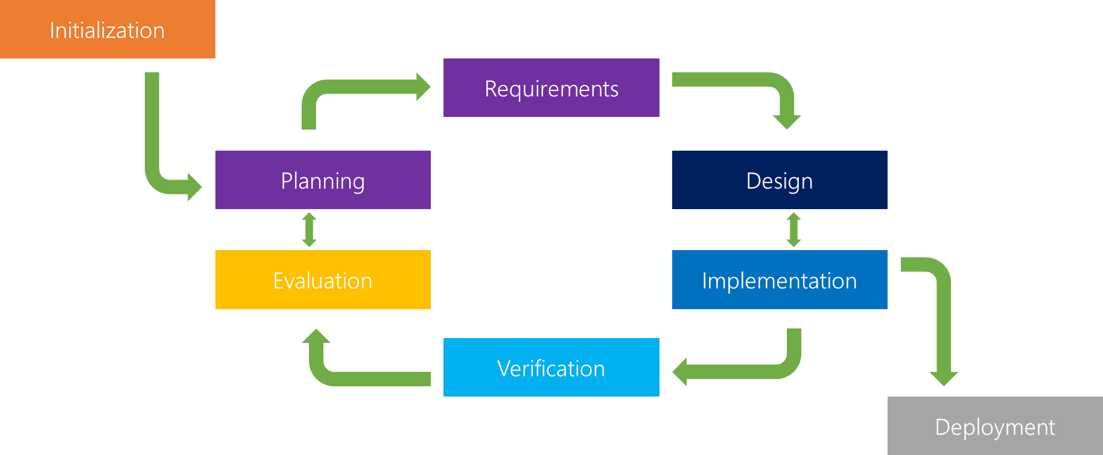

**(THINKTHYME, 2024)**

The waterfall methodology consists of six (6) phases which are detailed below:

* Requirement Gathering and documentation**:** This is the most crucial phase of the project and is likely to be where success and failure are set in stone. This is mostly research and the building of a clear business case. It is also about project design, making sure all people involved in the project know their roles. A good strategy is to create what is sometimes referred to as swimming lanes.

This is a flow diagram of tasks and outcomes divided amongst team members and laid out along a timeline. It is also something that can be devised on a chart, with dependencies set. This way individuals viewing this overview of the work to be done can see how they fit in with the work of others and how any slipping of time can adversely impact the flow of work.

* System Design**:** As with most project management strategies, the waterfall has firm roots in software production. It is where no coding takes place but instead, specs are established for how the work should be completed. It is easy to see how this extrapolates out to other sectors.

In construction, for instance, this would be the part of the process where the architect draws out the plans, the electrician might design the lighting model, the plumber the water model and the builder a design the work cards for different crews.

* Implementation**:** This is where the product gets produced. Waterfall project management tends to work best where there is a concrete outcome that must be created over a set period. Everything in this phase should already be designed, planned, and thoroughly documented in Phase 2. (System Design).

There should be no need to stop to reflect because everything is set in stone in the system design. Individual workflows will be reliant on the whole team doing what is specified.

* Testing**:** If there are failures at this point, then there is no other choice than to go back to phase 1(requirement gathering and documentation) and redesign the whole project. This is the biggest failure of this methodology and why subsequent project management methodologies tend to emphasise iterative processes, which reflect and adapt the work based on a short burst of work followed by testing.

This way the project stays on track and potential failures are spotted before a point, such as this, where a failure means starting all over again. However, what you are guaranteed with the waterfall methodology is that there will be no drift from the initial brief and requirements. It is a simple matter of saying we want Z and we are going through steps A-Y to achieve it.

* Delivery**:** Here the work is complete and submitted to the clients, deployed, or released to the customer.
* Maintenance**:** In software terms, this phase is all about creating the patches and updates that overcome any problems in the coding. In the construction industry, it would be remedying the snag list created by the customer. If there is a significant issue at this stage, it is possible for the project to revert to stage 1 again and the whole thing starts over.

There are three (3) basic principles of the waterfall methodology:

* Strict, one-way structure**:** When using the waterfall method, you split your project into discrete stages that allow you to complete each stage in order. There is no going back or changing course if something unexpected happens. Instead, if something goes wrong, you must start at stage one again.
* Little to no stakeholder involvement after the first stage**:** Due to the structure of the waterfall methodology, you must document all stakeholder interactions in the first stage. After this, due to the strict structure of the waterfall model, there is no way to implement changes and stakeholder communication ceases.
* In-depth upfront documentation of the entire process**:** To solve some of the limitations of the waterfall method, documenting each stage in detail upfront is critical. As you won't be able to receive feedback from clients throughout the process, you need to make sure to document all essential requirements before starting the project.

The waterfall approach has been popular in the construction industry where there needs to be strict order to activities. In construction, once a stage has been completed, it is often irreversible. For example, there is no way to “unpour” concrete. Similarly, you cannot begin laying bricks until the concrete foundation is down.

However, it has since been adapted more generally to project management. It’s especially well-known for its use in software development to create products such as customer relationship managers (CRM) and similar project management tools.

HOW DOES THIS RELATE TO THE EPR PROJECT IN MY NHS TRUST**:**

Electronic Patient Records (EPR) have become a major part of healthcare IT today. The approach to EPRs is likely the biggest technology decision my trust (University Hospitals Plymouth NHS Trust) has taken, and it has been in the planning stages for the past 6 years. It’s a huge investment that comes with consequences that will last for decades and going live is just a start. Some of the aims of electronic Patient Records (EPR) within my NHS Trust would include the following:

## AIMS AND OBJECTIVES OF EPR INTRODUCTION TO MY NHS TRUST

* The reduction in the number of times you need to log into different IT systems.
* Provide safer care and treatments for patients because patient notes will always be available to clinicians, consultants, nurses, and other healthcare professionals electronically.
* This will reduce the reliance on paper processes and the risk of lost or misplaced patient notes, and documents.
* Support for more collaborative and flexible ways of working.
* Make information available for clinical decision decision-making, quality improvement and research purposes.
* Improve operational performance and put our patients and service users at the centre of our care.

University Hospitals Plymouth NHS Trust have over one hundred (100) clinical IT systems which consist of 30 core clinical systems and a further 70 other bespoke systems and they don’t integrate well with each other or with our regional and local partners which makes us heavily reliant on paper notes. It is very difficult to share information, deliver integrated care, or transform care. Our IT infrastructure is ageing and needs constant investment and improvement to help maintain it. The digital knowledge of our clinical and operational staff is evolving and increasing, and we need to match this with the systems that we use as a Trust to enable the very best ways of working and better decision-making. The EPR IT system is co-designed by clinical staff which includes Doctors, Nurses, Midwives, Pharmacists, and allied health professionals to make sure it meets the needs of those who will use it. And bring real benefits to their patients in preparation for the new Electronic Patient Record (EPR) I was designated to design a business process model that captures patients' entire journey from point of admission to discharge in preparation for when the procurement team would be going out in search of the right product. I will be presenting my design to various stakeholders on the 29th of January 2024, and this will be for them to make any vital observations and amendments if any before I hand it over to the procurement team.

**ELECTRONICS PATIENT RECORDS(EPR) FRAMEWORK**

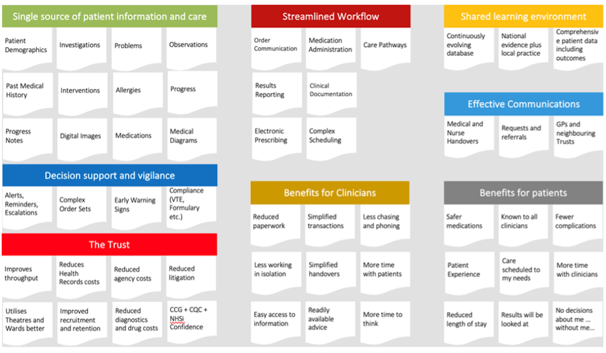

**(Best Practice Group PLC, 2021)**

KEY FINDINGS AND RECOMMENDATIONS**:**

We are recommending Electronic Patient Records (EPR) to help manage patient information and care, streamline workflow, decision support and vigilance. The likelihood is following the pathways that the healthcare industry is going and the other Trusts across the country, that we are recommending a similar system to be put in place like Electronic Patient Records (EPR).

I will discuss the introduction **of Electronic Patient Records (EPR)** which would be rolled out within my NHS trust and how this would help improve service delivery within the Trust.

WHAT IS EPR**?**

This is an **Electronic Patient Record (EPR)** which is a digitised version of an individual’s paper medical record, alongside a whole host of other information about the patient (immunisation status, lab test results, personal statistics, billing information (which in this is used for international patients that are not residence in UK to be qualified for free healthcare), allergies and suchlike. The benefit to the patient means they can attend any hospital as their full health record will be available for doctors to access, including medication, consultation history, scan images, etc.  Having a full record for healthcare professionals minimises the risk of something important being overlooked and compromising the care provided.

This information, which is collected for all patients, can be used to provide better and more targeted healthcare for the individual, and collectively to provide the data needed to deliver care more efficiently and effectively to the population and to assist in the creation of new treatments and techniques.

The collective digitised health records are securely stored in an **Electronic Patient Record (EPR)** system allowing for improved workflow efficiency, safety checks, prompts and so forth. The EPR system can also be linked to other NHS systems (e.g., Drug prescribing system, GP systems in the community (GP Connect), community health systems) and hospitals.

BENEFITS OF SHARED SYSTEM ACROSS THE TRUST AND THE COMMUNITY AND POTENTIAL SERVICE IMPROVEMENTS**:**

* The benefit of the **Electronics Patient Record (EPR)** will help University Hospitals Plymouth NHS Trust to cover a lot of miles across Devon and Cornwall and Patients would be able to visit more hospitals with ease this would include community hospitals or community specialist care centres. The EPR will also minimise data repetition by staff members across hospitals in the region.
* **The Electronic Patient Record (EPR)** will help mitigate the rurality of the local area through enhanced clinical sharing and virtual clinical input i.e., shared patient records mean that somebody who lives in a rural area and doesn’t have the means to attend appointments in the hospital can have a medical/medication review with a consultant remotely, saving them the time to make long journeys. This can also improve patient experience with our services.
* This will also give the trust the ability to manage patient information across all platforms and make sure up-to-date patient information is available on all devices across several locations in the Devon and Cornwall area.
* The benefit to patient safety and faster treatment outcomes with the sharing of knowledge and insights across all sites and the opportunities to share IT services which minimises the purchase of more EPRs by other NHS Trusts across the region.
* This will enhance individual experiences for patients by removing the need to always provide personal information to healthcare professionals each time they have appointments and this
* also poses the risk of patients or staff members forgetting vital information each time the patient attends appointments.
* **The Electronic patient record (EPR)** will increase productivity and eliminate the need for unnecessary repetitive tests while enhancing the safety of patients by making comprehensive and trustworthy allergies, medications, diagnostic and social context information available in all healthcare settings, i.e., Accident and emergency (A&E) and when an ambulance is summoned or called.
* This will provide individual access to shared healthcare records and promote citizens' engagement in their own treatment and adherence to medication and care plans.
* Help enhance healthcare professionals’ comprehension of a patient's condition and allow clinicians to create a tailored treatment plan if necessary.
* These will help reduce unnecessary hospital admissions and encourage more appropriate hospital admissions by providing healthcare workers with more information about the patient when making clinical decisions. And eliminate manual information requests.

## HOW I COMMUNICATED THIS TO VARIOUS STAKEHOLDERS:

I communicated this to various stakeholders by meeting with each stakeholder to discuss their expectations from the new EPR and make sure they were carried along throughout the process of business process modelling which I designed using Microsoft Viso and after the design phase went back and forth to make sure that the stakeholders were happy and satisfied with the progress I made throughout the design. I was meant to present the final project design to the various stakeholders on the 22nd of December 2023, but this was moved to the 29th of January 2024. I know that I can never get it 100% correct in terms of the design, which is expected. And outlining the various benefits of Electronic Patient Records (EPR) to the Trust and how this will help them deliver good patient care to their patients across the Trust and its regional partners.

I sent the business process model to the procurement and project implementation teams ahead of the meeting for them to look at the design and come up with any changes and for them to include anything I have missed in the design process. We had a meeting over Microsoft Teams on the 19th of January 2024 at 2:30 pm to try and see what needed to be added before the presentation to the stakeholders on the 29th of January 2024. Below is the screenshot from the meeting.

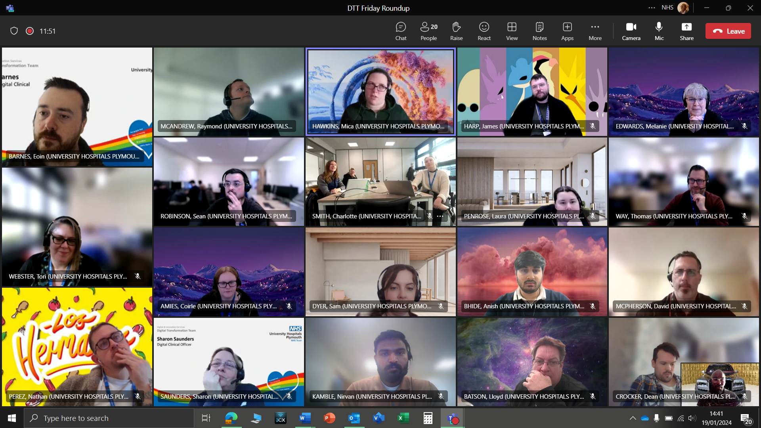

**Electronic Patients Record (EPR) Project Implementation Meeting 19th January 2024**

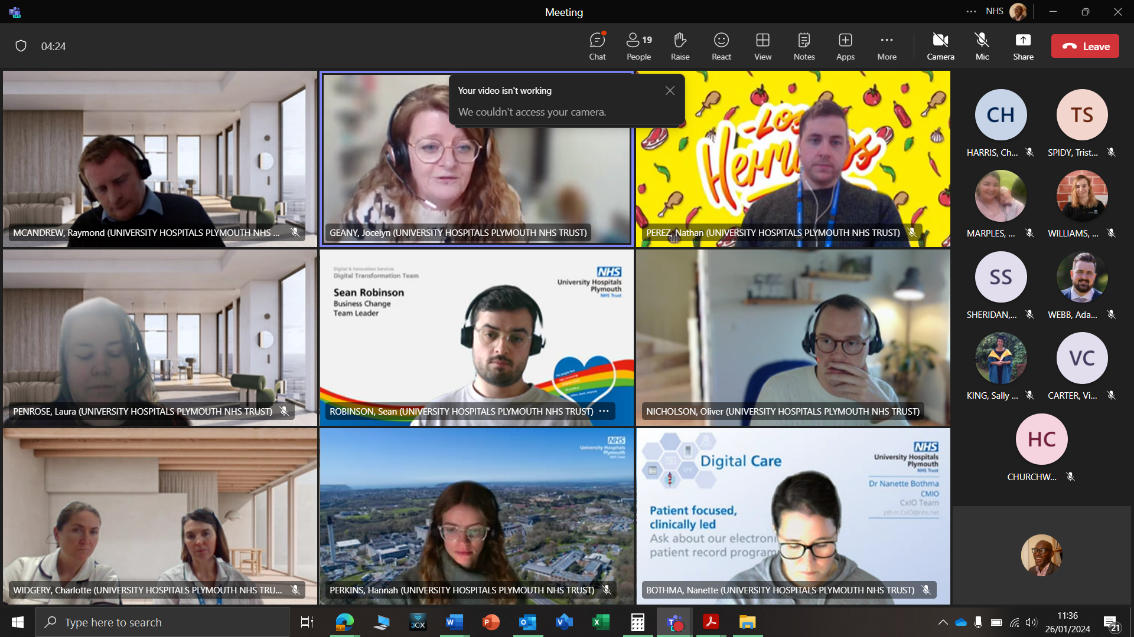

**Electronic Patients Record (EPR) Stakeholders Engagement Meeting 26th January 2024**

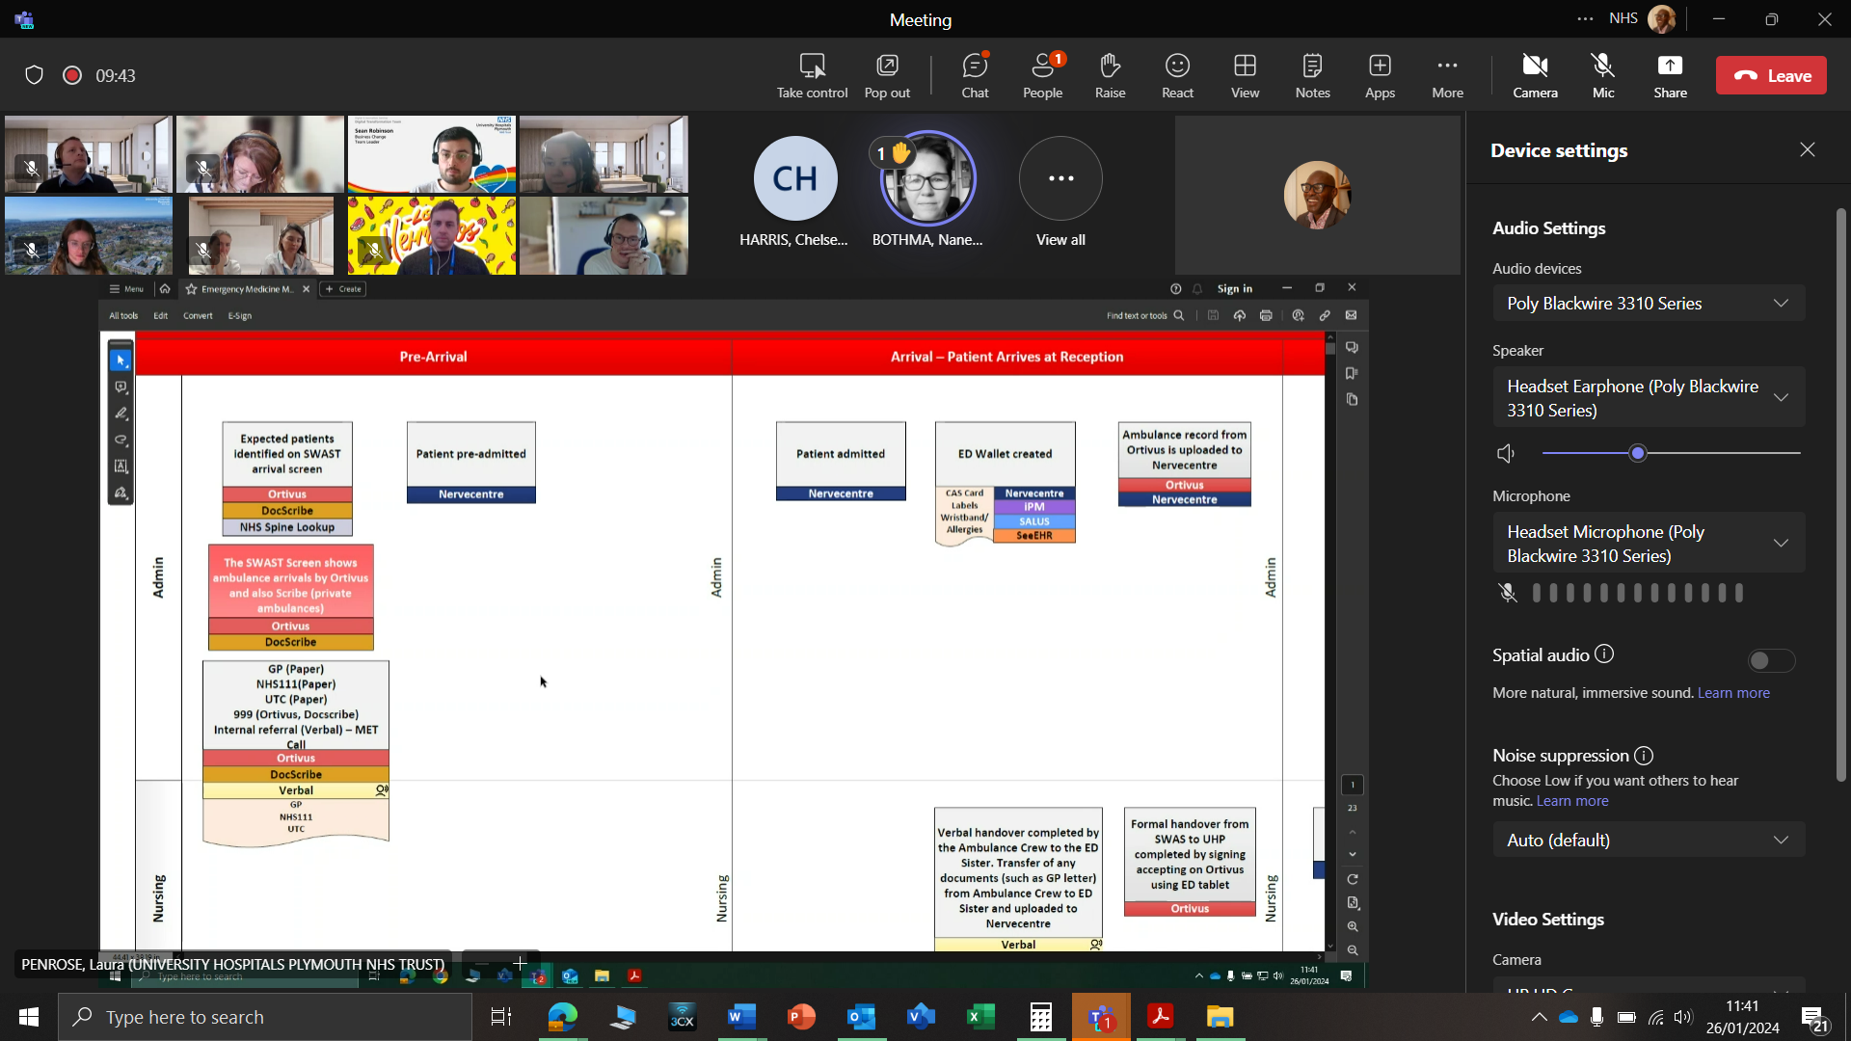

**Electronic Patients Record (EPR) Baseline Mapping Stakeholders Engagement Meeting 26th January 2024**

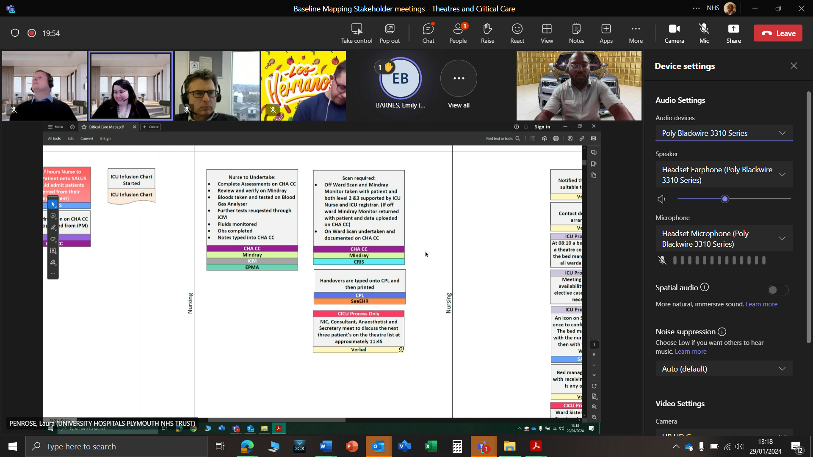

**Electronic Patients Record (EPR) Theatre Baseline Mapping Stakeholders Engagement Meeting 29th January 2024**

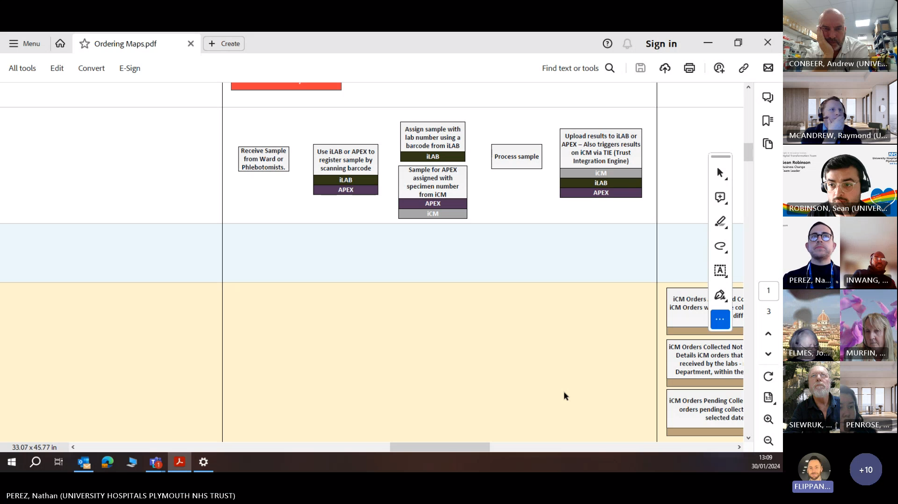

**Electronic Patients Record (EPR) Theatre Baseline Mapping Stakeholders Engagement Meeting 30th January 2024**

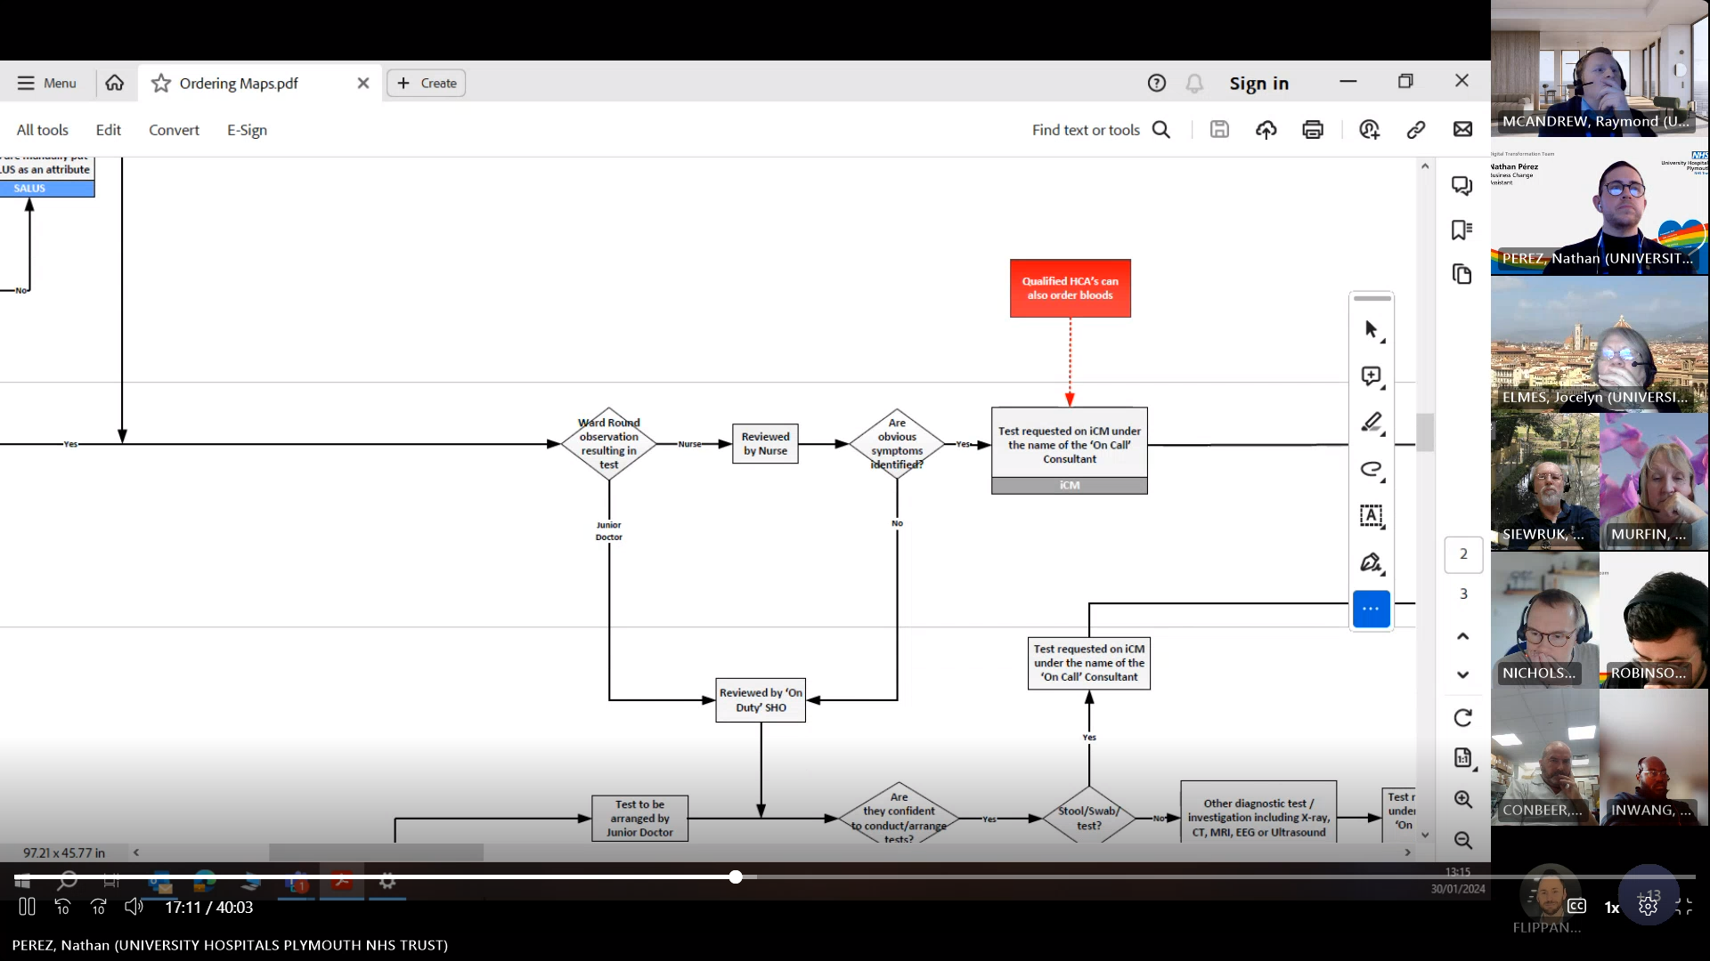

**Electronic Patients Record (EPR) Theatre Baseline Mapping Stakeholders Engagement Meeting 30th January 2024**

ELECTRONIC PATIENT RECORDS (EPR) BASELINE MAPPING STAKEHOLDERS’ ENGAGEMENT**:**

The stakeholder engagement baseline map presentation was a great opportunity for the stakeholders to review and understand the process modelling that captured all the Theatre processes of a patient's journey from the point of admission, treatment, and to the point of discharge. As my screenshots explain in the pages above. The stakeholders were engaging with their questions about the process modelling and also filled the gaps that I missed while designing the process. I know getting it right the first time was never going to be easy, and the stakeholders confirmed that in their viewpoint.

The stakeholder’s engagement regarding the pharmacy medication prescribing process was well received by the stakeholders and they contributed to some minor changes that were not picked up at the time the process modelling was put together by the Business Change Team (BCT). The stakeholders offered to meet with me on an individual basis to go through the process maps so that corrections can be made in the areas that we have not addressed properly during the time of design.

## EPR -BENEFITS TO MY NHS TRUST

|  |  |
| --- | --- |
| **Clinicians**  Clinicians will have more information at their fingertips to make better, more effective decisions. You’ll have automatic access to decision support tools, meaning your decisions will be made based on the best available information. An EPR will:   * make you more efficient. * create a smoother care journey for your patients. * enhance communication across clinicians and teams. * reduce duplication and reduce some of the data collection burdens from people by capturing some things automatically. * enable you to monitor patient outcomes much more effectively and build upon what works for patients. ​​​​​​​ | **Administration Staff**  Requesting paper notes will reduce significantly as the patient record will be accessed digitally so administrators will have immediate access to the record.  It will make several administrative tasks easier to manage as information will flow around the organisation more easily.  The types of administrative tasks that will be different with an EPR are:​​​​​​​   * Patient appointments will be sent digitally, not by letter. * Requesting paper notes will slowly stop as the patient record will be accessed digitally so administrators will have immediate access to the record. * Access to the full patient record can be from anywhere.   Fewer paper-based processes such as paper form filling/processing |
| **Patient Perspective:**  It will improve the patient experience in the Trust. They will only have to tell their story once - rather than being asked for the same information at every point in their care journey. They will be safer - the Electronic Patient Record will flag up things like allergies and past interventions. These changes will also allow patients to engage with their care much better and strengthen the partnership between them and clinical services. | **Collaboration Benefits**  A shared EPR could improve patient care by replacing paper-based notes and records with a new suite of digital tools and technologies. A shared EPR could give us the ability to see a patient's record when they present with a health or care need, including records from other settings in the county/region.  This means that clinicians would be working with a much fuller picture of the patient leading to more informed decisions without having to rely on the patient giving their history repeatedly. It also means that less time would be needed to contact other professionals from another part of our system to 'fill the gaps' because it will all be there in the digital record. |

EPR STRATEGIC BENEFIT OUTCOMES**:**

|  |  |
| --- | --- |
| **Benefits to patients:**   1. Consistently high-quality patient experience, characterised by care delivered with dignity, respect and excellent communication. 2. Health outcomes are as good as the best. 3. No untoward events such as hospital-acquired infections, pressure sores or falls. 4. Services that are easy to access and simple to navigate. 5. Excellent communication from hospital to GP. | **Benefits to staff:**   1. High levels of job satisfaction and clarity about what is expected. 2. Job security with prospects for progression, for those that want it. 3. Opportunities to participate and develop research and innovation in practice. 4. Positive reputation. 5. Financially sound. |
| **Benefits to partner:**   1. Services in the right places, without duplication. 2. Services that represent value for money. 3. Delivery closer to the patient and delivered in partnership with others. 4. Consistent achievement of quality and performance standards. 5. A “low maintenance” provider of services. | **Benefits To Regulator:**   1. Delivery of NICE guidance. 2. Financial health and a positive risk rating. 3. Reputationally sound. |

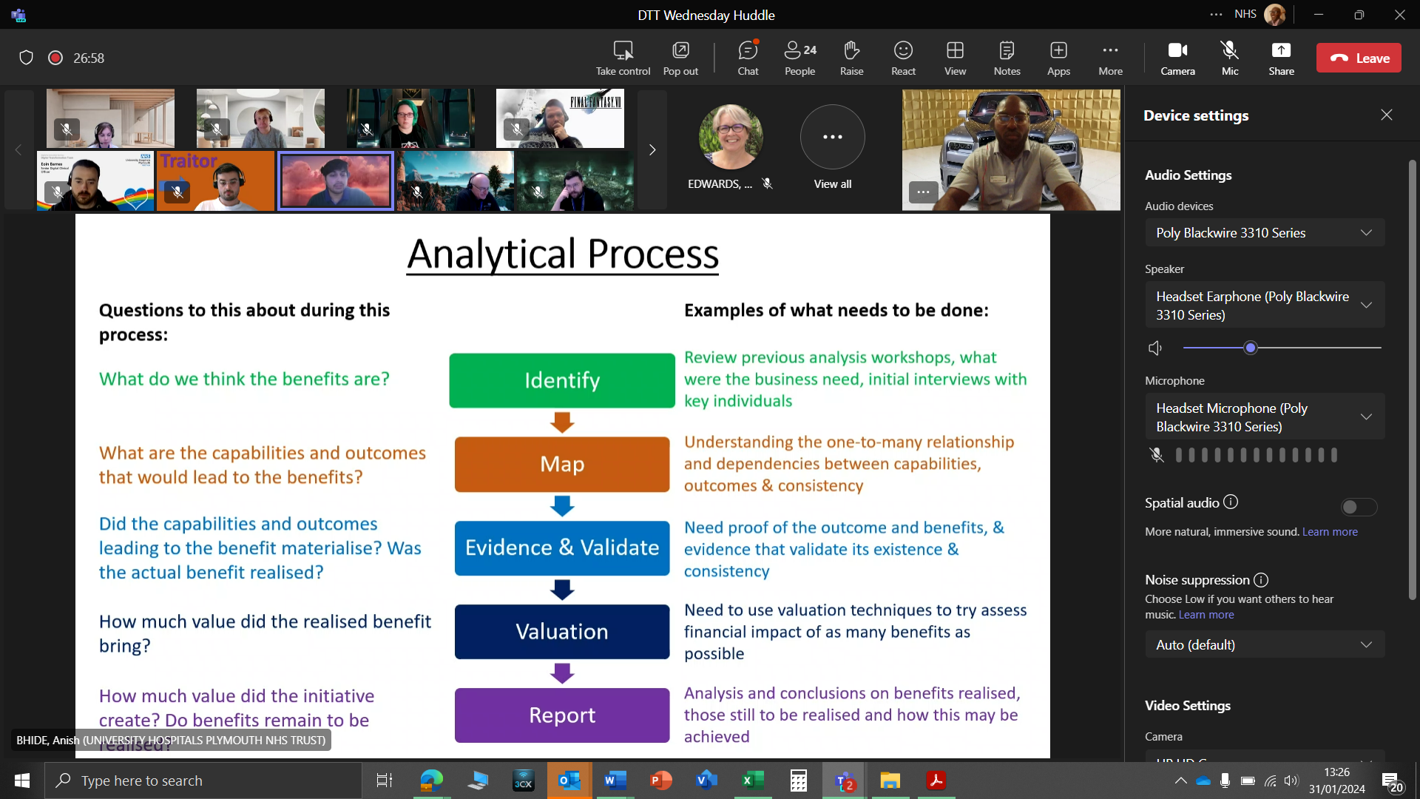

**Benefit Realisation Analysis for EPR Meeting 31st of January 202**

## BENEFIT OF OUTBOUND DATA SHARING

* These will benefit the data stored in the NHS spine, such as the demographic database which is the **Patient Demographics Service (PDS)** and the **Summary Care Records (SCR).**
* Data interchange via NHS spine, such as **e-referrals(eRS**) and **electronic prescribing medication and administration (EPMA).**
* The data that flows to the NHS national databases (Clinical research, NHS business services, appointment databases and the Quality Outcome Framework (QOF), to mention a few.
* For patient**:**

1. enhances individuals' experiences by removing the need for them to constantly provide the same information to multiple health and care professionals, with the risks of forgetting anything vital.
2. increases productivity by eliminating the need for unnecessary, repetitive tests.
3. enhances safety and experience by making comprehensive and trustworthy allergy, medication, diagnostic, and social context information available in all health and care settings, such as A&E or when an ambulance is summoned.
4. provides individuals with access to shared healthcare records, which promotes citizens' engagement in their own treatment and adherence to medication and care plans.

* For clinical**:**

1. enhances health and care professionals' comprehension of a patient's condition, allowing clinicians to create a tailored treatment plan if necessary.
2. may reduce unnecessary hospital admissions or encourage more appropriate hospital admissions by providing health and care workers with more information about the individual when making clinical decisions.
3. Save time by eliminating the need to request information manually.

* Service providers and commissioners**:**

1. avoids redundant examinations or assessments, which saves money.
2. improves adult and child safety by exchanging alarms across numerous care settings.

## EPR BENEFITS FROM SHARING THE SAME SYSTEM:

* Overall Benefits**: -**

1. The services will be covering a lot of miles across Devon.
2. Patients can visit more hospitals with ease which includes community hospitals or community or specialist care.
3. This will be no repeat of data to the different staff members.
4. The same system will help us to mitigate the rurality of our local area through enhanced clinical sharing and virtual clinical input for example a shared patient record means that somebody who lives in X area could have a medication review with a consultant in big city remotely saving them a long journey and improving their experience of our services.
5. Up-to-date information on a range of devices.
6. Faster pace to build the EPR system and lower cost.
7. Benefits for patients’ outcomes and safety will be achieved sooner with this sharing of knowledge and insights.
8. Cost saving (reduced payments to EPR supplier partners as well as opportunities for shared IT services.
9. No need to have different EPR knowledge for staff.

* Overall challenges**: -**

1. Effect will be increased when the system is to be shared across two or more organisations. Need to have a proper Executive.
2. Engagement of the organisation - Implementing an EPR system is a significant transformation initiative. Behavioural change is required for clinical transformation. Organisational involvement is required for clinical and operational leaders to take ownership of the change and allow employees to participate in shaping it. When two trusts are involved, everything becomes more complicated.
3. Information governance is putting in place the proper agreements to allow personnel to access and support a system that stores information on patients who have received care from both institutions. Data sharing and data processing agreements may be included. Patients may not expect their data to be shared across two trusts, thus steps must be taken to engage patients and communicate this.

* lesson learned by the organisation**.**

1. Determine additional expenses - there are significant savings, but there are some additional costs. When the new trust joins, the trust that is already on the EPR will have to re-test all its interfaces. Determine the costs and how they will be shared by the two trusts.
2. Manage the change control process - a decision must be made about when the new trust should be included in the process of managing what modifications are made to the EPR. The quickest method for a new trust to get the benefits of full participation may be to first focus on the business of going live and then participate in change control.
3. Begin data migration work with a third-party supplier as soon as possible - transferring patient data into a system that is already in use necessitates extreme caution. Begin as soon as possible. Also, do not do it in-house. Use a third-party source with the necessary tools and knowledge

SWOT ANALYSIS BENEFITS TO ELECTRONICS PATIENT RECORD(EPR**)**

* SWOT Analysis**:**

**Electronic Patient Records (EPR)** would eliminate the long-standing tradition of using paper notes and switch to a new innovative digital system instead. This means the patient journey will be smoother by ensuring we deliver safe, personal and effective care. No matter the hospital the patient is admitted to the hospital would be able to access personal records quickly and securely. This will also eliminate repetition or duplication of information again and again. This will give all Clinicians and consultants access to everything they need, right at their fingertips which is from allergies to prescribing medications, it's all included in the new **Electronic Patient Records (EPR)** system. And the Nurses, Clinicians, consultants can spend more time with patients.

**STRENGTH**

* Real-time, point-of-care data entry.
* Standardised classification of reasons for patient encounter(i.e. ICD-10 or ICPC-2)
* Effortless, remote management of clinical information.
* Improve efficiency(i.e. avoidance of diagnostic test duplication).
* Monitoring of morbidity local traits.

**WEAKNESS**

* Instalment and maintenance cost (Cost savings for large integrated institutions, not small rural practices)
* Reduce productivity during initial implementation phase (exacerbated by limited workforce in rural practice healthcare (PHC) units).
* Conflicting evidence in literature regarding improving quality of rural care.
* Synchronization of records (may be difficult to update records in a coordinated fashion at two locations where care is provided simultaneously.

**OPPORTUNITIES**

* Data banking (Preservation and storage).
* Data synthesis (i.e., creating epidemiologic profiles of catchment area residents)
* Ability to synch up with mobile devices, allowing access to patient records from remote locations.
* Adjustment to regulatory compliance (i.e., NHS or insurance carrier new mandates).
* Networking (i.e., Practice based research network in primary care with access to Electronic Patient Records (EPR) system)

**THREATS**

* Adverse events may occur because of shortcomings of EPR system users, equipment or organisational/system capacity.

1. Human threats (i.e., careless employees or hackers)
2. Natural and environmental threats (i.e., flood, fire)
3. Technology failure (i.e., system crashing).

* Privacy and confidentiality concerns (i.e., unauthorised transmittal of patient record information)
* Health professional liability concerns (i.e., malpractice risk)

CONCLUSION**:**

In conclusion, the introduction of Electronic Patient Records (EPR) across the trust would help the Trust and the regional partners in managing patient records so that patient care can be monitored and make sure that patient records/data can be stored in a more centralised place for easy access and management. This will help the Trust keep track on all the medications, treatments, surgical appointments, and community records in an easily accessible location for University Hospitals Plymouth NHS Trust (UHPTH).

## REFERENCES:

* [Electronic Patient Records – How to procure an EPR software system (bestpracticegroup.com)](https://www.bestpracticegroup.com/electronic-patient-records-how-to-procure-an-epr-software-system/)
* [Electronic Patient Records - Where are we now? (elht.nhs.uk)](https://elht.nhs.uk/patients/EPR)
* [HTN Trends Series: EPR Trends in the UK - htn](https://htn.co.uk/2020/11/13/htn-trends-series-epr-trends-in-the-uk/#:~:text=There%20are%20two%20types%20of,schema%20and%20software%20development%20team.)
* [(2) The Benefits of Conducting a SWOT Analysis for Your Business | LinkedIn](https://www.linkedin.com/pulse/benefits-conducting-swot-analysis-your-business-gavin-bottrell/)
* [Advantages of SWOT Analysis (6 Benefits and 4 Limitations) (status.net)](https://status.net/articles/swot-analysis-process-benefits-limitations/)
* [5 Surprising Disadvantages of SWOT Analysis (pestleanalysis.com)](https://pestleanalysis.com/5-surprising-disadvantages-of-swot-analysis/)
* [SWOT analysis pros and cons: definition, use and tips | Indeed.com UK](https://uk.indeed.com/career-advice/career-development/swot-analysis-pros-and-cons)
* [What is PESTLE Analysis? An Important Business Analysis Tool](https://pestleanalysis.com/what-is-pestle-analysis/)
* [VMOST Analysis (Sondhi) explained - Toolshero](https://www.toolshero.com/strategy/vmost-analysis/)
* [MOST Analysis - What It Is And How To Use It | BusinessAnalystMentor.com](https://businessanalystmentor.com/most-analysis/)
* [Norfolk and Norwich University Hospitals NHS Foundation Trust » Electronic Patient Record (nuh.nhs.UK)](https://www.nnuh.nhs.uk/about-us/joint-working-across-norfolk-and-waveneys-acute-hospitals/electronic-patient-record/#:~:text=Some%20of%20the%20aims%20of,of%20lost%20or%20misplaced%20documents)
* [EPR - Benefits (sharepoint.com)](https://nhs.sharepoint.com/sites/RK9_UHPNTDigitalCareHub/SitePages/What-does-and-EPR-mean-to-me-.aspx)
* [Agile Software Development (learncybers.com)](https://learncybers.com/agile-software-development/)
* [Waterfall Methodology | What is Waterfall Methodology | Pipedrive](https://www.pipedrive.com/en/blog/waterfall-methodology)
* [Waterfall Project Management Methodology Explained - ThinkThyme](https://thinkthyme.com/project-management/waterfall-project-management-methodology#:~:text=The%20Basic%20Principles&text=The%20fundamental%20principle%20of%20waterfall,is%20reliant%20on%20the%20next.)

# **Chapter 4 - Requirements Engineering and Management**

**APPRENTICESHIP COURSE WORK**

**Requirements Engineering and Management**

# INTRODUCTION

Project Background**: -**The ongoing project within University Hospital Plymouth NHS Trust is the preparation for the introduction of Electronic Patient Records (EPRs) that would aim to replace a significant number of current systems in the Hospital that are outdated, and inefficient. Patients are getting delayed and stay longer in the hospital than they may need to. Clinicians are getting increasingly frustrated with a huge number of systems and streamlining patient pathways. The old system is cluttered, and the response time is not fast enough. This includes the efficient sharing of patient details such as previous/ current treatments, and medications with other hospitals So, we need a new system replacement preferably electronic.

The new system will also allow the hospital to maximise a ‘virtual ward’ project to help safely facilitate discharges, reducing additional hospital visits by complex patients. This project is a result of legislation that was passed by the government in 2014 by the then Health Secretary Jeremy Hunt who asked NHS England to transition to a more digitalised patient management system that would be accessible to clinicians all over the Country whenever a patient is undergoing treatment, no matter the location.

In England, there is no known legislation governing Electronic Health Records (EHRs) or Electronic Patient Records (EPRs) specifically. There are legislations and regulations about health and medical practice that make references to medical records (both paper and computerised/electronic forms). There are however a few legislative provisions that apply specifically to electronic medium that dictates the type of IT systems that General Practice (GPs) can use in their practice or legislation about ePrescribing. GP and hospital records contain all relevant information relating to the patient's treatment and journey through the acute care pathway. Also, the National Health Service (NHS) introduced Summary Care Records (SCR) nationally in 2008 and it is used to store read-only PDF files on a central NHS computer called the NHS spine and is accessed nationally based on strict access control measures by authorised healthcare staff.

The government launched the development of the National Programme for Information Technology (NPfIT) NHS Care Records Service in 2002, which was intended to deliver an electronic health records system to help manage patient records from across the UK. There were problems with poor user requirement analysis, the failure to address patient confidentiality, overambitious timescales, and enormous cost overruns. A total of 189 NHS Trusts have now introduced new Electronic Patient Records(EPR), the government gave the deadline of December 2023 in the [Plan for Digital Health and Social Care](https://www.gov.uk/government/publications/a-plan-for-digital-health-and-social-care/a-plan-for-digital-health-and-social-care) which was published on the **29th of June 2022**.

NHS England is investing £ 1.9 billion to support hospital trusts to either adopt a new or improve their existing systems to ensure every hospital in England can benefit from digital transformation. Last year NHS England spent over £400 million to support 150 NHS trusts, and a further £500 million will reach trusts this year and University Hospitals Plymouth NHS trust will be one of them.

90% of NHS trusts were expected to have implemented Electronic Patient Records (EPR) by December 2023 and 100% by March 2025. Also, 80% of the Care Quality Commission (CQC) registered adult care providers with digital care records by March 2024 and ensure all health and social care settings have the right infrastructure and connectivity to work digitally. Increased cyber security capabilities, resilience, clinical safety, and accessibility.

The Government introduced The Health and Care Act which introduced significant reforms to the organisation and delivery of health and care services in England and received royal Assent in April 2022. The main purpose of the Health Care Act is to establish a legislative framework that supports collaborations and partnerships working to integrate services for patients. Among a wide range of measures, the Act also includes targeted changes to public health, and social care and the oversight of quality and safety. At the heart of the changes brought about by introducing the new Act is the formalisation of Integrated Care Systems (ICSs).

ICSs are partnerships that bring providers and commissioners of various NHS services across a geographical area together with local authorities and other local partners to collectively plan health and care services to meet the needs of the local population and that includes the creation of Integrated Care Board (ICB) and Integrated Care Partnership (ICP). After a rigorous process The University Hospitals Plymouth NHS Trust is teaming up with Torbay NHS Trust and Royal Devon & Exeter Hospitals NHS Trust to secure the Electronic Patient Records (EPR) called “**EPIC**” because most of our patients and service users are from the catchment areas of Devon, and Cornwall. But Cornwall is procuring a different Electronic Patient Record (EPR) which is called “**CERNER**” and we are in talks with our preferred provider “**EPIC**” to see if the systems will be able to talk to each other to avoid or limit the involvement of paperwork or printing of patient confidential documentation and it being misplaced while in transit. The system will be fully integrated with all the various dashboards that make work life easier for all the staff and stakeholders.

The entire Trust would have to undergo a lot of changes, including cultural (ways of working) and enhancements in preparation for the new system that would be coming in the next couple of years (2026). The preparation kicked off with the upgrade and design of the brand-new process models using process mapping to capture current states (As is) so that the procurement team and the business case team can have something to show when showing the providers to go with. In our case, there were over a dozen providers who were coming to pitch to our Trust what their service would look like what they could do and how the new system would integrate our existing systems into the new preferred system.

The change would also include the overhaul of the entire Trust computer systems, hardware capable of dealing with the software efficiently, and digitalised printers that match the new process. These changes will not only be carried out at our main site, but they will also be extended to our community levels which in this case are (**Tavistock Community Hospital, South Hams Community Hospital, and Mount Gould Hospital**) which are all under our management and umbrella.

Business Goals/ Objectives**: -** The benefit of the new system is that it would bring more visibility to the various stakeholders (Patients, Consultants, Nurses, Junior Doctors, and clinicians) by making work easy and more streamlined patient information down to the most required and making it much more efficient to manage and help the staff to handle workloads and patient appointments/pathways more effectively. This information, collected for all patients, can be used to provide better and more targeted healthcare for the individual, and collectively to provide the data needed to deliver care more efficiently and effectively to the population and to assist in creating new treatments and techniques. This includes the patient being able to have more information at their fingertips to manage their care proactively. The new system will help the various stakeholders (consultants, Junior Doctors, Nurses, Matrons, Clinicians, and various clinical staff) to manage patient prescriptions, X-rays, Scans, and blood/urine test requests all in one system.

Benefits/ Rationale**: -** Electronic Patient Records (EPR) have become a major part of healthcare IT today. The approach to EPRs is likely the biggest technology decision my trust (University Hospitals Plymouth NHS Trust) has taken, and it has been in the planning stages for the past 6 years. It’s a huge investment that comes with consequences that will last for decades and going live is just a start. Some of the aims of electronic Patient Records (EPR) within my NHS Trust would include the following.

This new system will also our staff to manage patient pathways/treatments and visits more effectively to the site or virtually that need to be scheduled as well as surgeries. This will streamline the processes for patients, but also for the clinicians, Consultants and Nursing team.

I wanted to just briefly talk about how this will springboard our administrative pathway waiting list and referral functionality which runs in the background and tracks the patients against their target due dates. This makes it very convenient and easy to make sure that we're not missing those patients and that we're getting them scheduled in a timely fashion, as well as meeting government targets.

Electronic patient records (EPRs) will give clinicians and various medical staff access to vital patient information when and where they need it, alerting them to immediate risks and giving them more time to care for their patients promptly. This will help our trust to change the way we operate and allow for the use of more advanced technology systems for patient care while enhancing productivity and experience for staff members, as well as improving the flow of information between services, which in turn makes it easier to provide care.

**COVID-19** has shown that having digital and data tools at the NHS's disposal can be as important as having the right medicines. Whether through underpinning the initial operational planning, clinical research into treatments, and then the rapid, highly targeted NHS **COVID-19** vaccine rollout, data and digital technology have played a central, but largely hidden role in how the NHS has responded to the biggest public health threats.

Supporting Independent Healthy Lives: **-** Enhanced national digital channels will give patients and people more control over their lives. They will be able to interact easily with different health and social care providers, and access more resources for meeting their health and care needs when and where they choose. The digital transformation that focuses on building trust with people and their families will enhance but not entirely replace the health and social care systems. For those who cannot access digital services, the traditional paperwork service will still be available to them.

#### For patient:

* enhances individuals' experiences by removing the need for them to constantly provide the same information to multiple health and care professionals, with the risk of forgetting anything vital.
* increases productivity by eliminating the need for unnecessary, repetitive tests.
* enhances safety and experience by making comprehensive and trustworthy allergy, medication, diagnostic, and social context information available in all health and care settings, such as A&E or when an ambulance is summoned.
* provides individuals with access to shared healthcare records, which promotes citizens' engagement and being proactive in their treatment and adherence to medication and care plans.
* Putting NHS services in people’s pockets through digital channels by increasing the functionality of the NHS App and website to offer features that help patients stay well, get well, and manage their health.
* Scaling digital health self-help, diagnostics, and therapies.

#### For clinical**:**

* enhances health and care professionals' comprehension of a patient's condition, allowing clinicians to create a tailored treatment plan if necessary.
* may reduce unnecessary hospital admissions or encourage more appropriate hospital admissions by providing health and care workers with more information about the individual when making clinical decisions.
* Save time by eliminating the need to request information manually.
* Service providers and commissioners**:**
* Avoid redundant examinations or assessments, which saves money.
* improves adult and child safety by exchanging alarms across numerous care settings.
* Overall Benefits**: -**
* The services will be covering a lot of miles across Devon.
* Patients can visit more hospitals with ease which includes community hospitals or community or specialist care.
* This will be no repeat of data to the different staff members.
* The same system will help us to mitigate the rurality of our local area through enhanced clinical sharing and virtual clinical input for example a shared patient record means that somebody who lives in X area could have a medication review with a consultant in big city remotely saving them a long journey and improving their experience of our services.
* Up-to-date information on a range of devices.
* Faster pace to build the EPR system and lower cost.
* Benefits for patients’ outcomes and safety will be achieved sooner with this sharing of knowledge and insights.
* Cost saving (reduced payments due to the reduction of multiple systems with the introduction of one system) as well as opportunities for shared IT services.
* No need to have different EPR knowledge for staff – consistent ways of working.
* Exploring oversight options with NHS England and the Care Quality Commission (CQC) which will aim to signal to the health and social care sector that digitalisation is a priority.
* Identify the essential, non-negotiable standards of digital capability and explain how we will monitor and support compliance where appropriate.
* Overall challenges**: -**
* The effect will be increased when the system is to be shared across two or more organisations. We need to have a proper Executive and project co-ordination/sign-off.
* Engagement of the organisation - Implementing an EPR system is a significant transformation initiative. Behavioural change is required for clinical transformation. Organisational involvement is required for clinical and operational leaders to take ownership of the change and allow employees to participate in shaping it. When two or more Trusts are involved, everything becomes more complicated.
* Information governance is putting in place the proper agreements to allow personnel to access and support a system that stores information on patients who have received care from both institutions. Data sharing and data processing agreements may be included. Patients may not expect their data to be shared across two trusts, thus steps must be taken to engage patients and communicate this. GDPR (General Data Protection Regulation) needs to be considered.

### Lessons learned by the organisation.

* Determine additional expenses - there are significant savings, but there are some additional costs. When the new trust joins, the trust that is already on the EPR will have to re-test all its interfaces. Determine the costs and how the two trusts will share them.
* Manage the change control process - a decision must be made about when the new trust should be included in the process of managing what modifications are made to the EPR and the impact on this. Can it be configured locally, or will there be a knock effect if it is a national change? The quickest method for a new trust to get the benefits is understanding the business and the gap of moving from ‘As Is’ to ‘To be’. Other factors will be discussed with the supplier and national changes can be made on the supplier’s roadmap.
* Begin data migration work with a third-party supplier as soon as possible - transferring patient data into a system that is already in use necessitates extreme caution. Begin as soon as possible. Also, it could not be done in-house Use a third-party source with the necessary tools and knowledge.
* Testing the system before go live.
* Baselining – how the business works, but against each of the benefits expected from the project e.g. patient length of stay being reduced due to better visibility of patient information.
* Benefits/ Rationale to Maternity Pathway**: -** The new electronic Patient Records (EPR) For the care of patients, we can also monitor and track the on-time targets or the potential or the potential for breaches. This will give Clinicians and the nursing team quick access to the PTL report where I can track and manage all the active pathways. So reporting is key and being able to track and monitor can save our staff time because they do not have to re-enter this information in a separate PAS (Patient Administration System). Work cues are the basis for a lot of the follow-up care that needs to happen, whether that's a referral to a new speciality or a waiting list that needs to be booked.

The hope is we may be able to allow the patient to do some of their scheduling, especially in those cases where there might be additional things the patient needs to answer. So, we could group this by location and if we are collecting geolocation information, we can even display that here on how far away it is from the patient's home. Doing that calculation automatically We can see the patient instructions. We will also have access to that original order or request and any questions, comments or scheduling instructions that were filled out by the Clinician/consultant. A good example of this would be for plain film X-rays, requested by GPs. We can open up these types of appointments, as they are not seeing a clinician, they are just having the test. They can choose the location (we have multiple) and time appropriate for them and this would also reduce the number of administration staff needed to book the appointments. This should also reduce DNAs (Did not attend).

Below is another example of another dashboard where we would be able to track and manage things like the individual pathways and look at those breaches and long waiters.

Here we can manage our referrals and authorisations so that all the referrals that are waiting for triage are in this list and enable us to track and monitor the progress of the staff doing the triage. This will allow us to know those on the waiting lists for outpatient visits, as well as inpatient surgeries that need to be scheduled. The waiting list again is configurable on which waiting lists appear in which work list, so you can assign this out to different secretaries. This will allow us to modify and update the columns within the displays, making it easy to track, sort, and in some cases even philtre on some of the different information.

### Benefits/ Rationale to Urgent Care and Emergency**: -**

The new electronic Patient Records (EPR) will allow us to monitor real-time patients coming from emergency patients coming from those operating theatres as well as other direct admissions for patients who are coming in for their appointments. This could even include community facilities rehab or skilled nursing facilities. Part of the responsibilities of the new Electronic Patient Records (EPR) is managing our bed assignments across our hospitals.

**1.4** Stakeholders: **-** Below is the list of various stakeholders with whom I will be interacting on the project along with elicitation techniques.

|  |  |  |
| --- | --- | --- |
| **Stakeholder** | **Role** | **Elicitation Technique** |
| Consultants | Clinician | Interview |
| Matrons | Patient Care | Workshop |
| Administrative Staff | Secretaries | Teams Meeting/ Road Shows |
| Porters | Patient movement | Interviews/ Road Shows |
| Anaesthetics | Patient Care | Interview/Shadowing |
| Pharmacist | Patient Medication dispensing | Meetings/ Shadowing |
| Bed Managers | Patient bed allocations | Interviews/ Shadowing |
| Senior Nurses | Ward managers | Interview/Shadowing |
| Midwives | Maternity Team | Interview |
| Discharge Case Managers | Patient Discharge Journey | Interview/ Shadowing |
| Radiographers | Sonographers | Interview/ Shadowing |
| Community Mental Health Team | Mental Health Nurse | Interview/ Teams Meeting |

* 1. Constraints**: -** University Hospitals Plymouth NHS Trust have over one hundred (100) clinical IT systems which consist of 30 core clinical systems and a further 70 other bespoke systems and they don’t integrate well with each other or with our regional and local partners which makes us heavily reliant on paper notes. It is difficult to share information, deliver integrated care, or transform care. Our IT infrastructure is ageing and needs constant investment and improvement to help maintain it. The digital knowledge of our clinical and operational staff is evolving and increasing, and we need to match this with the systems that we use as a Trust to enable the very best ways of working and better decision-making. The EPR IT system is co-designed by clinical staff which includes Doctors, Nurses, Midwives, Pharmacists, and allied health professionals to make sure it meets the needs of those who will use it. And bring real benefits to their patients in preparation for the new Electronic Patient Record (EPR) I was designated to design a business process model that captures patients' entire journey from point of admission to discharge in preparation for when the procurement team would be going out in search of the right product. I will be presenting my design to various stakeholders on the 29th of January 2024, and this will be for them to make any vital observations and amendments if any before I hand it over to the procurement team.
  2. Dependencie**s: -** The entire trust will depend on one centralised system that will make life easier and also incorporate some of the vital in-house systems into the final product.

The system will be built to the specifications and requirements of the University Hospitals Plymouth NHS trust. We have in-house systems such as SeeEHR, eDischarge, Electronic Prescribing Medicine Administration (EPMA), and to list a few.

We will be looking for a system that all systems both in-house and the community can depend/rely upon for patient care, as we have over 50 thousand patients across Plymouth, Cornwall and Exeter axis who rely on our services for their healthcare treatments.

# REQUIREMENT:

The new system will help the trust handle complex situations in terms of business processes, patient care and how patient treatments are carried out to guarantee patient safety and security. The new system will require new roles to be created along the way to accommodate the workloads that the new system would bring with it. The roles will include a lot of System Analysis, Information Analysis, Data Analysis and Change Analysis to help manage the information and patient data that will be collated when the new system is in place.

**2.1 In Scope: -** The new system will bring a huge change to the way we as an NHS Trust operate and how we look after our patients who are in our care with various types of healthcare needs. That is why I was tasked with capturing the current business process models (Current State or As Is) within the process map design of the various service lines and how they carry out their daily tasks so that we don’t leave anything unattended or captured before meeting with the preferred supplier. This process was not that straightforward because most of the stakeholders were not forthcoming with what their expectations were from the new system, which made it a bit difficult to understand what to capture in the process map and what should be left out. After a lot of rigorous pain and painstaking deliberations, we came to a consensus about the way all the needed modules would be captured in the final process modelling of the process mapping to keep all the various stakeholders happy with the final product.

* + Hospital at Night
  + Booking Centres Monitoring
  + Electronic Alert System
  + Pottering management and tracking
  + Easy Information Access
  + Medicine to take home monitoring tracker.

The process mapping was the most difficult part of the data collation process in preparation for the new system. The reason is that there are a lot of different service lines across the NHS trust to meet with and discuss their expectation regarding the design of the new **Electronic Patient Records (EPR).**

**2.2** Out of Scope: **-** The business case for the new system has been drafted and is in the final stages of approval all the current business models (Current State) have been designed and presented to the various stakeholders and all corrections carried out and final versions signed-off by stakeholders. Then we realised that something was missing in the system that was not included in the original pitch. Still, we as an NHS Trust thought it would help us handle our cancer treatments and help us improve our cancer patient treatment experience **Oncology** module would attract extra funding that we didn’t plan for, which would run into 100 million of pounds. So right now, we are back to the drawing board to try and find extra funding to accommodate the module we desperately need to make life and work easier for our patients and service users and, for the various stakeholders to be able to carry out their duties perfectly well and accurately. Then looking back, we don’t want to purchase a product or system that doesn’t address all our concerns when it comes to patient journey and care, I have been tasked with picking up the designing of the current **Oncology** process model(As Is) and also meet with all stakeholders to have their input into the design process and also take on their contributions to the final design process and sign-off.

Below is the process model (Current State or As Is) captured in the Process map using Microsoft Visio.



**Oncology Cancer Inpatient Treatment Pathway**

# REQUIREMENT ELICITATION:

**3.1** Elicitation Techniques**: -** When conducting elicitation techniques various techniques can be useful, such as workshops, Brainstorming, Observation, and interviews.

|  |  |  |
| --- | --- | --- |
|  | **Advantages** | **Disadvantages** |
| **Observation**:  By observation, we mean to look at the requirements for the developing system with full concentration | * It provides varieties to the stockholders[a]. * It provides us with the detailed information about the developing system[z] * How the user will interact with the system, so it gives this type of results in advance. | * The requirements may not be up to date. * These requirements always evolve and need revisions. * some requirements may not be implementable and need to be up to the facts and possibilities. |
| **Interviews**: Interviews are in-person meetings where the business analyst asks questions to get information from the stakeholders | * Good for a complex topic * The interviewer can deeply understand the interviewee's views. * In interviews high response rates are produced. | * inconsistent interviewer may affect the data. * This technique is time-consuming. * There are small people involved. * The interviewer may ask closed questions. |
| **Brainstorming:** Brainstorming is the name given to a situation when a group of people meet to generate new ideas around a specific area of interest. | * Brainstorming technique is low cost. * The group involved in this technique, does not need to be highly qualified. * It is a very easy technique to understand. * It helps you to create new ideas and get answers to old questions. * It provides widespread involvement throughout the group. * Brainstorming does not need more resources. | * If the group is not properly organised, it can take more time. * One can’t describe his opinion in front of the group. * Due to go into the detail that something does not use. * Some people are afraid to talk with leadership. * Not good for large groups which may cause some people to say at the same time. * There are repeat of opinions if the people don’t give attention. |
| **Workshops**: Workshops are the technique to share different ideas about different technologies by doing presentations and meeting people from different backgrounds. Collecting valuable feedback suggestions and business opportunities. | * Expanding social network among people from the same background. * Exchanging and sharing up-to-date knowledge. * Exploring new business opportunities. * Attracting investments for the business. * Making new customers. | * It involves travelling to other countries. * It consumes a week of business time. * It demands a lot of preparation and time. |

I conducted meetings with various stakeholders on various occasions by scheduling face-to-face meetings and they were very helpful all through the process from start to finish, by being willing to meet and discuss how the business situation analysis would help with clinical delivery within each ward. They contributed to the design and development of the new process systems. The stakeholders/stockholders have supported me with all projects reviewing all the business modelling designs and making corrections and meetings to discuss the future state of the business models. I wouldn’t be able to finish my projects without input from stakeholders. They are the end users of the finished project so they must have a say in the design until the rollout, as our job is to make sure they are looked after and satisfied with the product.

I had to set up meetings with all the stakeholders/stockholders (Senior Nursing staff, Consultants, Clinicians, Medical directors, and Matrons) to discuss what is expected in the system. I ask questions about the changes that need to be carried out in the new system to address them by collecting all the information, and data that would help me build and design the target state (Future State) and then compare both information and note the changes that this would address while also identifying the gaps that would be addressed.

The stakeholders' engagement (Nursing staff, ward Managers and clinicians) was very instrumental to my being able to carry out the design of the process modelling. The wards and clinical staff would rely more on this new system to help them understand and treat their patient better. I had to go to the wards to observe how things were done and ask questions about what to expect from the new centralised system.

I had to conduct individual and group interviews with ward staff and stakeholders to try and understand what is expected in the new system. I visited wards to spend a day with the ward Nurses to observe how things are done and how the new system would help consultants and clinicians manage their patients and workload effectively. The table below shows the list of all the stakeholders I met with on various occasions.

Below is the list of key stakeholders that I will be engaging with during this project along with the **Elicitation Techniques** that I used to gather my requirements from them: -

|  |  |  |
| --- | --- | --- |
| **Stakeholder** | **Role** | **Elicitation Technique** |
| Consultants | Clinician | Interview |
| Matrons | Patient Care | Workshop |
| Administrative Staff | Secretaries | Teams Meeting/ Road Shows |
| Porters | Patient movement | Interviews/ Road Shows |
| Anaesthetics | Patient Care | Interview/Shadowing |
| Pharmacist | Patient Medication dispensing | Meetings/ Shadowing |
| Bed Managers | Patient bed allocations | Interviews/ Shadowing |
| Senior Nurses | Ward managers | Interview/Shadowing |
| Midwives | Maternity Team | Interview |
| Discharge Case Managers | Patient Discharge Journey | Interview/ Shadowing |
| Radiographers | Sonographers | Interview/ Shadowing |
| Community Mental Health Team | Mental Health Nurse | Interview/ Teams Meeting |

Meeting with some of the main stakeholders I conducted via Microsoft Teams because most, if not all the stakeholders/stockholders had busy schedules that conflicted with each other. So, after a lot of consultations and agreement between the various parties, I agreed with most of them to conduct this virtually and it was a success which gave me a wonderful result to work with and produce a great dividend. The Consultants, Clinicians and medical staff were helpful and forthcoming with wonderful ideas on what to include and how to make the system work better for every stakeholder to enjoy.

The Community Nursing team was the hardest to track down because they are always very busy attending to the community needs, the only way we could make sure they had input in the process was to conduct meetings virtually. The emergency staff also were forthcoming with great ideas after looking through the process map.

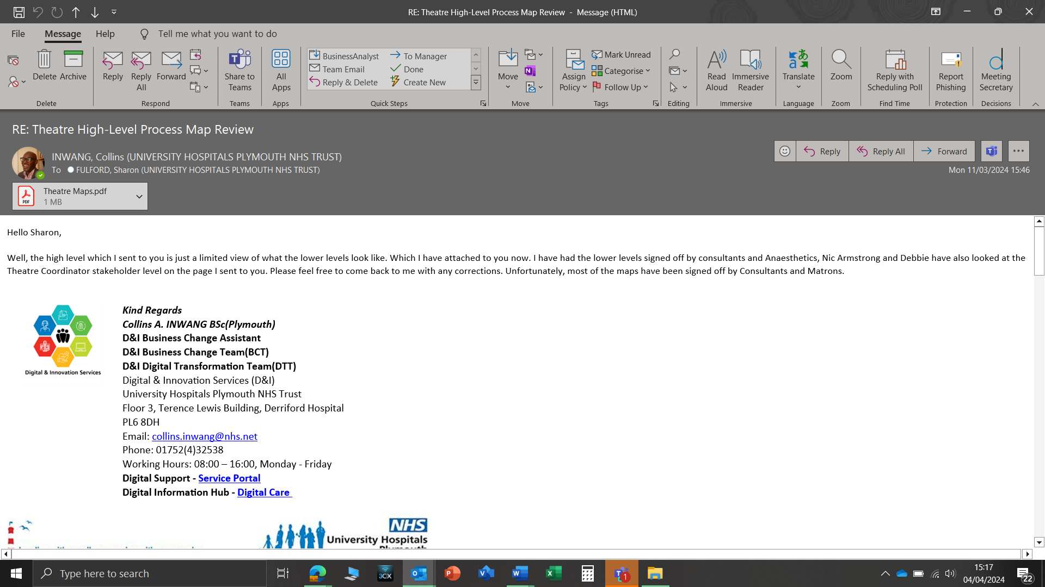

**Meeting correspondence with one of the major stakeholders**

The validation process included sending process maps to stakeholders and setting up meetings with individual stakeholders on a one-to-one basis to try and picture what their concerns are about the functionality of the system. Also, make sure their concerns are captured in the final version of the process.

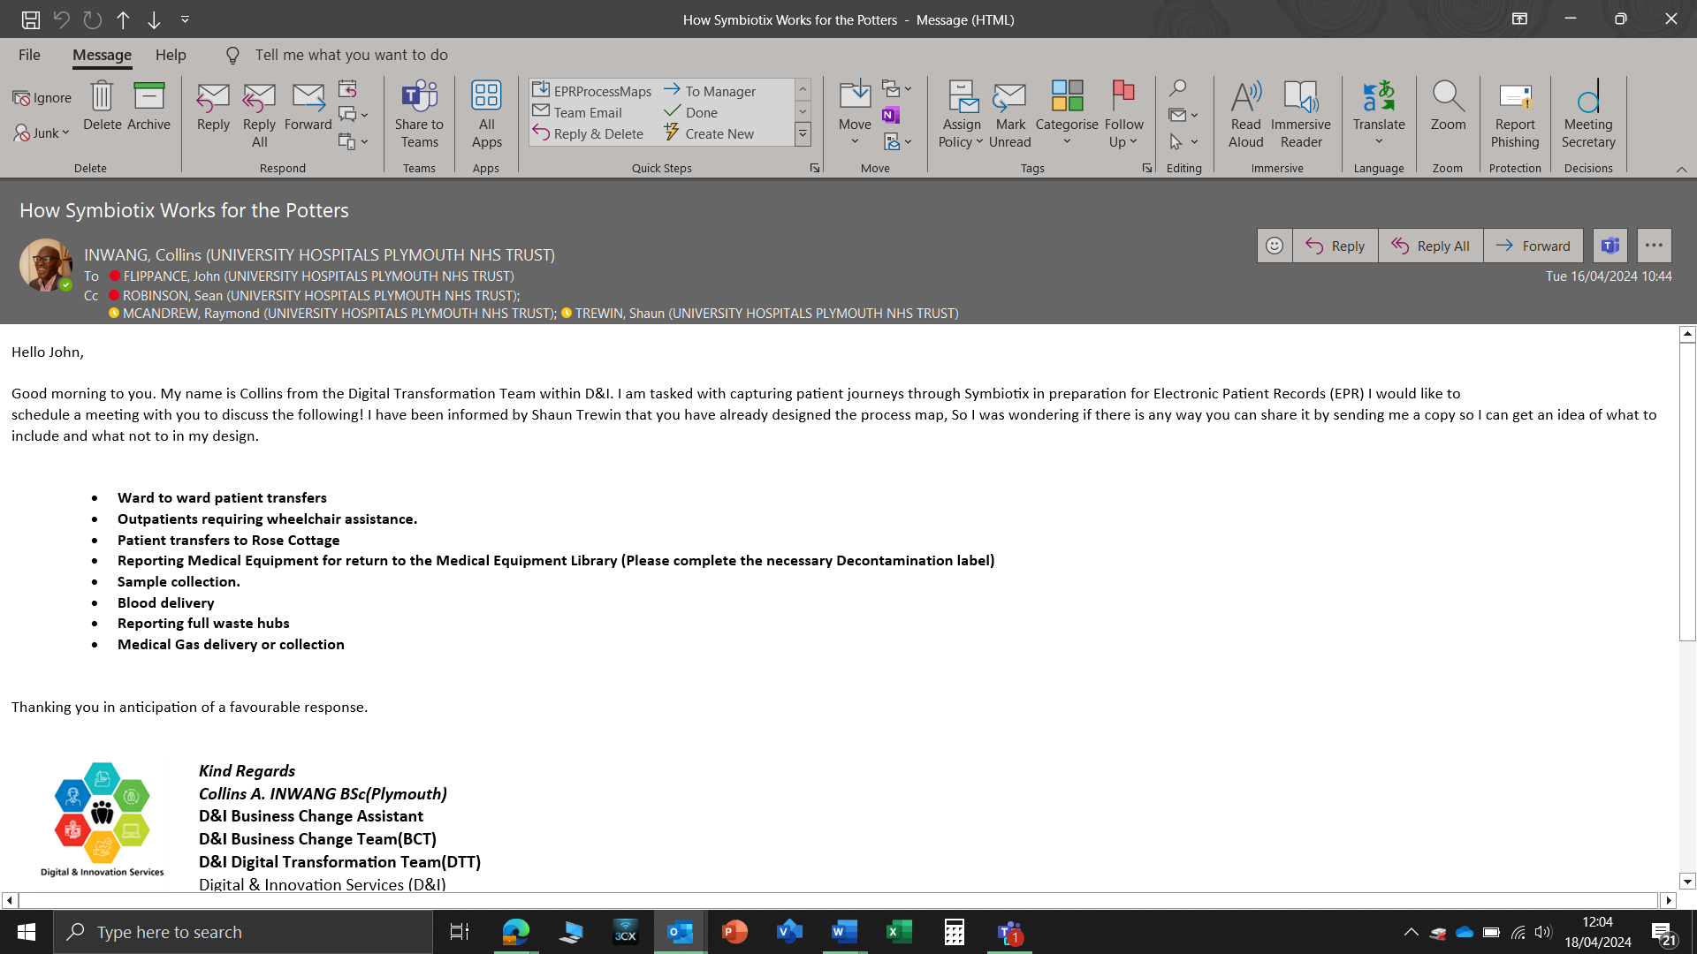

**Meeting requests to some of the stakeholders**

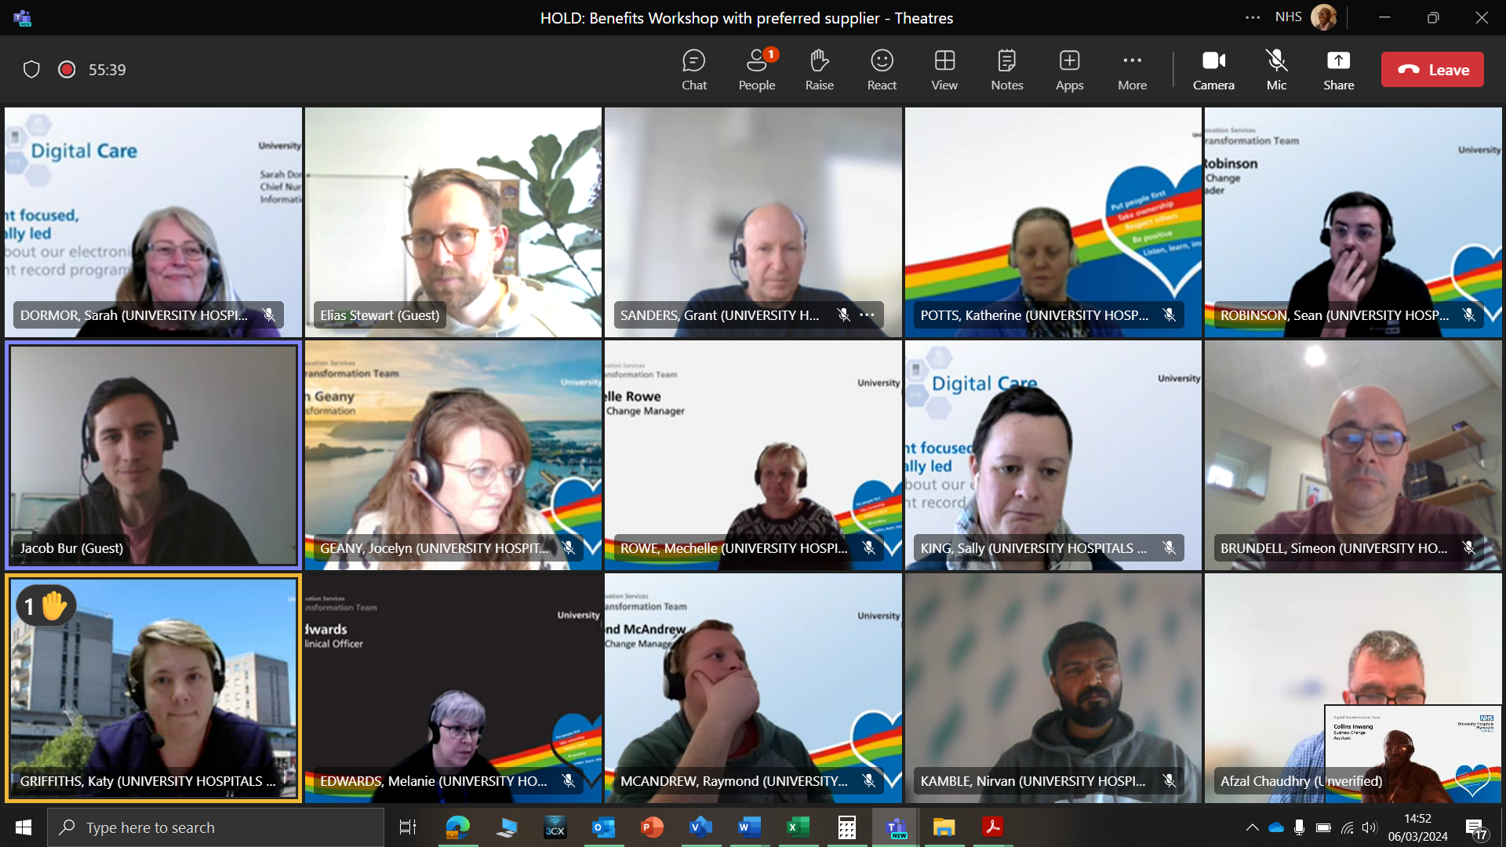

**Stakeholders Engagement Meeting**

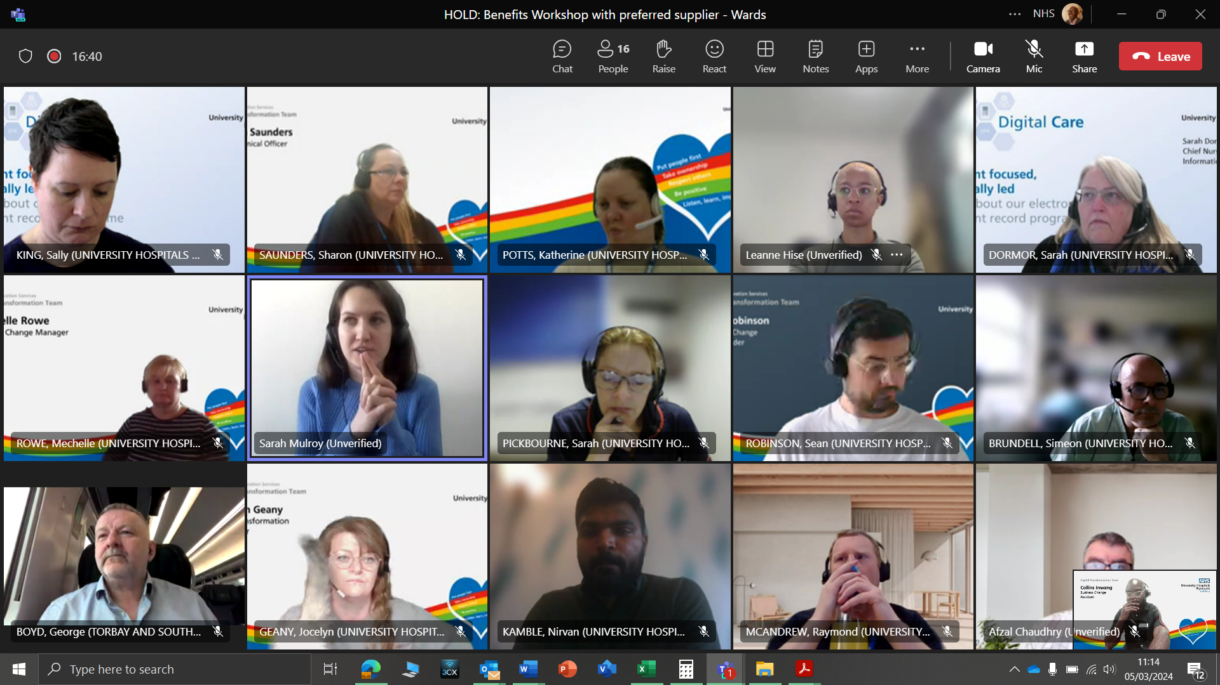

**Stakeholders Engagement Workshop**

**3.2** The Front-end Interface**:** When designing the mock-up of the front-end I engaged with various stakeholders/stockholders and talked about how we can accommodate and make the portal accessible to a variety of our service users and staff members with various health issues and challenges such as physically, earing, and virtually impaired to be able to use the system as well and interact with through various buttons, text boxes, images, navigation menus and list boxes and voice recognition service on the home page. When it was time to discuss our expectations of the new system with the preferred supplier, all these points were made known to them. It is very important to our Trust to make provisions and accommodate all manner of users across the entire platform because our service users, patients and staff members are our number one priority as a healthcare provider. As healthcare providers/organisations, we need to accept and treat everyone who uses our services equally.

**3.3** Functional Requirements**: -** This can be defined as the desired operations of a program or system in software development and systems engineering. The systems in system engineering can be either software electronic hardware or a combination of software-driven electronics. Functional requirements can also be referred to as part of requirements analysis (also known as requirement engineering), which is an interdisciplinary field of engineering that concerns the design and maintenance of complex systems. During the requirement elicitation, I made it very clear that I was gathering requirements, not solutions. The reason for this approach is that stakeholders would not necessarily agree on the functionalities that may be into the new system may have.

When gathering the requirements during the workshops I ensured that I was gathering clear requirements and some stakeholders insisted on a particular solution. However, I refrained from that because if you drive a particular solution forward, it may not cover all the requirements. For example, some of the solutions were conflicting and overlapped with each other i.e. some stakeholders in the Theatres wanted where they could monitor and dispense medications according to patient needs and not waste and I made it clear that this has already been addressed in the Inpatient design face which will be replicated across the board as a standard requirement for the final product. Even at that, I had to set up a meeting with all the stakeholders in one place to try and address their concerns and come to a consensus so that we can move forward together as a unit and a trust that is working towards the same goals in terms of our expectations concerning the **Electronic Patient Records (EPR).**

However, I made sure the requirements were clear and very easy for the various stakeholders to follow and also there were no ambiguous conflicting requirements i.e. wanting to have control of who they can admit to the Emergency Theatre for a procedure to was not visible and a lack of clarity on what was meant to go into the new system so I set up meetings with the top Theatre stakeholders to discuss where improvement can be made and there were disagreements with what should be included in the final process mapping which was not clarified and I had to set up a meeting with all the stakeholders involved so that we can come to an understanding and agreement on a way forward.

**3.4** Prioritisation Approach**: -** During the requirement of the session process I utilised the prioritisation approach **Moscow** which is also Moscow analysis is a popular prioritisation technique for managing requirements. The acronym Moscow represents four (4) categories of initiatives which are Must-have, should–have, could-have, won’t-have, or will not have right now. The “W” can also mean “Wish”. As the diagram below explains

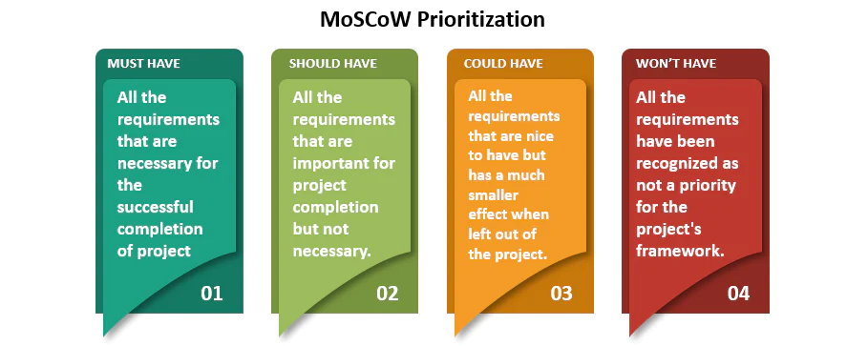

**(T, 2023)**

The reason I used the Moscow framework is that it has been defined in a way that allows the delivery of minimum usable requirements to be guaranteed. It is regarded as the most popular prioritisation technique for managing project requirements and also helps to contextualise the value of the task or future of the project. And provides a way to categorise users' requirements based on their priorities. It also helps develop a clear understanding of the Must Have, Should Have and Could Have categories while constraining the number of Must Have to those that could be completed within budget at a level of certainty chosen by the Trust.

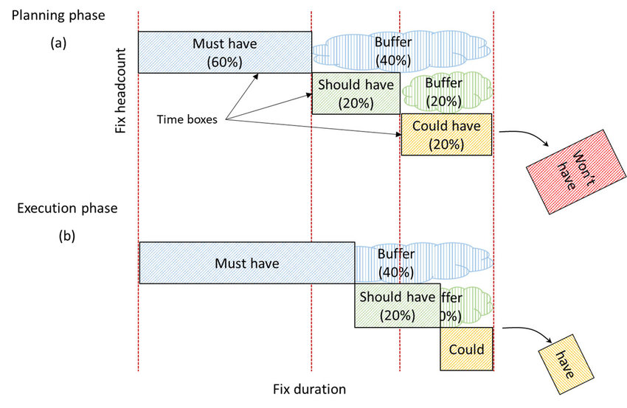

**Moscow rules at play: a) During planning, b) in execution**

**3.5** Non-Functional Requirements**: -** This can be defined as a set of specifications that describe the system’s operation capabilities and constraints. These are the requirements that outline how well the system operates, which can include things like speed, security, reliability, and data integrity. Though the system will still work as expected, it won’t address all the stakeholder's expectations or the needs of the entire system.

Non-functional requirements also help keep functional requirements in check. Attributes that make the product/ system affordable, easy to use, and accessible, come from non-functional requirements.

Examples of Non-Functional Requirements**:**

* Performance Requirement:Performance defines how fast a software system (or its component) responds to certain users’ actions under a certain workload. It’s the core type of nonfunctional requirements no system can do without. In most cases, the performance metric explains how long a user must wait before the target operation happens (the page renders, a transaction is processed, etc.) given the overall number of users at the moment. But it’s not always like that. Performance requirements may describe background processes invisible to users, e.g., backup. But let’s focus on user-centric performance.
* Scalability Requirements**:** Scalability assesses the highest workloads under which the system will still meet performance and usability requirements. Importantly, scalability refers to the capacity of the system to handle growth in terms of both data volume and user load.
* Portability Requirements**:** Portability determines if a system or its elements can work in different environments. It usually includes hardware, software, or other usage platform specifications. In other words, it establishes how well actions performed via one platform are run on another. Also, it prescribes how well system elements may be accessed and may interact from two different environments.
* Compatibility Requirements**:** Compatibility defines how a system can coexist and interact with another system in the same environment. In other words, these requirements specify how *compatible* the software product is with other programs. For instance, software installed on an operating system must be compatible with its firewall or antivirus protection. A lack of compatibility can lead to poor performance, errors, or data loss.
* Reliability Requirements**:** Reliability specifies how likely the system, or its element would run without a failure for a given period under predefined conditions. Traditionally, this probability is expressed in percentages. For instance, if the system has 85 per cent reliability for a month, this means that during this month, under normal usage conditions, there’s an 85 per cent chance that the system won’t experience critical failure.
* Maintainability Requirements**:** Maintainability defines the time needed for a solution or its component to be fixed, changed to increase performance or other qualities, or adapted to a changing environment.
* Availability Requirement**:** Availability describes how likely the system is accessible to a user at a given point in time. While it can be expressed as an expected percentage of successful requests, you may also define it as a percentage of time the system is accessible for operation during some period. For instance, the system may be available 98 per cent of the time during a month.
* Security Requirements**:** So, the nonfunctional requirements part will set up specific types of threats that functional requirements will address in more detail. But this isn’t always the case. If your security relies on specific standards and encryption methods, these standards don’t directly describe the behaviour of a system but rather help engineers with implementation guides.

**(engineering, 2023)**

FUNCTIONAL REQUIREMENTS**: -**

**4.1** Priority**: -** The main priority of the new **Electronic Patient Records (EPR)** is to address the shortcomings of the current system that is in place within the trust and make maximum use of the opportunity to change and include some new ideas and new ways of doing thing into the new system.

|  |  |  |
| --- | --- | --- |
| **M** | Must have | * **Improving flow and capacity:** EPR indicates to ward staff the type of bed clean based on the departing patient's clinical status- improving patient flow, bed capacity and efficiency across our wards. Real-time bed status information is available allowing for the management of high occupancy areas and planning of upcoming patient discharges. * **Hospital at Night:** Hospital at Night allows ward nurses to request jobs overnight or out of hours to a central point of access, coordinating clinical action In Basket is the EPR’s message-based task management system, which our clinicians use to streamline communication and coordinate clinical action across the trust with instant communication using the Electronic Patient Records secure messaging system. * **Improved antenatal and postnatal support:** Time-saving and beneficial for patient care as well as easier for staff. * **Booking centre:** The central booking office is now much more streamlined. EPR benefits the patients and the hospital. * **Rapid access to information:** EPR will allow staff to quickly access all of the patient's health records on one system (crucial for efficient emergency care). |
| **S** | Should have | * **Medicine take-home improvements:** EPR has improved the process for creating and writing medicine orders. Helping speeds up the discharge process. * **Pottering on the go:** The 'Rover' device helps with allocating porters to their next job. Porters will not be held back waiting for paperwork due to EPR, Virtual wards: providing care on the go and a general overview of the wards, and frailty success and ward overview and reduce the risk of infection by tracking every step of the patient care/journey. Medical devices directly connected to EPR automatically and continuously recorded directly into that patient's health record on EPR. * **Electronic alerts:** Frequent ED attendants and attendees with an emergency plan. |
| **C** | Could have | * **Fast Pass success:** Fast Pass allows patients to request an earlier appointment on **My Frimley Health Record** when cancellations or rebooking become available. Recording care at the bedside using mobile devices. * Medical devices directly connected to EPR automatically and continuously recorded directly into that patient's health record on EPR. * **Smartcards**: Use of smartcards synced to NHS Spine to automatically pull nationally held information about a patient into our EPR system. * **Virtual Fracture Clinic:** Help with service demand and improve patient care and experience. |
| **W** | Want to have/  Will not have this time | * **Clinical letter dictation:** Dragon Medical One (DMO), a state-of-the-art voice recognition system that converts voice to text directly in EPR. (The speed of patients receiving their letters is faster). |

**4.2** Requirement**: -** These is the system requirements that very essential and must, should and could be included in the new system. The table gives a suggestive list that we have given to the system supplier to make sure that the system meets the entire specifications that would last more than a decade:

Below are examples of some of the requirements:

|  |  |  |  |
| --- | --- | --- | --- |
| **ID** | **Requirement** | **Related**  **Non-Functional Requirement** | **Priority** |
| **FR-#TTAs** | * EPR has improved the process for creating and writing medicine orders. Helping speeds up the discharge process | NFR## | M |
| **FR-#HaN** | * Hospital at Night allows ward nurses to request jobs overnight or out of hours to a central point of access, coordinating clinical action In Basket is the EPR’s message-based task management system, which our clinicians use to streamline communication and coordinate clinical action across the trust with instant communication using the Electronic Patient Records secure messaging system | In Basket is the EPR’s message-based task management system, which our clinicians use to streamline communication and coordinate clinical action across the trust. | S |
| **FR**  **#FP** | * Fast Pass allows patients to request an earlier appointment on **My Frimley Health Record** when cancellations or rebooking become available. | The central booking office is now much more streamlined. EPR benefits the patients and the hospital. | C |
|  | * EPR indicates to ward staff the type of bed clean based on the departing patient's clinical status- improving patient flow, bed capacity and efficiency across our wards. Real-time bed status information is available allowing for the management of high occupancy areas and planning of upcoming patient discharges. | Improved communication between the patient and all staff involved. Improved pathways between teams and accountability for complex cases. Accessible app for patients known as My Frimley Health Record. Able to message the midwifery team on the app. |  |
|  | * BCMA- ensuring that the right medications and the right doses are given to the right patients and that the medication is recorded in the patient’s health record in our electronic patient record system. | Allergy information available on EPR improves safety for our patients. |  |
|  | * Secure chat system for porters to relay queries and messages directly to the team coordinators (speeding up the process and not requiring them to go physically and check with the team coordinators) | Benefits of the EPR system on our community site. |  |
|  | * In Basket is the EPR’s message-based task management system, which our clinicians use to streamline communication and coordinate clinical action across the trust. | Created a dashboard within EPR to give a complete view of the current bed states across all inpatient areas. |  |

**4.3** User Stories**: --** Below are examples of some of the User stories:

|  |  |  |  |  |
| --- | --- | --- | --- | --- |
| **ID** | **As a …** | **I want to be able to …** | **in order to …** | **Priority** |
| **NFR**  **#Chat** |  | Have a secure chat for porters to relay queries and messages directly to the team coordinators (speeding up the process and not requiring them to go physically and check with the team coordinators). | Speed up the process and not require them to go physically and check with the team coordinators). | S |
| **NFR**  **#1-2-1** |  | Following the main group discussion, they go straight onto a computer to read the handover and view their patients' records. | A simple handover process that doesn’t take too much time from patient care | M |
|  |  | Self-service kiosks allow patients to check in to their outpatient appointment themselves helping reception staff during busy periods and easing patient flow in these areas | Nurses use handheld devices called ‘Rover’. Workstations-on-wheels are used primarily by our doctors to record information during ward rounds. |  |
|  |  |  | Medical devices directly connected to EPR automatically and continuously recorded directly into that patient's health record on EPR. |  |

# NON-FUNCTIONAL REQUIREMENTS**: -**

1. Below are examples of some of the non-functional requirements:

|  |  |  |
| --- | --- | --- |
| **Category** | **ID** | **Requirement** |
| Security | NFR | Data security is a firewall against cyber-attacks that can help prevent any unwanted phishing that may occur. |
| Usability | NFR | How user-friendly is the system and can it work on tablets and smartphones mobile devices to be available 24/7 and |
| Performance | NFR | Response time must be less than 1 minute and autosave of data input while completing a task. |
| Availability |  |  |
| Capacity | NFR | Unlimited cloud storage capacity for the amount of data that will be handled across all the sites. |
| Accessibility |  |  |

REQUIREMENT ANALYSIS, VALIDATION & TRACEABILITY: **-**

Requirements Documentation Approaches**: -** We tend to use the Microsoft Workload Planner to list the progress made at every stage of the project, the disadvantage we encounter is I can’t add notes in detail. This is why we as a team also make use of Microsoft Excel to create a table with taps that represent the various stages of the project's progress which makes it easier for us to tick off every stage of the project that has been completed or signed off while also allowing us to add new project or remove completed projects. The disadvantage of using Microsoft Excel is the file can be corrupted and the data/ information stored is lost which can be painful and mentally exhausting.

I believe there are other prominent project management software that can help structure and organise every step/ phase of the project life cycle, such as

**JIRA:** Jira is a software application developed by the Australian software company Atlassian that allows teams to track issues, manage projects, and automate workflows.

|  |  |
| --- | --- |
| **PROS** | **CONS** |
| • Built for Agile and Scrum management • Excellent issue management for bug and issue tracking • Instant ticketing abilities to streamline problem-solving | • Can be complex to use • Collaboration features are extremely limited  • Might not be the best fit for all teams (engineering and software development focused) • Higher barrier to entry • Load times can lag |

One way of documenting project requirements is by using the Microsoft Excel spreadsheet which is our go-to place for project documentation this process helps us make sure all the steps and phases of the project are captured promptly in a spreadsheet with taps that represent all the projects that we are working on, and this helps us manage meetings and keep track of all our stakeholders/stockholders engagement meetings. During the project, I trace requirements with the use of a Microsoft Excel Spreadsheet which I designed to keep track of all the modifications and updates that are carried out during the project lifecycle using project ID so that when someone makes some changes I know who the source was and also when a change is to take place on the project I will make sure all the changes are recorded on the checklist to keep a record of all modifications and upgrades. I wanted a situation where if am not in the office or move jobs someone can pick up the spreadsheet look through it and make some changes where needed.

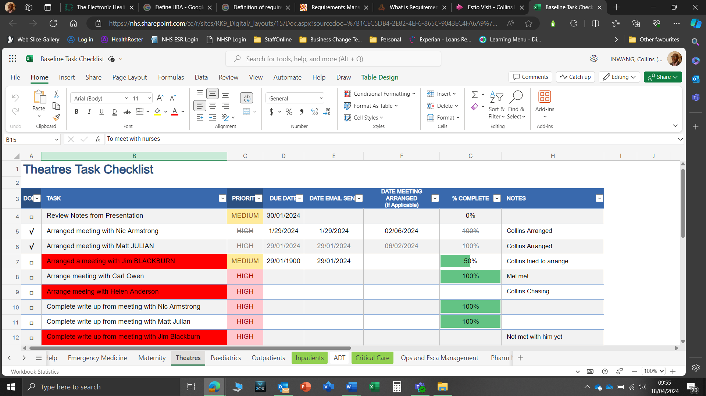

**Project Tracking Checklist the Inpatient Design Phase**

But Excel spreadsheet comes with a lot of pros and cons which I have listed in the table below: -

# ADVANTAGES AND DISADVANTAGES OF USING SPREADSHEETS FOR PROJECT DOCUMENTATION

|  |  |
| --- | --- |
| Advantages | Disadvantages |
| Familiarity and Ease of Use:  Excel’s widespread adoption in various industries is one of its greatest strengths for project management. Its intuitive interface and familiar functionalities make it an accessible tool for professionals at all skill levels. This ease of use reduces training time and allows teams to focus more on project execution than learning new software | Poor Handling of Large Datasets:  Another major drawback of Excel in project management is its poor handling of large datasets. Imagine a construction project involving hundreds of tasks, resources, and timelines. Using Excel to manage such vast data can be cumbersome and error prone. Excel struggles with performance issues when dealing with large files, leading to slow load times and increased potential for data corruption. Switching to project management software designed to handle large datasets efficiently is advisable to address this. These tools offer robust data processing capabilities, ensuring smooth and reliable management of extensive project data. |
| User-Friendly Interface: Excel’s layout is intuitive, with tools and features easily accessible, making it simple for users to navigate and use | Lack of Integrated Project Management Features: The third disadvantage is the lack of integrated project management features in Excel. For instance, a software development team using Excel cannot effectively track issues or bugs within the same platform where they manage their project timelines. Excel does not offer built-in tools for critical aspects of project management such as issue tracking, risk management, or resource allocation. To resolve this, integrating specialized project management software that includes these essential features can significantly enhance the management process, providing a more holistic and efficient approach to project execution. |
| Minimal Training Required: Most professionals have a basic understanding of Excel, reducing the need for extensive training. | Vulnerability to Human Error: Excel’s vulnerability to human error is another significant disadvantage. When a financial analyst manages budget allocations for a project in Excel, a simple mistake in formula or data entry can lead to substantial financial miscalculations. Excel lacks the advanced error-checking features found in specialized project management tools, making it prone to errors that can have far-reaching implications. Adopting software with built-in error-checking and validation mechanisms can help mitigate these risks, ensuring more accurate and reliable project management. |
| Quick Adaptation: Teams can quickly adapt to using Excel for project management, thanks to its familiar environment. | Limited Visual Project Tracking Tools: The fifth disadvantage revolves around Excel’s limited visual project tracking capabilities. Excel’s basic charts and graphs provide insufficient visualization for effective tracking for a project manager overseeing a complex project with multiple dependencies and milestones. Excel lacks advanced visual tools like Gantt charts or Kanban boards, making it challenging to get a comprehensive view of the project status. Implementing project management software that offers a range of visualization tools can dramatically improve the tracking and presentation of project progress, facilitating better decision-making and communication. |
| Flexibility and Customization: One of the key strengths of Excel in project management is its remarkable flexibility and capacity for customization. It allows project managers to create a setup that precisely fits their projects’ unique requirements and complexities. This adaptability ensures that Excel can be tailored to meet your specific needs, whether you’re tracking a simple task list or managing a complex project with multiple dependencies. | Absence of Automation Features: Excel’s lack of automation features is a significant drawback. When a project manager needs to update project status regularly, doing this manually in Excel is time-consuming and prone to errors. Excel does not offer automation capabilities for repetitive tasks like data entry, status updates, or report generation. Adopting project management tools with automation features can save valuable time and reduce the likelihood of errors, allowing project managers to focus on more strategic aspects of their projects |
| Tailor-Made Solutions: Excel enables users to design spreadsheets that cater specifically to the demands of their project, whether it’s for tracking milestones, resources, or budgets | Inadequate Security for Sensitive Data: The seventh disadvantage concerns Excel’s inadequate security features for sensitive project data. For example, a healthcare project handling patient data in Excel faces a high risk of data breaches due to Excel’s basic security measures. Excel does not provide robust security features such as user access controls, encryption, or audit trails, essential for managing confidential data. Implementing project management tools with enhanced security features is crucial for protecting sensitive information and ensuring compliance with data protection regulations. |
| Adaptability for Various Projects: Its versatility makes it suitable for various projects, from small-scale plans to large, multi-faceted endeavours | Limited Integration with Other Tools: A critical limitation of Excel is its inability to integrate seamlessly with other tools and systems. Consider a logistics project that requires integration with external inventory and shipping systems. Excel’s limited integration capabilities make synchronizing data across different platforms challenging, leading to inefficiencies and data discrepancies. Transitioning to project management software with robust integration capabilities with other tools can streamline processes and ensure consistent and accurate data flow across systems. |
| Customizable Templates and Formulas: With various templates and the ability to create custom formulas, Excel provides endless possibilities for personalizing project management approaches | Limited Scalability for Growing Businesses: The ninth disadvantage is Excel’s limited scalability. Excel’s capabilities may not scale accordingly as a business grows and its projects become more complex. Excel cannot efficiently manage the increased project size and complexity for a rapidly expanding company. This limitation can hinder the growth and scalability of project management processes. Upgrading to scalable project management software can accommodate the growing needs of a business, ensuring that project management capabilities evolve in line with the company’s growth. |
| Cost-Effectiveness: Excel proves to be a highly cost-effective solution for project management. Many organizations already have Microsoft Office Suite, which includes Excel, eliminating the need for additional investments in specialized software. This affordability makes it particularly appealing for small businesses and startups with limited budgets.  No Additional Software Purchase: Excel is often already part of the existing software suite in many organizations, requiring no extra expenditure.  Reduces Overhead Costs: Companies can allocate resources elsewhere by avoiding the costs associated with purchasing and maintaining specialized project management tools.  Ideal for Budget-Conscious Projects: Excel’s affordability makes it an excellent choice for projects where keeping overhead low is a priority.  No Additional Software Purchase: Excel is often already part of the existing software suite in many organizations, requiring no extra expenditure.  Reduces Overhead Costs: Companies can allocate resources elsewhere by avoiding the costs associated with purchasing and maintaining specialized project management tools. | Lack of Dedicated Support and Updates for Project Management: Lastly, Excel’s lack of dedicated support and updates specific to project management is a notable disadvantage. For instance, a project team encountering issues with Excel will find limited support options tailored to project management needs. Excel does not provide such targeted support, unlike specialized project management software that offers ongoing support and regular updates focused on improving project management functionalities. Opting for project management tools with dedicated support and continuous updates can ensure smoother project execution and access to the latest features and improvements. |
| Ideal for Budget-Conscious Projects: Excel’s affordability makes it an excellent choice for projects where keeping overhead low is a priority. |  |
| Advanced-Data Analysis Capabilities  Excel’s advanced data analysis capabilities are a significant advantage for project management. It offers a range of features like PivotTables, conditional formatting, and complex statistical functions, enabling managers to analyse project data deeply and make data-driven decisions.  Comprehensive Data Analysis Tools: Features like PivotTables and advanced charting allow for detailed data analysis and visualization.  Support for Complex Calculations: Excel can handle complex statistical functions and calculations, which is crucial for data-intensive projects.  Data-Driven Decision Making: Analysing trends and patterns empowers managers to make informed decisions based on real-time data. |  |
| Integration with Other Microsoft Products: Excel’s seamless integration with other Microsoft Office applications like Word, PowerPoint, and Outlook enhances its utility in project management. This compatibility allows for efficient data transfer and communication, streamlining various project management processes.  Effortless Data Sharing: Easy import and export of data between Excel and other Microsoft applications facilitate a smoother workflow.  Unified Communication: Integration with Outlook allows for efficient communication and scheduling within project teams.  Enhanced Reporting: The ability to incorporate Excel data into PowerPoint presentations and Word reports simplifies the creation of comprehensive project documents.  Effortless Data Sharing: Easy import and export of data between Excel and other Microsoft applications facilitate a smoother workflow.  Unified Communication: Integration with Outlook allows for efficient communication and scheduling within project teams.  Enhanced Reporting: The ability to incorporate Excel data into PowerPoint presentations and Word reports simplifies the creation of comprehensive project documents |  |
| Scalability: Excel’s capability to handle large datasets makes it a scalable tool for project management. Whether managing a small team or a large enterprise project, Excel can adapt to the increasing complexity and volume of data.  Handles Large Volumes of Data: Excel’s robust framework supports large datasets, which is essential for big projects.  Flexible for Project Growth: Excel scales up to accommodate additional data and complexity as projects expand.  Adaptable for Various Team Sizes: Excel can be efficiently used by small and large departments, maintaining its effectiveness across different scales. |  |
| Real-time Collaboration (with Office 365): With Office 365, Excel supports real-time collaboration, allowing multiple users to edit the same spreadsheet simultaneously. This feature promotes teamwork and ensures all team members access the most current project data.  Simultaneous Editing: Teams can work on the same document, improving collaboration and efficiency.  Access from Anywhere: With cloud-based capabilities, team members can access and update project data from different locations.  Live Updates: Real-time updates ensure that all collaborators work with the most recent data, reducing the risk of errors or outdated information. |  |
| Robust Reporting Features: Excel offers robust reporting features that enable project managers to generate comprehensive and visually appealing reports. These reports can track project progress, analyse performance, and communicate effectively with stakeholders.  Customizable Reports: The ability to create tailored reports allows for more effective communication of project status and outcomes.  Visual Data Representation: Excel’s charting and graphing capabilities help present data in an easily understandable format.  Detailed Performance Tracking: Managers can track project performance against key metrics and timelines, improving project control |  |
| Automation through Macros and VBA: Excel’s macros and VBA (Visual Basic for Applications) scripting offer automation capabilities, reducing manual effort and increasing efficiency. This feature is handy for repetitive tasks and streamlining project management processes.  Time-Saving Automation: Automate repetitive tasks like data entry and formatting, freeing time for more critical project management activities.  Custom Scripting Options: VBA allows the creation of custom scripts and enhances Excel’s functionality to suit specific project needs.  Error Reduction: Automation minimizes the risk of human error in repetitive tasks, ensuring higher data accuracy |  |
| Wide Range of Templates and Resources: Excel’s vast array of templates and online resources make it an even more powerful tool for project management. From Gantt charts to budget trackers, templates are available for almost every aspect of project management. |  |

Requirement Validation: - The validation I carried out was done by having workshops across the Trust and inviting staff members to come through with suggestions and feedback on what they think of the idea and the benefits of the new system. I validation process I used was to send the process maps to the service lines for them to review and then get back to me with their preferred date so that I could send out meeting invites through Microsoft Teams so that we could get the stakeholders' views and contributions while encouraging stakeholders' engagement in the process. This allowed me to showcase the process modelling (Process Mapping) diagrams that I designed using Microsoft Visio so that I could get inputs from the stakeholders' concerns. This was an opportunity for me also to understand what their expectations were regarding the new system and how to address it without leaving any vital steps and information out in the final design. Even though it was not an easy task.

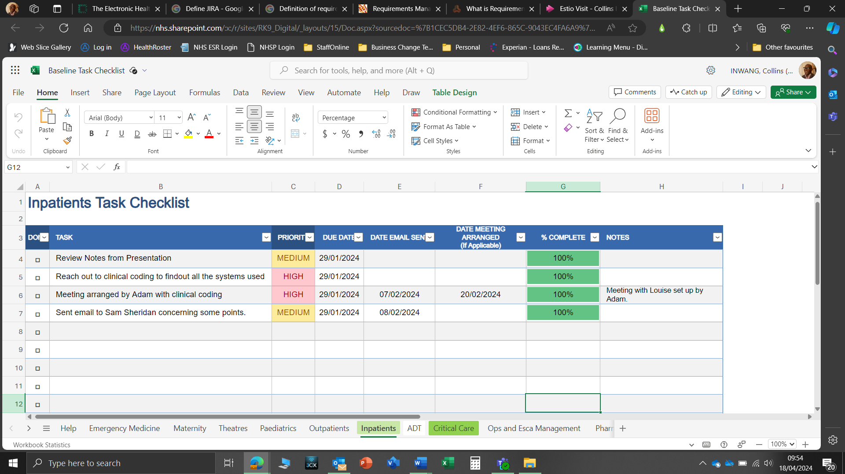

**Project tracking checklist for Inpatient**



**Project tracking checklist for Theatre**

Requirements Management: - This can be defined as the process of documenting, analysing, tracing, prioritising, and agreeing on the requirement and then controlling change and communicating to relevant stakeholders. This means for the electronic Patient Records (EPR) project to be successful we must aim to be result-driven. In today’s competitive environment within the Healthcare sector, there is no room for failed projects or stale performance. The goal for University Hospitals NHS Trust is to be successful long term which is becoming more difficult because of the fast global expansion within the Healthcare sector than ever before.

Requirements management keeps all the teams involved in sync with one another and helps provide visibility into what is needed or happening and when it is happening throughout the entire project life cycle. It is also very important for the team to understand what the goal of the project is. Change Control or let me say Uncontrolled changes can cause many different problems such as additional rework, lack of first-time quality, unpredictable schedule deviation and cost issues. Following a change process can make requirements changes very easily to deal with. The requirement change process must be able to propose, analyse, improve and implement any changes within a requirement during any part of the project. Traceability- allows for the University Hospitals NHS Trust to manage the entire life of the project requirement. This will help us understand how traceability helps ensure accurate delivery of the stakeholders' needs and expectations.

The tracing is more related to system development and would help add value to the project. Traceability will help improve the scope management within the project and potentially prevent the team from overseeing an identified requirement. Missed requirements can sometimes lead to huge cost increases if it is implemented late or if there is a slight delay in the implementation stages. This is why Traceability can help provide the ability to track the priority of all the requirements and their changes. We know it can be difficult to implement without the right tools or resources we can run into a cost overrun and not worth the benefit we originally assumed. This is why we use Excel spreadsheets to keep track of all the steps and procedures of the project life cycle and make amends as we go along. This in turn gives me a good understanding of where the gaps are so that I can correct them in good time for the final episode of the project.

During the project, I trace requirements with the use of a Microsoft Excel Spreadsheet which I designed to keep track of all the modifications and updates that are carried out during the project lifecycle using project ID so that when someone makes some changes I know who the source was and also when a change is to take place on the project I will make sure all the changes are recorded on the checklist to keep a record of all modifications and upgrades. I wanted a situation where if am not in the office or move jobs someone can pick up the spreadsheet look through it and make some changes where needed.



**Project Tracking Checklist the Inpatient Design Phase**



**Project tracking checklist for Theatre**

Changes to the system or let me say upgrades will be done within the ten-year lifespan of the final project, and this will be managed in phases to limit service disruptions across the Trust and also make sure there is Business as Usual (BAU) while the upgrade is being carried out across all the sites.

I have been involved in the change preparations for the forthcoming system. I know the question everyone will be asking is “How can you determine the change when the new system has not yet been implemented?”. I would say you are right to question this because it is too early to determine the changes that may occur, but I am looking into the future and what would be needed to change during the piloting phase rollout. This will be the period to take stock of what is working and what needs to be corrected to have a smooth and easy system that won't fail in a few months. In the preparation stages for the Electronic Patient Records (EPR), I plan on taking the step of preparing Microsoft Excel Spreadsheets that will be updated regularly about the changes that we think will happen during the launch and piloting phases of the project. Something similar to my project tracking spreadsheet that I have put a screenshot above.

Benefits Realisation and Management: - When delivering a project of this nature one thing to consider is the benefits this will bring to the trust and the management process in place to help understand the benefits which are highlighted at the start of the document. The benefit realisation metrics will help us understand all the positives and the negatives which will be managed by a team of benefit realisation experts who will monitor, document and generate reports within the first three (3) months of the go live. The benefits that will come from the implementation of the new system in this case will include the following:

Virtual Fracture Clinic: This will help with service demand and improve patient care and experience.

Rapid access to information: EPR will allow staff to quickly access all of the patient's health records on one system (crucial for efficient emergency care).

Electronic alerts: Frequent ED attendants and attendees with an emergency plan.

Smartcards: Use of smartcards synced to NHS Spine to automatically pull nationally held information about a patient into our EPR system.

Single source of truth: Since EPR has all the patient information on the system which would also be the most updated information it would be a single source of truth (making it easier for quicker, safer and better care).

Real-time information for effective management: EPR benefits us by providing real-time updated information on the patient through dashboards.

Using digital technology to identify and treat sepsis quicker: Benefits of EPR on detecting sepsis (early detection and faster response) Barcode medication administration: BCMA- ensuring that the right medications and the right doses are given to the right patients and that the medication is recorded in the patient’s health record in our electronic patient record system.

Allergy improvement: Allergy information available on EPR improves safety for our patients.

Referrals to our community sites: Benefits the EPR system on our community site. Smart Tools: Smart Tools are time-saving shortcuts that our staff can use to pull various information into their documentation.

Automation of vital patient data from medical devices directly connected to EPR automatically and continuously recorded into that patient's health record on EPR.

Recording care at the bedside using mobile devices: Nurses use handheld devices called ‘Rover’. Workstations-on-wheels are used primarily by our doctors to record information during ward rounds.

Patients do not stay in the hospital for longer than necessary: Processes have become faster, discharge summaries are completed within EPR, and doctors can remotely provide care and prescribe medication without needing to be with a patient.

Improving flow and capacity: EPR indicates to ward staff the type of bed clean based on the departing patient's clinical status- improving patient flow, bed capacity and efficiency across our wards. Real-time bed status information is available to manage high

occupancy areas and plan upcoming patient discharges.

Recording care at the bedside: Wows are moveable devices that allow clinicians to use the EPR while also spending face-to-face time with the patient. This allows for real-time recording of patient information, medication, and demographics.

Making Everyday Matter: Help our patients at home as safely and quickly as possible. Also able to use 'In Transit' (virtual waiting area).

Patients do not stay in the hospital for longer than necessary: Processes have become faster, discharge summaries are completed within EPR, and doctors can remotely provide care and prescribe medication without needing to be with a patient.

Improving flow and capacity: EPR indicates to ward staff the type of bed clean based on the departing patient's clinical status- improving patient flow, bed capacity and efficiency across our wards. Real-time bed status information is available to manage high occupancy areas and plan upcoming patient discharges.

Medicine take-home improvements: EPR has improved the process for creating and writing medicine orders. Helping speeds up the discharge process.

Pottering on the go: The 'Rover' device helps with allocating porters to their next job. Porters will not be held back waiting for paperwork due to EPR, Virtual wards: providing care on the go and a general overview of the wards, and frailty success and ward overview and reduce the risk of infection by tracking every step of the patient care/journey.

Hospital at Night: Hospital at Night allows ward nurses to request jobs overnight or out of hours to a central point of access, coordinating clinical action In Basket is the EPR’s message-based task management system, which our clinicians use to streamline communication and coordinate clinical action across the trust with instant communication using the Electronic Patient Records secure messaging system. Fast Pass success: Fast Pass allows patients to request an earlier appointment on My Frimley Health Record when cancellations or rebooking become available.

Fast Pass success: Fast Pass allows patients to request an earlier appointment  
on My Frimley Health Record when cancellations or rebooking’s become available.

Instant communication: The benefit of Electronic Patient Records (EPRs) is secure messaging within its system.

A new way of check-in: Self-service kiosks allow patients to check in to their outpatient appointments themselves helping reception staff during busy periods and easing patient flow in these areas.

Responding to deteriorating patients: EPR benefits from the way the Rapid Response Team works.

Productivity and efficiency: Benefits of EPR improving productivity and efficiency at the hospital.

How all the Benefits would be managed: -

In other to manage some of the benefits for example Benefit 2 “Rapid access to information” after a couple of months we would check to see if there are any data discrepancies how best to manage it and how it has been delivered the way we expected it to. This is where benefit number 4 will be useful “Smartcards” This will help Sync with the nationwide NHS spine for pulling nationally held information on patients. “Instant communication” This feature can help the clinical team keep each other updated about the patient's treatment journey and what next to do when it comes to the treatment plan. “Improving flow and capacity” This can improve patient flow on the wards and help the ward team keep track of what type of cleaning is needed when a patient is discharged before a new patient is admitted to the ward while understanding and keeping patient flow at a 100% turnaround.

Stakeholders' feedback on the benefits of Electronic Patient Records (EPRs): Below is an example of some of the feedback I got from various stakeholders regarding their benefit expectations.

|  |  |
| --- | --- |
| Stakeholders Names: | Feedback: |
| Hannah Nunn: | No longer have lengthy one-to-one handovers. Following the main group discussion, they go straight onto a computer to read the handover and view their patients' records. |
| Charlotte Foster: | The benefit of not having to share one hard copy of notes. |
| Claire Tolliday: | Created a dashboard within EPR to give a complete view of the current bed states across all inpatient areas. |
| Mark Lepine-Williams: | Secure chat system for porters to relay queries and messages directly to the team coordinators (speeding up the process and not requiring them to go physically and check with the team coordinators). |
| Vicky Gentry: | Benefits of EPR on infection incidents. |
| Phil Earl: | Staff viewpoint of benefits of EPR for the Rapid Response team. |
| Tanya Santa Caterina: | The appointment templates we use within the Snap board feature ensure all patients receive a fair and appropriate time allocation. |
| Vicky Gentry: | Benefits of EPR on Infection Incidents. |

CONCLUSION: **-**

In conclusion, during the investigation and information gathering, I ***learnt***that in most cases the stakeholders/ stockholders are very sure what they want the new system to address and what should be included in the business model and processes captured in the design phase of the process mapping stages for them to see.

The visuals are designed so that modules can be added, and corrections done in the future, and the future state has not yet been decided or what to include in the future state when designing the process model/future state. Even with this, I still learnt that “**NOT**” all information gathered was relevant and a lot would be changed and not allowed in the future state/desired situation because of the financial implications and there are also modules that would have to be added on which I am capturing the business process model via process mapping using Microsoft Visio.

The process modelling/mapping of the current state of the inpatient journey is ***What went well*,** even though I was apprehensive about it during the presentation to stakeholders/stockholders’ expectations and changes in the final process mapping, and I was so glad that I met all expectations. On the other hand, the Theatre patient journey was the hardest one for me because the current state/current business practice was more complicated for me due to many stakeholders/stockholders coming up with different ways of doing things within their service lines which was mentally draining for me because of the back and forth, but the support I got from my team leader and colleagues got me through it and also gave me the boost I needed to push through. Even though I am still chasing some of the stakeholders to put their final stamp of approval on the finished design. It made me realise my patience and strength of being able to weather the storm of rejection in terms of the stakeholders accepting my first process modelling of the desired state.

I had to schedule new meetings with the stakeholders (Consultants, Matron, Nurses, and Secretary) to understand what the new process is supposed to address so as to not make mistakes or have it rejected again. ***What I will do differently*,** is make sure that I meet with all the stakeholders/stockholders more than regularly to get their input till the very last design and make sure I send the sample design to them after every stage of the design is completed as many times as possible for them to look at and make corrections before I design the desired situation/future state process model.

# References**:**

* [The Health And Care Act: Six Key Questions | The King's Fund (kingsfund.org.uk)](https://www.kingsfund.org.uk/insight-and-analysis/long-reads/health-and-care-act-key-questions?gad_source=1&gclid=Cj0KCQjw2a6wBhCVARIsABPeH1sYbqG0XNqVZsdEe8LIXNWpLvtA8znraxRsgQU39Af_6eWnVZcHSeAaAm5wEALw_wcB)
* [The Electronic Health Records System In the UK | Centre For Public Impact (CPI)](https://www.centreforpublicimpact.org/case-study/electronic-health-records-system-uk?utm_term=&utm_campaign=United+Kingdom+-+Dynamic+Search+-+How+We+Help?&utm_source=adwords&utm_medium=ppc&hsa_acc=9564221613&hsa_cam=1641146868&hsa_grp=68170737292&hsa_ad=314833667704&hsa_src=g&hsa_tgt=dsa-527069888850&hsa_kw=&hsa_mt=&hsa_net=adwords&hsa_ver=3&gad_source=1&gclid=Cj0KCQjw2a6wBhCVARIsABPeH1v2Ke3eTdvVx2k_JlX7AEfB_qKDMUWcZk_5tvuXbzQGRcMIIArzHTQaAuyBEALw_wcB)
* [Interim Report prepared by Milieu Ltd for the European Parliament under Service Contract IP/C/PETI/IC/2008-042 (europa.eu)](https://health.ec.europa.eu/system/files/2016-11/laws_united_kingdom_en_0.pdf)
* [90% of NHS trusts now have electronic patient records - NHS England Digital](https://digital.nhs.uk/news/2023/90-of-nhs-trusts-now-have-electronic-patient-records)
* [A plan for digital health and social care - GOV.UK (www.gov.uk)](https://www.gov.uk/government/publications/a-plan-for-digital-health-and-social-care/a-plan-for-digital-health-and-social-care)
* [NHS England hits 90% target for electronic patient records | Computer Weekly](https://www.computerweekly.com/news/366560172/NHS-England-hits-90-target-for-electronic-patient-records)
* [What is functional requirements? | Definition from TechTarget](https://www.techtarget.com/whatis/definition/functional-requirements)
* [What is Jira? | Definition and Overview (productplan.com)](https://www.productplan.com/glossary/jira/)
* [Microsoft PowerPoint - Requirements Engineering v5.1 All days (estio.co.uk)](https://elms.estio.co.uk/file/64a7b362062551fb41f6a49f31ffb98d/RE%20Slides%20All.pdf)
* [Writing Effective Requirements (estio.co.uk)](https://elms.estio.co.uk/file/fa35a72eb27c75e4b8812df81e0151cb/Writing%20Effective%20Requirements.pdf)
* [Nonfunctional Requirements: Examples, Types and Approaches (altexsoft.com)](https://www.altexsoft.com/blog/non-functional-requirements/)

# Chapter 5 - DATA MODELLING

**APPRENTICESHIP COURSE WORK**

**DATA MODELLING**

## INTRODUCTION:

The value of data can also be referred to the benefits and advantages that organisations can derive from their data assets, such as innovations, services, security measures, improved decision-making, better customer experiences, increased operational efficiency, and revenue streams. Good data allows organisations to establish baselines, benchmarks, and goals to keep moving forward. Because data allows organisations to measure, establish baselines, find benchmarks, and set performance goals.

Data helps organisations plan and make better and more informed decisions, which gives companies the confidence to make better decisions when presented with up-to-date results on some specific data sets regarding their company's day-to-day encounters with data. This in turn helps companies understand and track the performances of the various teams within the organisation. Whenever data analysis is performed, data can reveal how a particular project is performing and how cost-effective it is to the company and add clarity to the requirements of a better outcome across the organisation.

This is where Data Analysis come into focus to help the business understand where the problem is originating from along the way. This also saves time, manpower, resources, and finances! Data modelling helps organisations to understand and have an accurate idea of when to make improvements when it comes to processes and understand its market, users and competitors in the industry.

For example, within the hospital environment where I work, we deal with a lot of patient data and is very important this allows us to know how our services are being provided and see trends in terms of sickness, and illness statistics also gives our trust the power to manage how patient and service users’ data is used and stored for maximum efficiency.

Data modelling is essential to organisations and plays a vital role in software projects. Without data modelling, you cannot clearly understand what your company or any database should look like and how your application will be built upon it. The importance of data modelling allows you to identify the possible relationships between different pieces of data, which will determine what type of queries can be carried out against that data.

We are currently in the market to secure Electronic Patient Records for the whole trust that will help us store, manage and retrieve patient records at any given point in time. The bigger EPR is EPIC which will be rolled out across University Hospitals Plymouth NHS Trust in the fall of 2025, but at this present moment Royal Eye Infirmary (REI) can't wait till that time specified, so we arranged to put in place a mini–Electronic Patient Records (EPR) for the department to use for the main time while we put things in place for the big rollout.

The project we are working on right now is called **MediSIGHT** which is a temporary solution till the big project is completed in 2025. This will help the department to understand their patient more and how to manage each patient's needs daily, this will also help all the clinical staff give their best to individual patients and service users.

As part of this project to help understand how the data was structured, I was required to do some data modelling I will use a class diagram to model the data and see how the data is structured, and also the business rules.

## WHAT IS A CLASS DIAGRAM:

In software engineering, a class diagram can be defined as an illustration of the relationships and source code dependencies among classes in the Unified Modelling Language (UML). A class can also be referred to as a method and variables in an object, which is a specific entity in a program or the unit of code representing that entity. Class diagrams are useful in all forms of object-oriented programming (OOP).

In a class diagram, the classes are arranged in groups that share common characteristics. A class diagram resembles a flowchart in which classes are portrayed as boxes, each box having three rectangles inside. The top rectangle contains the name of the class; the middle rectangle contains the attributes of the class while the lower rectangle contains the methods, also called operations, of the class. Lines, which may have arrows at one or both ends, connect the boxes. These lines define the relationships, also called associations, between the classes.

This is a description of a group of objects all with similar roles in the system, which consists of the following:

1. Structural Features(attributes).
2. Behavioural Features(operations)

This can be seen in the diagram below:

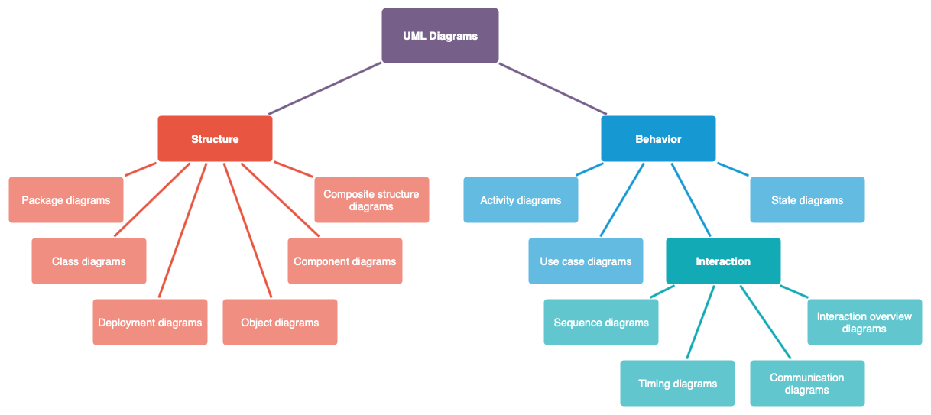

**(Fergusson, 2018)**

## Benefits of UML:

* Simplifies complex software designs and can also implement Object Oriented Programming (OOP) a concept that is widely used.
* It reduces thousands of words of explanation in a few graphical diagrams that may reduce time consumption to understand.
* It makes communication more clear and real.
* It helps to acquire the entire system in a view.
* It becomes very easy for software programmers to implement the actual demand once they have a clear picture of the problem.

Investigating the Data Model: **-**

1. Interviews**:** I conducted meetings with various stakeholders on various occasions by scheduling face-to-face meetings which also fell on the day the clinical team were having seminars. I had to station myself within the department so that all the various stakeholders could stop by and have a chat with me while reviewing the data process modelling that I designed. They were very helpful all through the process from start to finish, by being willing to meet and discuss how the data modelling would help with clinical delivery within the Royal Eye Infirmary (REI). They contributed to the design and development of the new process systems by having their say in the design process and it was beneficial because The stakeholders/stockholders supported me with data modelling by reviewing all the business modelling designs and making corrections and meetings to discuss their expectations and also aired their concerns about the structure of the process I designed because Royal Devon University Healthcare NHS Foundation Trust(RDUH) had the same process incorporated into their Electronic Patient Records(EPR) and are not getting a good or better results. It was not easy to get all the stakeholders to engage with me on the first day of the conference that was held within the whole department.

I had to set up meetings with all the stakeholders/stockholders (Senior Nursing staff, Consultants, Clinicians, Medical directors, and Matrons) to discuss what is expected in the system. I ask questions about the changes that need to be carried out in the new system to address them by collecting all the information, and data that would help me build and design the target state (Future State) and then compare both information and note the changes that this would address while also identifying the gaps that would be addressed.

1. Conference**:** The Royal Eye Infirmary had a consultant/clinician conference which took place within the walls of the department, I spoke to the service line manager about coming to set up a stand within one of the training rooms so that I can meet some of the various stakeholders when they break from the conference and have a chat with them concerning their expectations of the new **Electronic Patient Records (EPR)** which is being rolled out across the trust and its partners. The conference was for 3 days from the **22nd –** to the **24th of May 2024** which I also documented as one of my interactions as a reflective log. The first day was a struggle for me to get the stakeholders to come in and engage with me when they had a break from the conference, even after the service line Manager sent out emails on my behalf 1 week and a half ahead of time, it was still hard to get engagement going, but the second day was not as smooth sailing either as I thought it would be, I was deflated and concerned about the turnout and it made me question why would it be this hard to get stakeholders to contribute to a project that would help make their lives and work much easier in the long run. Towards the afternoon when they were on break from the conference I was lucky enough to have two prominent stakeholders come into the training room where I was set up to chat with me and offered to be of help with the project and it was a very good opportunity for me to ask them questions about their expectations and what help would the new system bring to them and how it would help in reducing patient waiting times and theatre schedules fast-tracked.
2. Primary Analysis**: -** I know it is not easy to get the best out of all the various stakeholders at this crucial time when everyone is under pressure to meet multiple deadlines in preparation for the **Mini-Electronic Patient Records (EPR)** which is why some of the stakeholders get frustrated about the way things are done, I give them reassurances that most of the systems covered in the Mini EPR would be transferred to the bigger EPR when the time comes so that I don’t have to come back to them for interviews or ask for ideas. This tactic helped them relax and be forthcoming with ideas and information about what they expected to be addressed in the new system and how to make the most of it.
3. Secondary Analysis**: -** I had meetings with the various stakeholders and service line managers to discuss how the data is gathered and how they arrived at all the documentation structures that would be used to develop and design the Mini EPR for the department. The department gave me access to some departmental documents so that I could review and understand how all the various documents would sit in the final system after finishing. And also make sure that I get detailed information from the stakeholders about how things are done currently within the department to enable me to understand how to approach the data modelling design process and all the class diagrams that would make the design a success.









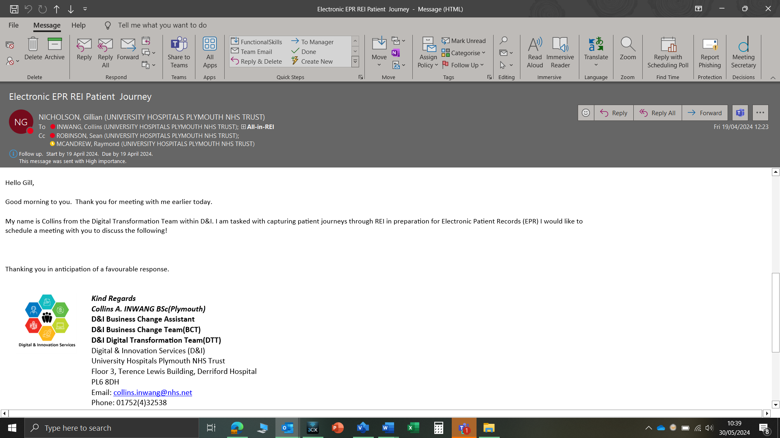

**Email Communications to Actors/ Stakeholders**

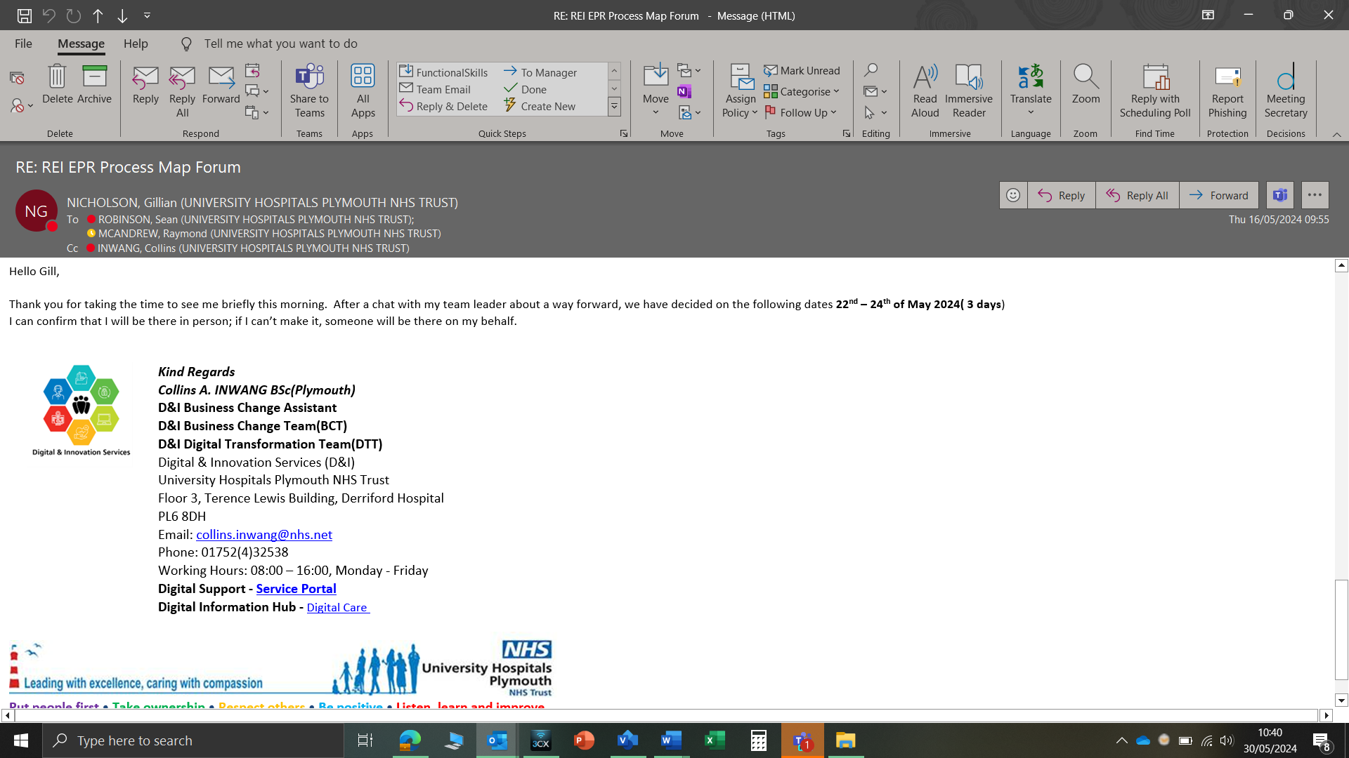

**Email Communications to Actors/ Stakeholders**

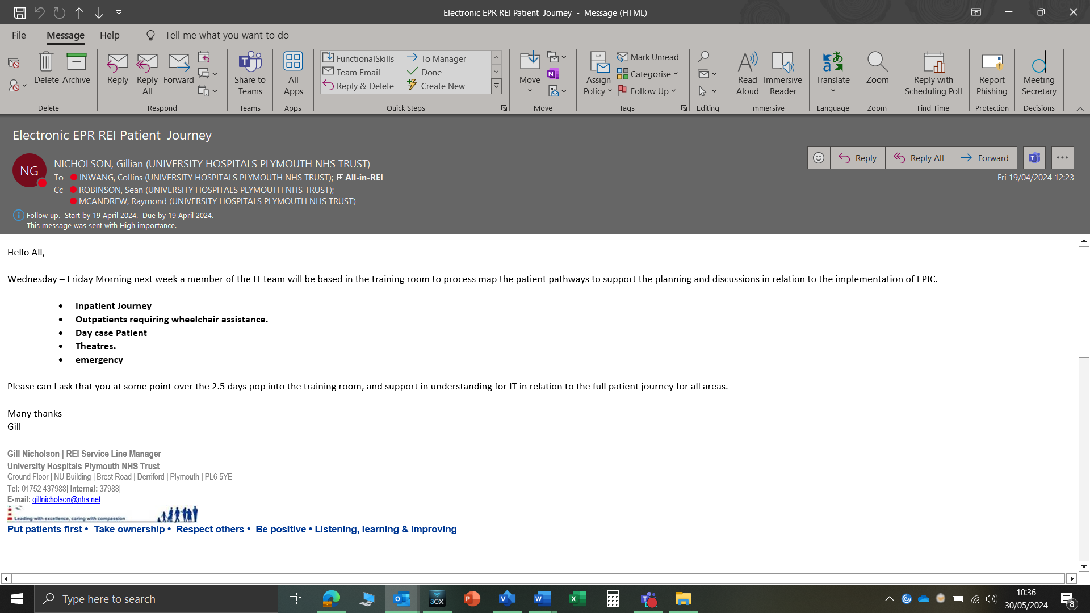

**Email Communications to Actors/ Stakeholders**



**Process Modelling I used to understand what the stakeholders want from the final design**

Documenting the Data Model**:** There are so many ways to document requirements. Some can be referred to as narrative techniques, while some can be diagrammatic approaches and the Business Analyst must select which techniques best suit the situation at hand.

Within my trust we tend to use the agile methodology approach when it comes to projects and its documentation is produced with the highest level of detail and is also defined at the early stages of the project while also making sure that changes can be applied when necessary, during the project lifecycle and development phase.

The benefit of agile methodology in this case is that it reduces the maintenance overhead when it comes to managing detailed requirements documentation while the solution is in development. And it also reduces the risk of redundancy that may occur in specific requirements in earlier on, but only for them to change again before the implementation.

This can also face drawbacks that could lead to inconsistencies and scope creep, as focusing on individual requirements can lead to overlooking the vision for the solution and business objectives.

**(Debra Paul, 2020)**

Software Used in Designing the UML Class Diagram:I used Microsoft Visio which gave me the wiggle room to amend and shift the design anyhow I wanted it. I had to use software that everyone has access to, as its not everyone that has access to Visio licenses which cost a lot of money that the trust cannot afford at this time of cost-cutting and financial uncertainty when it comes to the Healthcare sector in the nation. Below are detailed explanations of each of the designs that are captured in the UML design phase.



**UML Class Diagram**

Issues Encountered when designing the Diagram**:** As I explained earlier in my investigation it took me a while to get the stakeholders engaged in the design phase of the Data modelling class diagram. I was able to get the various stakeholders to be involved in the design phase after a couple of days of intense persistent and it was an eye opener for me to see how much the department is desperate for a change and system upgrades which I think is vital to what we are trying to achieve as a trust and the wider National Health Service (NHS) nationally.

Analysing the Data Model**: -** According to how our data is structured in the system, a patient can have many treatments with different Clinicians and specialists on different occasions. Sometimes patients can be moved to other hospitals for more in-depth specialist treatments that are not carried out in all hospitals. You also have some instances where the system can have relationships of “**one – many, one - one, zero - one, zero – many”** that make the relationship unique depending on what and how the patient journey goes.

In some cases, the patient can also be treated or be admitted to a hospital that only specialises in certain treatments and which in this case can be at different locations or NHS trusts depending on the patient's needs. We have **one-many, and zero-many** in our UML Case Diagram. Also, the diagram demonstrates how patient data are stored and used to maximise usage while also minimising data lost in transit.

While looking at the data and the process at the same time another thing that came out is the inability of Clinicians to monitor patient activities remotely to know when the patient should be called into the department or not, this is why we opted for the new **Electronic Patients Record (EPR)** in the name of **MediSIGHT** as a temporary measure until the introduction and rollout of the bigger EPR called **EPIC** which would come into play in the fall of 2025. The inability of Clinicians to manage and pull patients' notes/records from previous appointments is a major setback and makes life difficult for the Clinician so we decided to introduce the mini EPR to help settle the difficulties momentarily for the next 18 months which will give clinicians control over their patient's notes and previous treatments because all the notes would be centralised in one location.

The current system is not meeting most of the Clinical needs of the patients and the Stakeholders are not getting the most out of the system. The table below addresses the activities of the current system (Current State) across the various pathways and the suggested ideas the new system (Future State) would address this which can also be referred to as **Must Have, Should Have**, and **Could Have.**

Conclusion**:**

In conclusion, during the investigation and information gathering, I ***learnt***that in most cases the stakeholders/ stockholders are not sure what they want the new system to address until the current state of the business model and processes is designed for them to see the visuals for them to be able to make corrections and amendments and also decide on what to include in the future state when designing the process model/future state. Even with this, I still learnt that “**NOT**” all information gathered was allowed on the future state/desired situation because the stakeholders kept moving the goal post and amending all the information that was agreed upon during the brainstorming stages of the process.

The Data Modelling/UML design of the entire process was mentally exhausting to say the least because of the frustration I got from the service line Manager is ***What went well*,** even though the Service Line Manager was difficult to deal with, the various stakeholders were much easy to convince and reassure them of what I was trying to achieve and how this temporary system would help make their life much easier till the permanent system comes into play late next year. It made me realise my patience and strength of being able to weather the storm of rejection in terms of the stakeholders accepting my first process modelling of the desired state.

I had to schedule new meetings with the stakeholders (Consultants, Sonographers, Nurses, Nurse Practitioners and Secretary) to understand what the new process is supposed to address to not make mistakes or have it rejected again. ***What I will do differently*,** is make sure that I get more engagement from all the various stakeholders as many times as possible for them to look at and make corrections before I design the desired situation/future state process model.

REFERENCES**:**

* (Vivek, 2024) - [Data Modeling: Benefits, Types, Importance & Steps Involved (zucisystems.com)](https://www.zucisystems.com/blog/what-is-data-modeling-and-why-is-it-important/)
* (Contributor, 2019) - [What is a class diagram? Definition from WhatIs.com. (techtarget.com)](https://www.techtarget.com/searchapparchitecture/definition/class-diagram#:~:text=A%20class%20diagram%20is%20an,of%20code%20representing%20that%20entity.)
* (Fergusson, Draw.io, 2018) - [UML diagrams - which diagram to use and why - draw.io (drawio-app.com)](https://drawio-app.com/blog/uml-diagrams/)
* (https://dspmuranchi.ac.in) - [classdiagram_MscIt_sem1.pdf (dspmuranchi.ac.in)](https://dspmuranchi.ac.in/pdf/Blog/classdiagram_MscIt_sem1.pdf)
* (Armstrong, 2023) - [Why is Data so important to companies? Here are the top 5 reasons (firebrand.training)](https://firebrand.training/uk/blog/why-is-data-so-important-to-companies-here-are-the-top-5-reasons#:~:text=Data%20helps%20companies%20make%20better,trends%2C%20and%20managing%20marketing%20drives.)

# **Chapter 6 - ACCEPTANCE TESTING**

**APPRENTICESHIP COURSE WORK**

**ACCEPTANCE TESTING**

INTRODUCTION**:**

Within this project am discussing the current system for scan requests called and how it is done using **iClinical Manager (ICM)** software. The current system process that we have in place is inefficient and includes too many steps without any visibility. It is causing a lot of dissatisfaction among the clinicians, consultants, nurses, **Sonographers, Radiographers** and most importantly the patients. We need to streamline the process to be more efficient and create more visibility. We are looking at improvements which will make life easier for the clinicians, and consultants who request scans and look at how we can carry the patient along in the journey. So, we have designed an in-house system called the **Radiology Acknowledgement System** (**RAS**) that sits within the **SeeEHR** platform and will replace the current system called **CDN Radiology Information System** (**CRIS)** and would help regulate and monitor scan requests better.

The system will be temporary until the big **Electronic Patient Records (EPR)** is acquired in the autumn of 2025. This will help clinicians and consultants search for patients using hospital/NHS numbers whenever they want to review or request scans, analyses, or examine scan results. The bigger EPR is **EPIC** but at this present, the Trust can't wait till that time specified, so we arranged to put this in-house system in place to help address the setbacks till next year.

**Radiology Acknowledgement System (RAS)** has been in the making for a long time now and going out and having various stakeholder engagement meetings. Roadshows to try and find out how we can help life and work easier for all the multiple stakeholders in terms of Scan requests, we realised that something was missing that needed to be corrected and make scan and imaging easy to manage. The pilot scheme is to be rolled out the week commencing **12/08/2024** and the first department would be **Maxillo Facial** which is the plastic surgery department, then **Ear Nose & Throat (ENT)** because they are next to each other and are the departments/service lines that were willing to give it a go.

As part of this project, I was required to do some user acceptance testing to try and fish out bugs that could stop the system from functioning to its full capacity and interrupt how stakeholders carry out tasks in the hospital. This can also hinder patient care and the experience regarding appointments, which are affected by the lack of speed and the slowing down of the system. I was required to be part of the testing team and support the testing phase in preparation for the final rollout.

Importance of Acceptance Testing**:** The main purpose of acceptance testing is to find errors, gaps or missing requirements compared to actual requirements. When software development projects are being done, there is a huge tendency for errors to occur in any phase of the life cycle. Only a few of them can go undetected, which is why it's important to carry out quality assurance to help address all the errors in the final code of the functionality and design.

Acceptance testing is very important to help identify any inconsistencies in the code early and fix them before the final product is delivered. This is why the following points are very important in testing:

* Saving Money: **-** software testing has a lot of benefits which include the cost-effectiveness of the project is one of the top reasons why companies test new systems. The testing of software is mainly to try and find bugs in the early phases, fixing them can help reduce the amount of money spent in the long run, which is why having the system testing done as you go along is very important.
* Security**: -** This is another crucial piece and is the most vulnerable and sensitive part of testing. The risk of users' information being stolen and sold or used for the benefit of financial demands, is the reason why it is important to demand a well-tested and more reliable system. As the system undergoes testing, the stakeholders and end users can rest assured that their details are in safe hands that they can rely on the finished product and the system is free from hackers' attacks and vulnerability.
* Product Quality**: -** For software to come to life, it is important that vigorous testing is carried out to determine its full functionalities and how well it works. This can help identify any bugs or defects in the system and fix these in the development phase of installation. Testing would then give room to calculate how many defects might still exist and analyse the quality of the software before going live.
* Improve Customer/end-user Satisfaction**: -** customers, end-users and stakeholders' satisfaction is always the end goal of all businesses, which is why continuous testing and measurement is very important before launching or going live. Systems that run without a glitch are more likely to result in smoother business operations.
* Software Upgrades/Add-ons**: -** The testing team can help the developers and engineers integrate new features and upgrades of functionalities into the existing systems because testing always accounts for continuous improvements. Our testing helps to ensure that the software meets the stakeholders, and product owner requirements for future integrations and evolutions. Implementing test cases to cater to specific scenarios, where upgrades can be performed at higher system performances, allowing developers to add new features as the system scales forward.

Test Phase Identification**:** The software testing lifecycle which is also referred to as STLC is a sequence of actions that is performed during the testing process of software to ensure that all the quality objectives are met. This can also include verification and validation.

1. Unit Testing**:** Unit testing can be referred to as a process of testing a unit, this can be the smallest piece of code that can be logically isolated in a bigger system. In most programming languages, that is a function, a subroutine, or a property. This can also be defined as a type of software testing that focuses on testing individual components of a software product. The “UNIT” in unit testing can be functions, procedures, methods, objects, or other entities in an application’s source code. Each development team decides what unit is most suitable for understanding and testing their systems such examples are object-oriented designs that tend to treat a class as a unit.

Unit testing relies on mock objects to stimulate other parts of code, or integrated systems, to ensure the test remains simple and predictable. The main goal of unit testing is to ensure that each unit of the software performs as intended and meets the expected requirements. The following steps are needed to carry out a successful unit testing:

* Planning and setting up the environment.
* Writing the test cases and scripts.
* Executing test cases using a testing framework.
* Analysing the results.

1. System Testing**:** System testing can be defined as the type of software testing that evaluates the overall functionalities and performance of complete and fully integrated software solutions. This can also be performed on a completely integrated system to evaluate the compliance of the system with corresponding requirements. System testing is performed by a testing team that sits independently of the development team and helps the qualities of the system impartially.

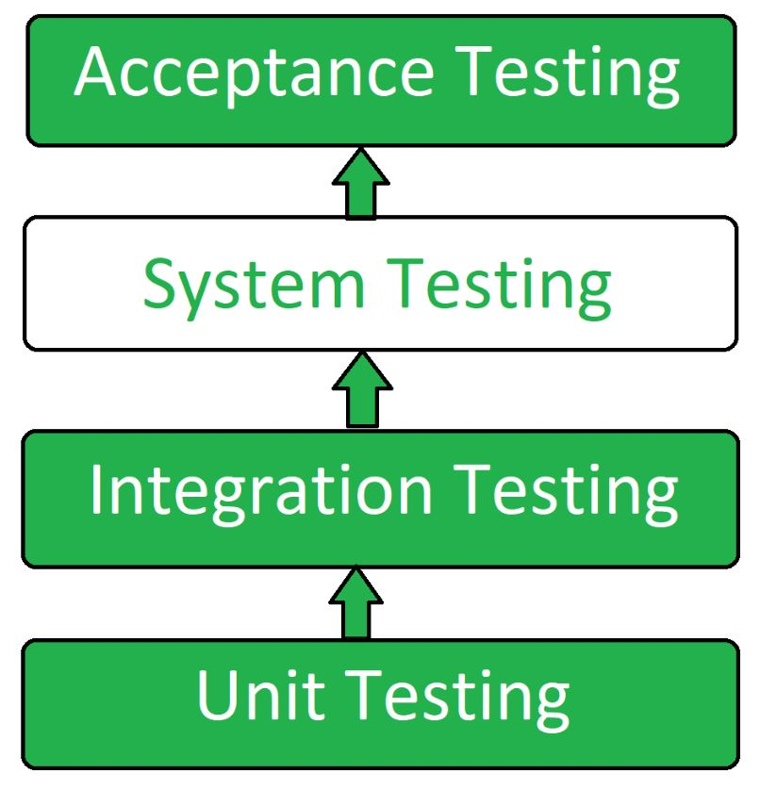

**(Geeksforgeeks, 2024)**

1. Integration Testing**:** This is defined as the process of testing the interface between two (2) software units or modules. It focuses on determining how correct the interface would be while also exposing the faults in the interaction between all integrated units. Also, integrated testing is carried out once all the unit testing has been completed. Integration testing focuses on verifying the interactions and data exchange between different components or modules of a software application and identifying any problems or bugs that may arise when different components are combined and interact with each other. Integrated testing is also carried out immediately after unit testing is completed and before system testing, in turn, helps to identify and resolve any integration issues earlier in the development cycle, reducing the risk of more problems later on that may be costly.

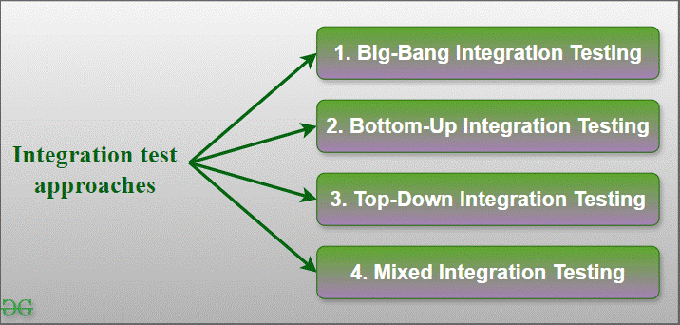

**(Geeksforgeeks, 2024)**

1. User Acceptance Testing (UAT):User Acceptance Testing (UAT) is defined as the process of ensuring that the software meets the business requirements and is ready for final deployment by validating its functionalities in a real-world scenario. And allows the end-users to test the software to ensure it meets their needs and requirements and also operates perfectly as expected, helping to fix any bugs or issues before the final rollout. UAT is also good for quality assurance, as it helps to ensure the software is user-friendly, reliable, durable, rugged, and meets all the criteria it was built for.

The main reason why **UAT** is used in the software testing cycle is to help identify bugs in the software, systems, and even the network that may cause a problem for users. **User Acceptance Testing** plays a vital role in ensuring that the software can handle and perform well to the required standards and development specifications.

There are 6 types of User Acceptance Testing (UAT) which are listed below:

* Beta User Acceptance Testing
* Black Box Testing
* Operational Acceptance Testing (OAT)
* Contract Acceptance Testing (CAT)
* Regulation Acceptance Testing (RAT)
* Alpha User Acceptance Testing

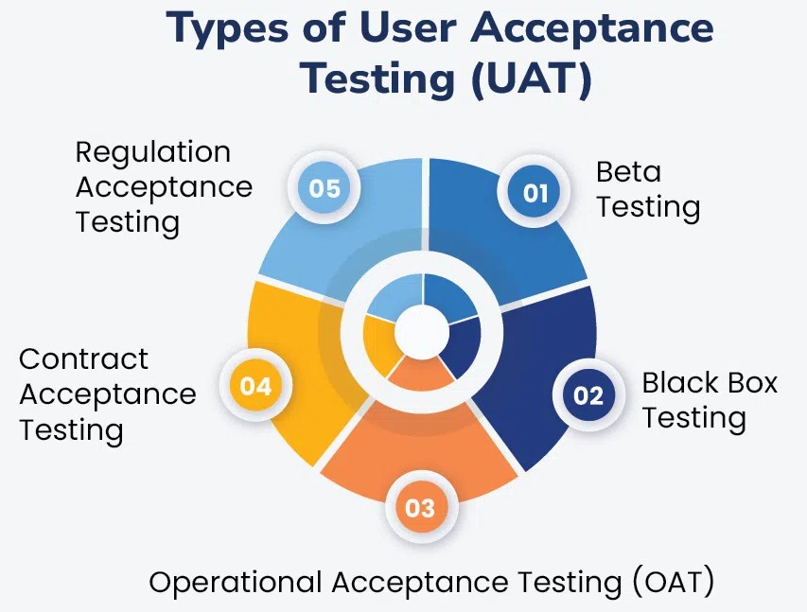

**(Geeksforgeeks, 2024)**

The Software Testing Life Cycle (STLC) is a direct associate of or part of the Software Development Life Cycle (SDLC) which is a framework of 6 core principles:

* Requirement Analysis.
* Planning
* Engineering and Design.
* Software Development
* Testing
* Deployment.

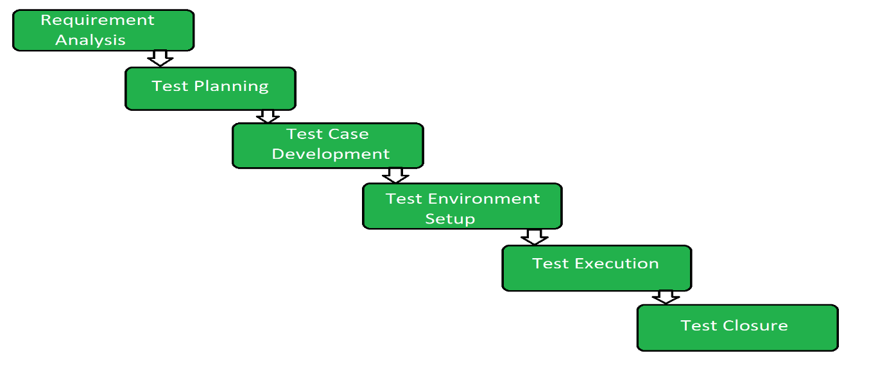

**(Geeksforgeeks**, **2024**)

Business Analyst role within the Testing Lifecycle**:**

The Business Analyst is regarded as one of the major players in identifying business requirements and converting them into business solutions. Business and system analysts translate the features of solutions necessary for the customer into software requirements that are understandable to the development team.

* Requirement analysis: - The team of BAs/SAs play leading roles during requirement gathering and at the analysis stage, as well as in the design stage. The BAs and SAs also monitor the code development and follow the testing phase during bug-fixing as change agents in the project development team to fulfil the customer’s requirement.

In simple words, the Business analyst gets actively involved in some testing phases so that they can verify and clarify requirements. The business analyst would be available to answer any questions that the software team may have.

Though the main role of the business analyst is to be the requirement owner of a project, they also play a significant role in software testing. To make sure that the developed system can meet the business needs, and also gets involved in assisting test case development, review, execution of part of test cases and support all the various stakeholders during testing activities.

I played a vital role in gathering all the relevant information and requirements for this project, in terms of process map designs and process modelling. I was tasked with going out there to meet with various stakeholders and stockholders to discuss the project and how the project would be beneficial for the entire trust's day-to-day engagements with all the various service users and patients. I made sure I listened to all the various points raised and also put their concerns into consideration and feedback.

* Planning**: -** Every project is unique and is also temporary. The business process management, regulatory compliance and digital transformation projects that business analysts may play a huge role in all come with different goals, scopes, teams, timelines, budgets, dependencies and risk factors. Though many projects can follow similar methodologies, they can be tailored to meet project scope constraints while taking advantage of available resources and lessons learned from previous projects.

As a business Analyst, I come with a unique and diverse set of skills and extensive experiences.This involves good communication skills some good knowledge of stakeholders' engagement and experience-based business knowledge. In any project lifecycle, if the business analysis planning is bypassed, it would pose a very challenging prospect of understanding the scope of work various stakeholders' expectations and the level of required input from the business analysis for the project which in turn makes the process far more difficult and can result in unrealistic expectations by all involved in the requirement related activities.

I organised drop-in sessions and road shows for the different stakeholders to interact with each other and share ideas on their expectations and how they want to final product to look and feel. This in turn helped me gather all the needed information for the development team to work with. I made sure the fears and concerns of the stakeholders were put into consideration earlier in the planning stages so that it would not hinder the project deadline when it came to the testing phase and piloting stages.

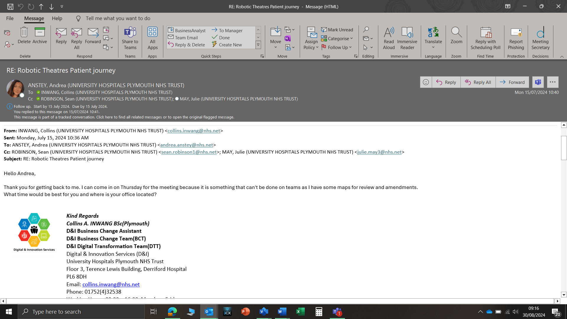

**Meeting Invitation screenshot**

* Engineering and Design**: -** The business role of the business analyst helps bridge the gap between various stakeholders, the product owner and the development team which consists of the testing team. These also help to interpret the business requirements into understandable tasks or user stories to match the final product/ system with the expected final business value. This is where my expertise as a business analyst was required to generate reports that represent the operations of the product promptly. Also assessing the target end-users/ stakeholders while modelling the process to reflect and align with the needs of the service users.

I also Organised stakeholder engagement meetings and seminars to propose smart ideas and be open to contributions from all parties through discussions, allowing experts to share ideas and road maps to help me explain the project vision and the business needs to all parties involved. Having feedback from previous meetings and seminars also helped me review any changes and tailor my questions to any changes that may have occurred.

* Software Development**: -** Business analysis is growing rapidly in the marketplace place which makes it more interesting to get the business analyst involved in the entire process and is pivotal as the linchpin between IT and business domains and plays a crucial role in shepherding companies through the complexities of digital transformation. The contribution of a business analyst in the software development lifecycle helps clarify the requirements involved in managing backlog items, such as user stores, and meticulously detailing the expectations for the development team which also includes acceptance criteria. Managing backlog can help break features into digestible, prioritised segments is crucial for streamlining workflow efficiently. And I suggested This can be seen in the images below: -

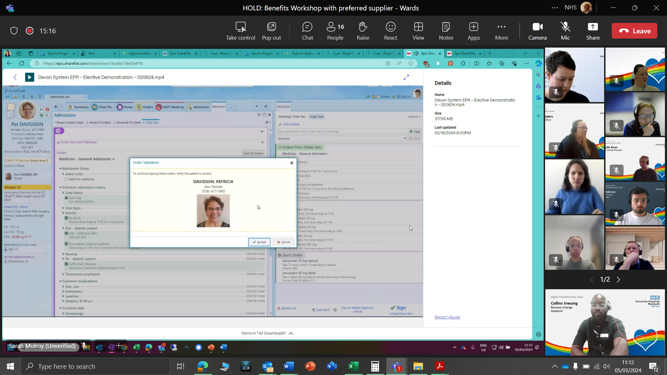

**User environment testing**

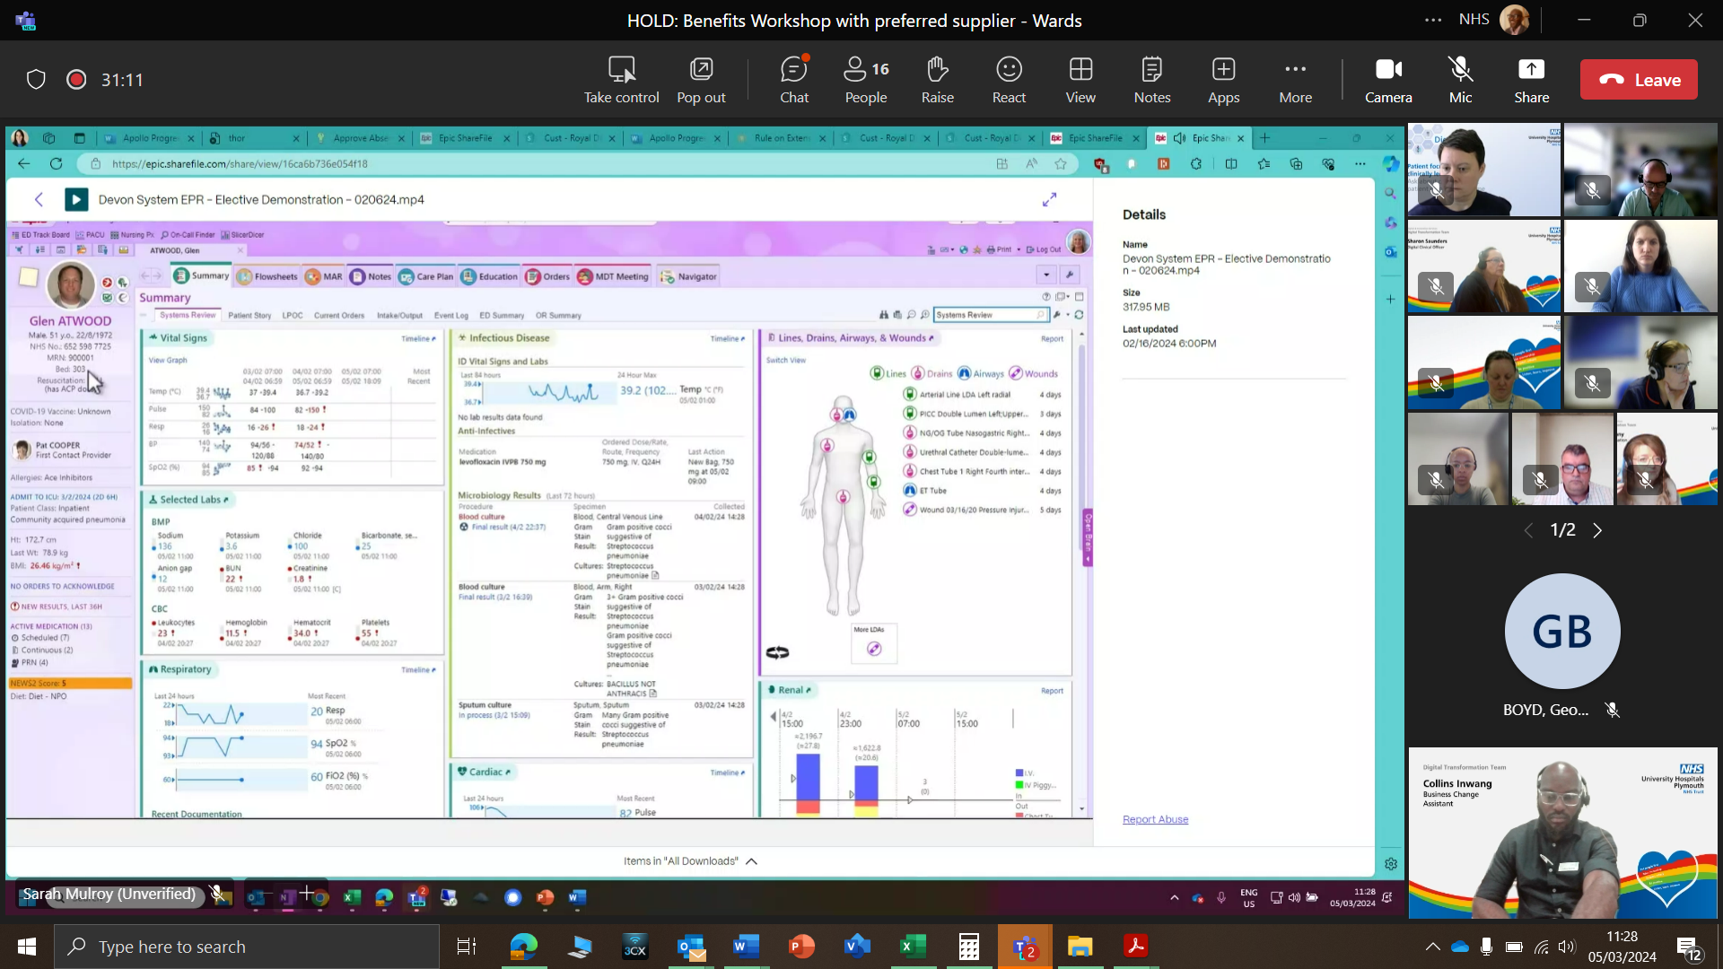

**User environment testing**

A business analyst also contributes to the project goal identification and pain point analysis by collaborating to discern overarching project objectives and pinpointing areas ripe for enhancement can form the bedrock of strategic decision-making. Also by striving to enhance benefits while minimizing implementation costs by scrutinising, refining, or even simplifying conceptualizations at the nascent stages is central to optimising project outcomes.

Effective requirement communication can help facilitate seamless comprehension within teams regarding task objectives and rationale is very paramount for cohesive execution. In this regard, I played a vital role in information gathering by going out to meet the stakeholders/stockholders to get their input and expectations and then presented my findings to the following team, software development team, testing team, Business Change Analyst, change analyst team and Clinical Support Officers so that we can discuss what is needed to complete the project from design to testing.

* Testing**: -** Testing can be referred to as executing a program or system to find defects. This is a concurrent lifecycle process of engineering, using and also maintaining test ware to measure and improve the quality of the software/product. The Business analyst can play a vital role by making sure the boundary conditions are met and protected in the process and see to it that the business rules are incorporated into the test cases while also assessing whether the testing phase meets the required validation process while also providing clarification on the requirements allocated to the components. The Business Analyst makes sure that the process flows are accurately represented in the test plans and also all the functional/non-functional requirements are not left out in the process by reviewing system cases prepared by the testing team.

During the testing phase, I met with various stakeholders such as Clinicians and Medical Secretaries to get them involved in the testing phase by creating an individual test environment for each of them so that they could try out the new system that we can collect the data and use it to monitor or address any gaps that may arise. As shown in the screenshot image below:-

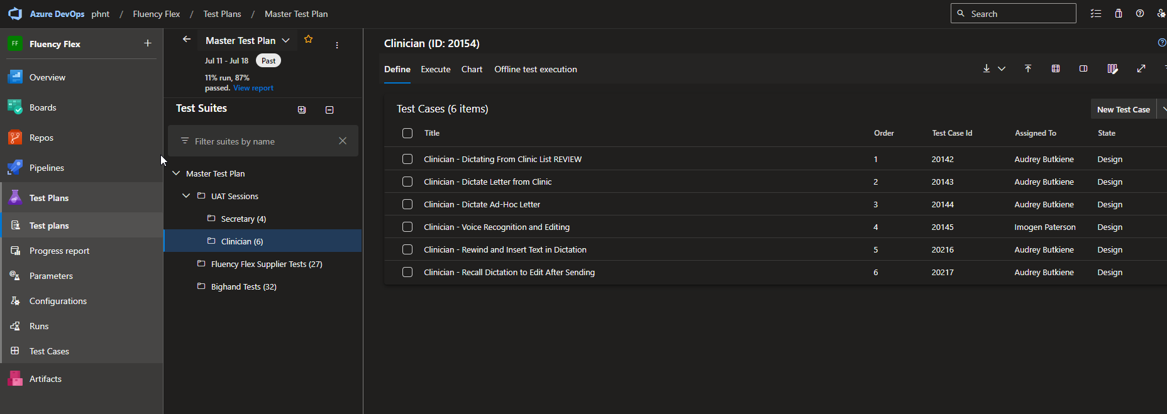

**Azure DevOps Test Script for Clinician (ID:20154)**

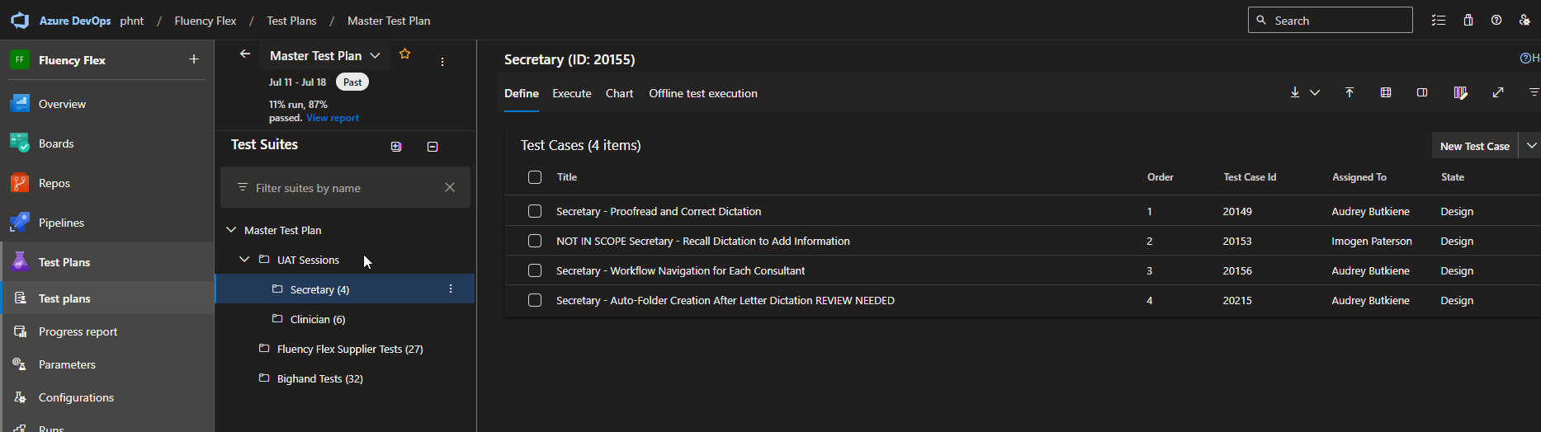

**Azure DevOps Test Script for Secretary (ID:20155)**

The Azure Test plan comes with a very easy-to-use browser-based test management solution that provides all the capabilities required for planned manual testing, user acceptance testing, and exploratory testing, and also serves as a feedback-gathering tool for various stakeholders.

* Deployment**: -** The deployment stage is where the business analyst helps to make sure that there is a smooth transition of the new application/system from the development environment to live or rollout while making sure that all the necessary configurations, integrations and data migrations are executed in a well-structured manner. The Business analyst can ensure that the solution or final system meets the requirements and objectives stated in the project initialisation and full business case meeting. I played an important role in providing end-user support during the rollout by designing a well-structured training material that contains all the necessary steps to follow to get the best out of the new system during the initial rollout or piloting period while also gathering feedback from the various Stakeholders/stockholders and end users so that we can understand where the system needs improvement and also document some lessons learned so that when we meet as a wider team I can present my findings. I also participate in post-deployment reviews with the project team, training team, and change Analyst to evaluate the overall success of the project rollout and identify any necessary adjustments if needed.

The way NHS Trust manage and facilitates Business acceptance of change is to make sure we incorporate our core values into the change process which is: -

## Put People First**: -**

I tend to follow the trust values which is to put patients and people first by making sure I carry the end users and service users along whenever we are looking to effect change in the way we operate because people are the ones who can fuel and sustain the momentum for change. The change initiative can fail if I don’t get staff, and service users involved and make sure they understand and believe in the process or are engaged in the change process.

This in turn makes change easier when the employees are involved in the change process, and we accomplish this through proactive communication strategies that create the desire for change across University Hospitals Plymouth NHS Trust. We carry out **road shows, seminars and, drop-in sessions** for staff members to ask questions and air their concerns about the new system and ask questions. We make sure there is a **test simulator (Dummy page)** for them to play around with and feel/ experience the change before the final rollout.

Empower Staff Members Through Communication**: -**

Communication is very vital and also an effective way to manage change within the Trust and the way the communication is carried out can provide clarity to the stakeholders, staff members, service users and everyone who would use the new system for why we need the change and mobilise employees with a sense of urgency for change. We carry out **surveys, small focus groups and formal feedback forms** so that the stakeholders, and staff members feel valued and more likely to embrace change by participating in making sure it happens without any pushbacks or setbacks.

I know it is not easy to try and sell change to staff members or stakeholders/stockholders who are used to one way or their one way of working, so we try to give them the platform to express their concerns and worries about the new system and make them feel valued and appreciated to be able to carry them along and get their opinions on the new system by making change compelling and exciting for them through purposeful, clear, precise and consistent communication. This strategy helps provide context for them to understand the **“why, what and so what”** of the change that is about to be implemented. This also helps answer most of the important questions that stakeholders/stockholders and staff members are thinking during this time **“How will this impact my work; what does this mean to me?”** in some cases with a clearer understanding of the change they can also be of assistance in carrying out the changes that are needed.

Ignoring Resistance to Change**: -**

We pay most attention to how change preparation is accepted across the Trust to determine the high and low momentum points across the stakeholders/stockholders and staff members to help leverage the points in time. During the high points, we as a team would celebrate our wins, which fuels the momentum to keep pushing and breaking the barriers. Sometimes it doesn’t go as planned in terms of acceptance, which we refer to as low points, then we go back to the drawing board and reset our communication strategies by listening to stakeholders/stockholders and staff members' input to help build trust and support for the new system.

Resisting change can be very bad and poisonous to the Trust’s journey through transformation and it is much easier to manage and counter when it is identified earlier on in the transformation/change journey. When am out and about for stakeholder/staff engagements I pay attention to the tone of their voice to try and detect resistance which can be their body language, withholding information and unwillingness to engage with me when I ask questions.

Supporting User Acceptance Testing (UAT): **-** Within my trust, I am indirectly involved in new system testing that occurs whenever we introduce new software systems across all the sites by being able to sit with the software development team (Soft Dev) to try and understand what happens whenever testing is carried out on a new system, and I can clearly say that the Soft Dev team uses the Microsoft Azure DevOps Server 2022 platform for system testing whenever there is testing to be carried out. The Azure Tests Plans provide rich and powerful tools that the test team members can use to drive quality and enhance collaboration during the development process.

My involvement in the User Acceptance Testing (UAT) for the **Radiology Acknowledgement System** (**RAS**) was to review the acceptance criteria by creating a training environment for users such as Clinicians, Secretaries and radiographers to have a play-around so that we could analyse the data that would help us understand where the system needs to be improved upon.

## Acceptance Criteria: -

My role is crucial in understanding the needs and analysing the requirements by translating them into acceptance criteria. My team bridges the gap between stakeholders/stockholders and the development team. And needed to test how long it would take for Clinicians and secretaries to pick up messages sent through by Radiographers and act upon them depending on the urgency of the messages we used a traffic light system to identify it urgency. I then created the test script to help understand the system better, the initial test failed, and this was shared with the entire team to help understand where the problem was coming from so that we could work on improving the faults. After which the system was retested. This is shown in the images displayed below: -

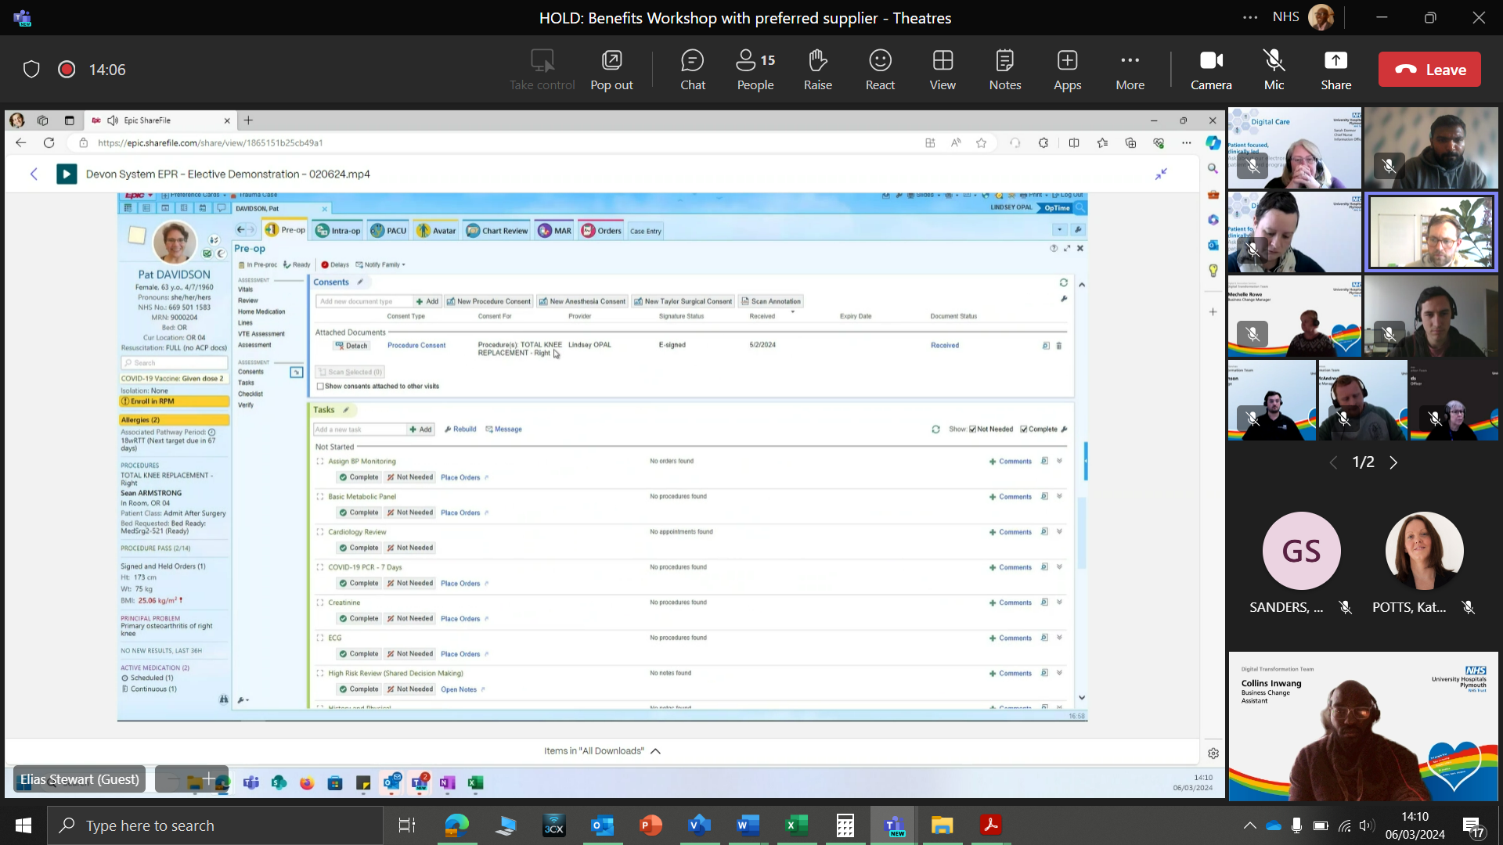

**Consultant/Clinical Staff Log-in Page**



**Azure DevOps Test Script for Clinician (ID:20154)**

I am part of a team that tends to use user stories to track the activities of the system users and stakeholders across the platform of the new system and follow strict and mandatory to be able to get how the system is used for different purposes by the stakeholders and staff members alike. As a consultant and clinical staff, we want the first things they see when they login to be the following: -

* Patient Details – In this section, they should be able to see the navigation bar with links that can take them to various pages such as **patient details** that can consist of DOB, Address and contact details as shown in the image below:
* Patient Medical/Treatment History**: -** In this section the Clinical staff should be able to look and view all the patient's past appointments and treatments that were carried out on the patient. And be able to see the dates of previous appointments and treatments that individual patients had undergone when they were last admitted to the hospital.

Defect Management Process/Procedure**:** If things do not go according to plan in terms of the system execution or rollout, that is encountering bugs during the testing phase, the testing team would execute the test script and record any bugs that are preventing it from running perfectly well and then review and assign it to be investigated before reproduction of the bug.

I get involved by collaborating with the testers, developers, and all the various stakeholders to ensure that proper documentation, tracking, and resolving of the defects are carried out accordingly. I will also make sure that effective communication is established between all the various teams and that the stakeholders are duly informed about the encountered defects and the process being followed to address them.

The project team which comprises Software Development, Quality Assurance, Test Engineers, and Business Analysts would meet to discuss the bug that has prevented the system from running smoothly and then I would look to see where the fault is coming from by revisiting all the various stakeholders to understand how I can address their concerns. And look at ways to improve the application while addressing the bug that has been detected by striving to optimise it while also based on the observation and analysis generated from the test run I and the team would make specific tweaks to the workflow to better categorise the found bugs and share it with the entire team that would allow us to proper describe the bug in a structured manner in terms of level of severity(High-Medium-Low) impact to the system performance. This would in turn help me and the team to determine the structured reporting guidelines step by step to try and reproduce the bugs and their full details by providing screenshots if needed.

## Conclusion:

In conclusion, during the investigation and information gathering, I ***learnt***that in most cases the stakeholders/ stockholders are not sure what they want the new system to address until the current state of the business model and processes is designed for them to see the visuals for them to be able to make corrections and amendments and also decide on what to include in the future state when designing the process model/future state. Even with this, I still learnt that “**NOT**” all information gathered was allowed on the future state/desired situation because the stakeholders kept moving the goal post and amending all the information that was agreed upon during the brainstorming stages of the process. During this time frame ***What went well*** was the willingness of the chosen departments to be used as a pilot rollout, and the happiness/ joy that was visible on their faces gave me and the team the confidence that all would go well during the pilot scheme and also we will be on ground to monitor the effectiveness of the rollout and take some feedbacks for future reference when the time comes for rollout across the whole trust. ***What I would do differently*** in this case would be to convince more service lines and Managers to sign up for the pilot scheme so that when the time comes for the final rollout there won't be too much work or departments to cover in the limited time frame that we have. I know it is not easy to convince more Managers to help speed up the rollout, but at the same time, these can help us to understand and prepare better next time.

## REFERENCES:

* (Smartbear, 2024): [What Is Unit Testing? | SmartBear](https://smartbear.com/learn/automated-testing/what-is-unit-testing/)
* (Bakharev, 2023)**:** [Unit Testing: Definition, Examples, and Critical Best Practices (brightsec.com)](https://brightsec.com/blog/unit-testing/)
* (Geeksforgeeks, 2024)**:** [System Testing - Software Engineering - GeeksforGeeks](https://www.geeksforgeeks.org/system-testing/).
* (Saini, 2020)**:** [Role of a Business Analyst in Software Testing | MindsMapped](https://www.mindsmapped.com/role-of-a-business-analyst-in-software-testing/)
* (LN Mishra CBAP, LinkedIn, 2022)**:** [(1) Role of Business Analysts in Testing | LinkedIn](https://www.linkedin.com/pulse/role-business-analysts-testing-ln-mishra-cbap/)
* (Microsoft Corporation, 2024)**:** [What is Azure Test Plans? Manual, exploratory, and automated test tools. - Azure Test Plans | Microsoft Learn](https://learn.microsoft.com/en-gb/azure/devops/test/overview?view=azure-devops)
* (Parthiban, 2021)**:** [7 Reasons Why Software Testing is Important (indiumsoftware.com)](https://www.indiumsoftware.com/blog/why-software-testing/)
* (Team, 2023)**:** [Why testing in software engineering is essential (6 reasons) | Indeed.com UK](https://uk.indeed.com/career-advice/career-development/testing-in-software-engineering)
* (McGuire, 2024)**:** [Why Is Software Testing Important in the Software Development Lifecycle? - Pulsion Technology](https://www.pulsion.co.uk/blog/why-is-software-testing-important-in-the-software-development-lifecycle/)
* (Metera, 2021)**:** [A Checklist for Business Analysis Planning - Business Analyst Articles, Webinars, Templates, Jobs (batimes.com)](https://www.batimes.com/articles/a-checklist-for-business-analysis-planning/)
* (Raval, 2020)**:** [(1) Planning a Project in Business Analysis | LinkedIn](https://www.linkedin.com/pulse/planning-project-business-analysis-adit-raval/)
* (Experts, 2024)**:** [Role of Business Analyst in Product Engineering - Goavega](https://www.goavega.com/ai-product-engineering/role-of-business-analyst-in-product-engineering/)
* (Hub, 2024)**:** [(2) What is the Role of a Business Analyst in Software Development? | LinkedIn](https://www.linkedin.com/pulse/what-role-business-analyst-software-development-devxhubcom-i0s3c/)
* (LN Mishra CBAP, LinkedIn.com, 2022)**:** [Role of Business Analysts in Testing | LinkedIn](https://www.linkedin.com/pulse/role-business-analysts-testing-ln-mishra-cbap/)
* (Shukla, 2024)**:** [What is the role of a business analyst during the deployment phase? - Quora](https://www.quora.com/What-is-the-role-of-a-business-analyst-during-the-deployment-phase)